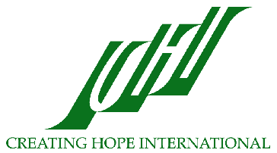
Creating Hope International
Empowering Communities Throughout the World

About Creating Hope International

Creating Hope International (CHI) is a 501(c)3 non-profit organization that provides education and health assistance to the people in the world with the greatest needs. CHI works at the grassroots responding to community requests, fostering community participation, and empowering people through culturally sensitive education and training. Believing that local communities know best what they need and are more effective implementers of programs than outsiders, CHI’s primary goal is to assist effective indigenous programs with technical assistance and empower communities to meet their own needs. CHI has:
- Provided technical assistance and training to Mexican villagers in building latrines as well as public, maternal, and child health services
- Trained teachers in Pakistan and Afghanistan
- Raised funds to support refugees in Iran and Pakistan
- Designed and provided educational materials for teacher trainers
Currently, CHI staff members are directing their efforts toward four projects; the Afghan Project, the Tibetan Bon Project, the Public Education Project, and the Alternative Health Project.

Afghan Project

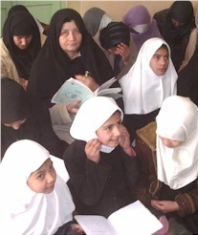
CHI has a long history of empowering Afghans through health and educational services, community building, and culturally sensitive programs. Since 1996, CHI has worked closely with the Afghan Institute of Learning (AIL), providing training and technical assistance with administration, finance, program, strategic planning, vision development, fundraising, budgeting, and proposal writing. AIL is now one of the largest Afghan women-led NGOs and provides health and education services to 350,000 women and children annually.

In the last four years, CHI has helped AIL secure much of its own funding and increase its annual budget to over $1,400,000. Almost 75% of AIL’s funds now come from direct grants to AIL. CHI is also building the capacity of AIL staff to manage book keeping and finances independently through technology-supported training. With initial advanced teacher training from CHI, AIL has now developed into the pre-eminent teacher training organization in Afghanistan. CHI staff has trained AIL staff in human rights, leadership and peace and helped develop culturally relevant human rights and health curriculum. AIL has successfully introduced these historically controversial topics to thousands of Afghan women.

With CHI’s help, AIL has grown from a small, local Afghan women’s community-based organization with an annual budget of approximately $30,000 to a large, internationally recognized, non-governmental organization with a broad array of quality health and education services that are changing hundreds of thousands of lives for the better. Now that it is an established NGO with a track record of success, AIL has begun to provide training and technical assistance to small local Afghan community-based organizations to help build the capacity of Afghanistan’s civil society sector.

Tibetan Bon Project

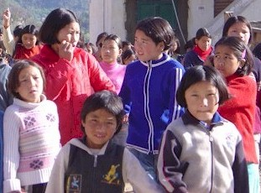
The Bon are a minority Tibetan ethnic group that fled to India when the Chinese invaded Tibet in 1959. In 1968, the Bon established a community in Dolanji, India on donated land. Today, 75 Tibetan Bon families (including more than 500 children) are settled there. The community has an orphanage, children’s hostel, school (to the 10th class), health center, and community farm. CHI assists the Bon to organize an administrative structure to meet the health and education needs in their community. CHI also helps them write grants and reports to improve their water, sanitary, health, education, and living conditions. Projects that CHI has worked on with Bon community include fundraising for water tanks, a storage building, health facility equipment, a drinking water well, and public toilets. CHI has also provided funds to purchase a milk cow and improve water and living conditions.

Now, CHI is working with Bon leaders to support education for the community’s children, including new Bon students who have left their homes in Nepal because of increased civil conflict. Since 2003, CHI has funded scholarships that allowed Bon youth to obtain secondary education. CHI is also supporting an essential oils project with this community. The Bon clinic treats over 40 patients each month with medicinal essential oils and has even begun to explore producing their own medicinal oils. They hope to eventually produce enough essential oils to stock the clinic and sell for profit.

Public Education Project

CHI’s public education efforts promote awareness and sensitivity to cultural differences, increase understanding, and help others value the cultural diversity of the world. CHI representatives educate people about the needs of Afghans and others in developing nations. CHI staff members have been interviewed on National Public Radio and Equal Access Radio and by television and print media. CHI staff has presented at Katholieke Universiteit in Belgium, University of Warwick in the UK, Tufts University and Harvard University in Massachusetts, University of the Pacific in California, and at peace education conferences in Korea, Turkey and Greece. A CHI staff person presented at the Council on Foreign Relations in New York and for the United Nations Population Fund in Afghanistan. Additionally, CHI staff has presented to local civic organizations, schools, and colleges.

Alternative Health Project

Americans today can expect to live longer than ever before. Unfortunately, increases in life expectancy also mean that people cope with chronic and terminal illnesses for years and even decades. This situation has prompted interest in healing alternatives to complement allopathic medicine. In 2001, CHI began supporting the research and work of alternative healers who have helped and healed many people and held two alternative healing workshops to introduce interested individuals to energy healing. In 2005 and 2006, CHI staff taught alternative health techniques at a women’s prison in Plymouth, Michigan.

Future Directions

In addition to continuing its work on these important projects, CHI has helped AIL raise funds to respond to the medical and relief needs of survivors of the October 2005 earthquake and the 2010 flood that devastated Pakistan and for emergency food relief in Afghanistan in 2006-2011. CHI is also working to foster the leadership qualities of women in the United States and abroad. With over 35 years of expertise in advancing the health and education of women and communities all over the globe, CHI board members, staff, volunteers, and constituents are enthusiastic about applying their skills and passion toward new projects as new needs and opportunities arise.

