Sexual Health and Reproductive Education (SHARE) Program:
A survey analysis on student knowledge
Clarissa Frayn, Abby LaBrant, Jo-Hanna Rifai, Julie Saracino

Introduction
Sexual Health and Reproductive Education (SHARE) is a peer education program that uses a comprehensive strategy to combat the spread of HIV/AIDS and other STIs, as well as the prevalence of other reproductive illnesses. SHARE uses innovative strategies (such as role-playing, debate, creative writing, and sharing personal experiences) to educate Rwandan youth about reproductive rights and issues regarding sexual health and reproductive education. Through this program, HDI seeks to ensure that young people engage in safe sexual health practices and do not have misconceptions about sexual health. To ensure future success, HDI uses student feedback to evaluate their current program.

Methods
HDI administered both a pre- and post evaluation test to all students who attended the SHARE training program. The aim of the evaluations is to gauge the student’s level of understanding of the topics covered in the SHARE training both before and after the fact. The pre-test was administered on the first day and the post-test on the last day. Another objective of the evaluation is to gain a better understanding of the overall effectiveness of the SHARE program so that HDI is able to identify and improve any potential weaknesses in the program. The pre-evaluation survey was administered to 27 students and was comprised of multiple choice and true or false questions designed to create a baseline of initial knowledge of the topics covered. The post-evaluation was administered to 30 students and was comprised of similar multiple choice and true false questions.
Questions that provided useful information regarding retention of program material are highlighted in this report. In both surveys, questions were largely the same with the hope that more students would respond with the appropriate answer on the post-test, proving that they were able to learn something new over the duration of the training and retain the information that they learned. Both sets of data are reported as percentages to limit error as a result of variation of classroom attendance between the first and last day of the program. Responses to each question were quantified using a Google form that extracted the recorded responses and created visual displays which highlighted both the percentages of attendees who responded with a particular answer as well as the number of attendees who responded with a particular answer.

Results and Discussion
Lesson 1 | Puberty and Hygiene
The purpose of this lesson is to provide students with a basic understanding of the physical, emotional, mental, and social changes that take place during puberty as well as to educate the students on how to maintain proper hygiene during their time of change. We recognize that puberty is a time of many changes for all teenagers and is often a time of great confusion over a normal and natural transition. Therefore, it is important that through this training we are able to equip young people with the knowledge of the changes that take place (physically, emotionally, and socially) and how to adapt to those changes. Below, we highlight the results of a question concerning the topic of puberty administered on both the pre-test and the post-test.

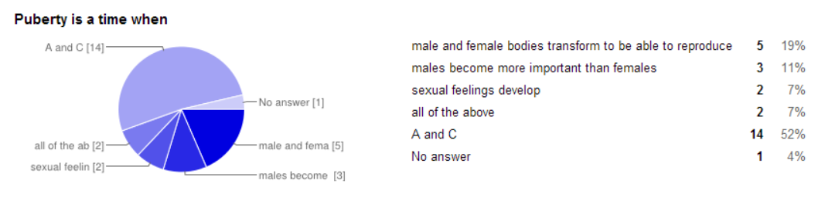
(Figure 1)

On the pre-test that the students were given before the training program, the attendees were presented with the statement, “Puberty is a time when” and were asked to choose the response which most correctly answered the statement. Figure 1 represents the answers that were received on the pre-test. Of the 27 respondents, 19% indicated that they believe it is a time when “male and female bodies transform to be able to reproduce,” 11% chose “males become more important than females in society,” 7% chose “sexual feelings develop,” another 7% chose the “all of the above” option, 52% chose the option of both “A and C,” and the remaining 4% did not answer the question.

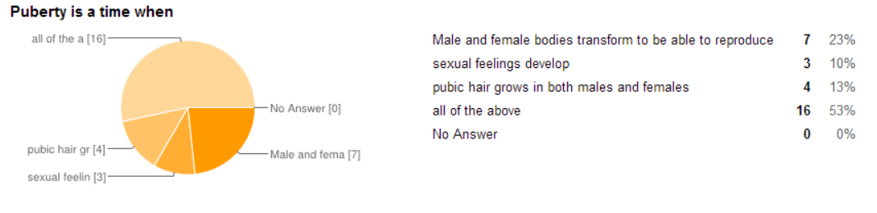
(Figure 2)

Figure 2 represents the answers from the post-test which was administered after the training was completed. Attendees were again presented with the statement, “Puberty is a time when” and were asked to choose the response which most correctly answered the statement. Of the 30 respondents of the post-test, 23% indicated that it is a time when “male and female bodies transform to be able to reproduce,” 10% chose “males become more important than female,” 13% chose “sexual feelings develop,” and 53% chose the “all of the above” option.

When analyzing these responses, it is critical to recognize that while the “all of the above” option on the pre-test is not the correct answer, the “all of the above” option is the appropriate and desired response on the post-test.

As represented in Figure 1 and Figure 2, a little above 50% of respondents on both the pre-test and post-test were able to correctly identify the changes that happen during puberty. While this number is significantly lower than what we would like it to be, it remains possible, and highly likely, that instead of reading through all of the available options before choosing their answer, students may have chose the first answer that they saw which seemed to be correct. This information correctly reflects the fact that most secondary school students have received some amount of education on puberty from their time in school, therefore equipping them with a more comfortable idea of the changes that happen during puberty.

Lesson 2 | Gender Stereotypes and Sexuality

The aim of this lesson is to help students understand gender stereotypes and how they may limit one’s ability to make healthy decisions, expand overall understanding of all versions of sexuality and the various types of sexual preferences, and to empower students to know and understand their sexual rights.

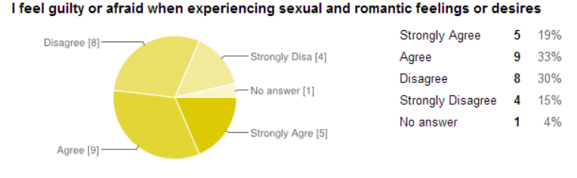
(Figure 3)
Figure 3 represents the student’s answers on the pre-test to the statement, “I feel guilty or afraid when experiencing sexual and romantic feelings or desires”. Nineteen percent of the 27 respondents indicated that they “Strongly Agree” with the statement, 33% indicated that they “Agreed”, 30% responded that they “Disagree”, 15% “Strongly Disagree”, and 4% of the respondents did not answer the question.
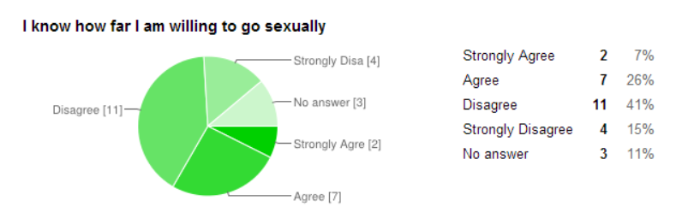
(Figure 4)
On the pre-test, the students were also asked to indicate whether or not they know how far they are willing to go sexually. Seven percent of the respondents indicated that they “Strongly Agree”, 26% indicated that they “Agreed”, 41% responded that they “Disagree”, 15% “Strongly Disagree”, and 11% of the respondents did not answer the question.

These two questions are designed to gauge the students’ level of comfort with
their individual sexuality. An important aspect of sexual health education is empowering students to understand their sexuality and encouraging them to think critically about how sexuality influences their lives, and the lives of those around them. When presented with the statement, “I feel guilty or afraid when experiencing sexual and romantic feelings or desires,” 52% of respondents either “Agreed” or “Strongly Agree” (Figure 3). Furthermore, when presented with the statement, “I know how far I am willing to go sexually,” 56% of respondents indicated that they “Disagree” or “Strongly Disagree” (Figure 4). One purpose of this lesson is to guide and encourage students to develop the values, which are necessary to respecting themselves and others. It is clear, based on the data, that there is a large body of youth who do not feel comfortable discussing and understanding their sexuality. It is said, “students who understand and value themselves and others are better equipped to develop meaningful and respectful relationships. They are able to take a positive approach to managing their lives and develop the necessary skills to prepare them for current and future life challenges” (State of New South Wales). Following this logic, it is critically important that in the future of the SHARE program, HDI spends more time discussing sexuality and developing a shared level of comfort doing so among the students. Through effective sexual education, students will be empowered to develop important and crucial sets of values, which will have a lasting, positive impact on their future relationships.

As mentioned earlier, one of the goals of this lesson is to inform students of what sexual rights are and empower them to understand their individual sexual rights. Below, we analyze a question that was asked concerning the sexual right to refuse sex.

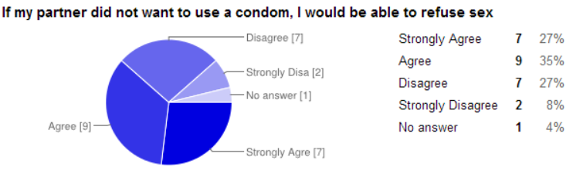
(Figure 5)

Figure 5 shows the student responses to the statement “If my partner did not want to use a condom, I would be able to refuse sex” on the pre-test. Twenty-seven percent of respondent indicated that they “Strongly Agree,” 35% “Agreed,” 27% “Disagree,” 8% “Strongly Disagree,” and 4% did not answer the question.

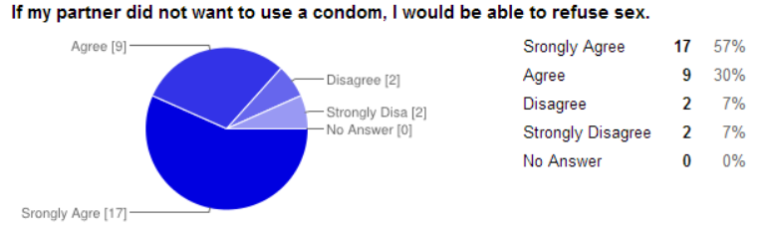
(Figure 6)
Figure 6 shows the student responses to the statement, “If my partner did not want to use a condom, I would be able to refuse sex,” from the post-test. Fifty-seven percent of respondent indicated that they “Strongly Agree,” 30% “Agreed,” 7% “Disagree,” and 7% “Strongly Disagree.”

After the training the percent of students that either “Strongly Agreed” or “Agreed” with this statement went from 62% (Figure 5) to 87% (Figure 6), which is a significant increase. Though ideally we would like 100% of the respondents to have felt like they “Strongly Agree” or “Agree” with the statement, there are possible explanations for the respondents having marked “Disagree” or “Strongly Disagree.” It is possible that due to the language barrier, the respondents did not fully understand what the question was asking. During training, the lesson on sexuality was taught by an HDI staff member. The information in this lesson is dense and complicated; therefore, we thought that it would be beneficial for them to have the information relayed to them in Kinyarwanda. Due to this fact, we are unable to know with resolute confidence that they were given a sufficient amount of information on sexual rights and what their sexual rights are to be able to answer this question the most appropriately. It is also possible that the respondents were unsure of what the question was asking, which may have resulted in them marking “Disagree” or “Strongly Disagree.”

Lesson 3 | Sex, Contraception, and Pregnancy

Lesson 3 covers topics including pregnancy signs and symptoms and the types and effectiveness of various contraceptives as well as a condom demonstration. The aim of the lesson is to educate students about why it is important to use contraception, categorize and explain the different types of contraception and their level of effectiveness.

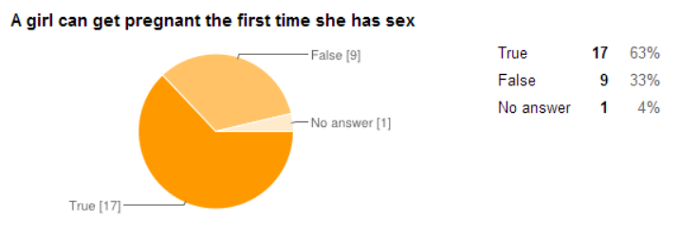
(Figure 7)

On the pre-test, students were asked to choose whether the statement, “A girl can get pregnant the first time she has sex,” was true or false. Sixty-three percent of the 27 attendees who took the pre-test answered that this statement was true, while 33% answered it was false, and 4% of the students did not answer the question (Figure 7).

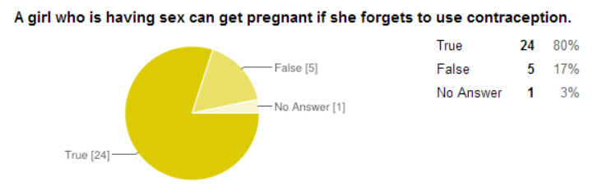
(Figure 8)

Figure 8 represents the students’ answers on the post-test to the statement, “A girl who is having sex can get pregnant if she forgets to use contraception.” Of the 30 attendees who took the post-test, 80% of students answered that this statement is true and 17% of students answered that this statement is false.

Both the pre-test and post-test also included the statement, “The only 100% sure way to prevent pregnancy is to abstain from sex.” On the pre-test, 52% of the respondents indicated that they believed this statement was true and 41% indicated that they believed it was false. The remaining 7% of respondents left this question blank indicating that they were unable to properly answer the question or did not understand what it was asking. The post-test showed that 83% of the students believed the statement to be true, 13% thought it was false, and 3% did not answer.

These questions are aimed at gauging the students’ level of knowledge and understanding of how pregnancy happens. Our hope is that from this lesson students would be able to correctly identify under what circumstances a female is able to become pregnant, as well as the most effective ways of preventing pregnancy. When students were asked on the pre-test if “a girl can get pregnant the first time she has sex,” 33% of respondents indicated that the statement was false, meaning that they do not think it is possible for a female to become impregnated the first time she engages in sexual intercourse (Figure 7). While this means that the majority of attendees understood that it is possible to get pregnant the first time one has sex, this is still a significant amount of respondents who do not understand the risks of having sex. Furthermore, on the post-test, 17% of respondents indicated the statement “A girl who is having sex can get pregnant if she forgets to use contraception” is false (Figure 8). Although this is again a small percentage, one of the main goals of the lesson is to enforce the idea that without contraception, the likelihood of a female getting pregnancy significantly increases. These figures could be understood further if we take into account that the lesson on pregnancy and contraceptives was taught in English, and therefore some information may have been misheard, misunderstood, or not comprehended at all. Overall, these results yield that after the training, more students were capable of answering the questions about pregnancy correctly, which means that the lesson about contraceptives helped the majority of students better understand forms of protection against pregnancy.

Along with questions about contraceptive use and pregnancy, students were also asked questions concerning confidence in their ability to obtain various types of contraceptives on the pre-test.

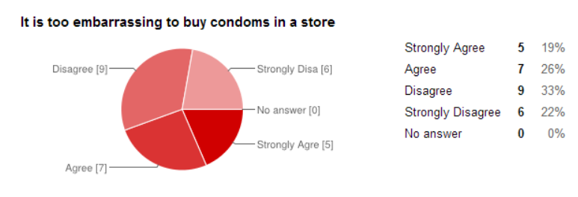
(Figure 9)
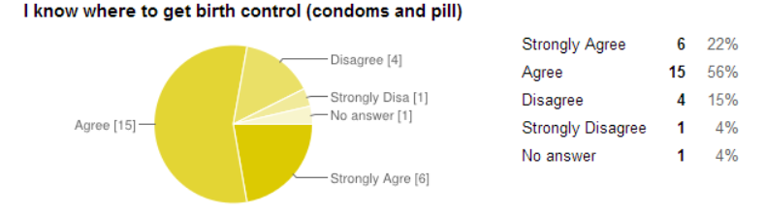
(Figure 10)

When students were asked to rate their level of comfort or agree/disagree to the question, “It is too embarrassing to buy condoms in a store,” there was a range of student responses. Most students, 33%, disagreed with this followed by 26% of students who “Agreed”, 19% “Strongly Agree” and 22% “Strongly Disagree” (Figure 9).
When students were asked if they knew where to get birth control, specifically condoms and the pill, most students agreed or strongly agreed. Twenty-two percent of students “Strongly Agree,” 56% “Agree,” 15% “Disagree” and 4% “Strongly Disagree” while 4% also had no answer (Figure 10).
These two questions were meant to gauge if the students knew where to access birth control and their level of comfort with buying birth control, specifically condoms in a store. Our hope was that the students would indicate that they both know where to access methods of birth control and feel comfortable buying condoms. When students were asked if they thought it was “too embarrassing to buy condoms in a store,” 33% disagreed and 22% strongly disagreed (Figure 9). While the majority of students, 55%, do not think it is embarrassing to buy condoms, 45% “Agree” or “Strongly Agree” with the original statement that they do think it is too embarrassing to buy condoms in a store (Figure 9). This could result in students feeling too embarrassed to go buy condoms and potentially engage in unprotected sex. While the data shows the majority of students feel comfortable buying condoms, it is important to acknowledge the large amount of students who also feel uncomfortable buying condoms. The SHARE Program Officer has confirmed this is a result of cultural values that engender shame or fear.when facing accessing contraceptives. It is difficult to absolutely determine but important to note that the students were closely split between their levels of comfort in buying condoms.
When students were asked if they “know where to get birth control (condoms and pill),” the survey revealed that 78% of students either “Agree” or “Strongly Agree” that they know where to get condoms and birth control pills (Figure 10). The majority of those answers, 56%, were “Agree” indicating that students were not necessarily 100% sure they knew where to get birth control. From casual discussion, it is very clear that students know that they can access condoms at any pharmacy, so perhaps the majority of “Agree” answers were because students were not entirely sure where to access birth control. Overall, the question revealed that most students know where they can access birth control.

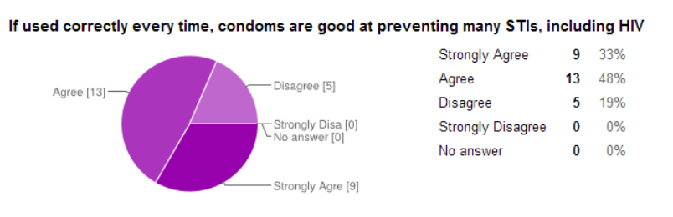
(Figure 11)

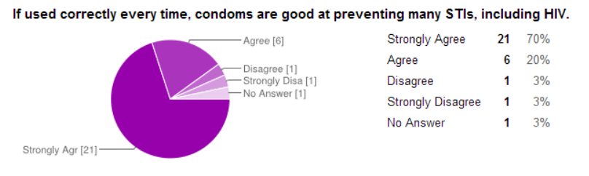
(Figure 12)
When students were asked, “If used correctly every time, condoms are good at preventing many STIs, including HIV,” the pre-test revealed that 33% “Strongly Agreed” and 48% “Agreed” and 19% chose “Disagree”, represented here in Figure 11. When the students were asked the same question in the post-test, “Strongly Agree” increased to 70%” and 20% answered “Agree,” while 3% “Disagree,” 3% “Strongly Disagree,” and 3% did not answer (Figure 12). The amount of students to answer “Strongly Agree” increased by 37% and students who answered “Agree” decreased by 28%; however, this can be accounted for in the percentage of people who “Strongly Agree” increasing significantly.

Analyzing data from the pre-test to the post-test will hopefully reveal an improvement of the students’ knowledge. The purple charts (Figure 11 and Figure 12) and green charts (Figure 9 and Figure 10) display the students’ overall understanding of contraceptives--birth control pills and condoms--demonstrating that the students have a better understanding of condoms than they do of birth control pills. Students were also asked on the pre-test whether or not condoms are good at preventing pregnancy (no figure shown in this report) to which 94% of students answered “Agree” or “Strongly Agree.” Regarding if condoms are good at preventing many STIs, including HIV, in both the pre-pest and the post-test, more than 70% of students answered “Agree” or “Strongly Agree.” Furthermore, the post-test revealed that 94% of students strongly agreed that condoms are good at preventing many STIs including HIV. This data indicates that the students have a solid understanding of the benefits of condom use for sexual health.
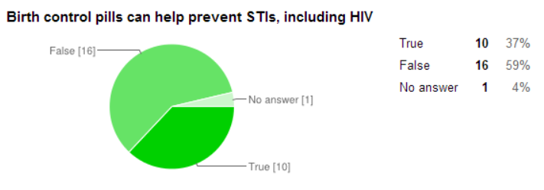
(Figure 13)

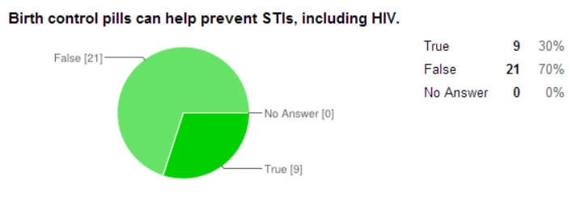
(Figure 14)

Comparatively, the students showed less of an overall understanding of birth control pills. This is indicated by 37% of students in the pre-test answering that birth control pills can help prevent STIs, including HIV, as “True” and the post-test with 30% answering “True.” While clearly the majority of students understood that birth control pills do prevent against pregnancy, there is a higher percentage of students who did not know that, compared to data on condoms.
It is exciting to note that the percentage of students who “Strongly Agreed” that condoms are good at preventing STIs, including HIV, increased from the pre-test of 33% to 70% on the post-test. This indicates that the students were more confident in their knowledge of what condoms prevent against after the training. In future trainings, the effectiveness of birth control pills as a form of contraceptive should be further emphasized, with even more emphasis put on the fact that while birth control pills are an extremely effective form of contraceptive, they do not offer protection against STIs. Making sure to clarify both of those statements more effectively may increase the students’ overall knowledge of contraceptives.

Lesson 4 | Sexually Transmitted Infections

Lesson 4 is a comprehensive lesson on sexually transmitted infections and aims to cover topics such as what the most common STIs are, understanding how STIs are transmitted and how to prevent transmission, identifying signs and symptoms, and what to do if you think that you might have contracted an STI.
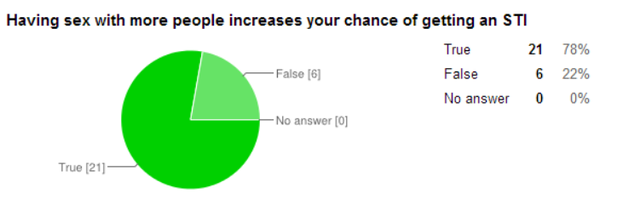
(Figure 15)

Figure 13 represents the students’ responses on the pre-test to the statement, “Having sex with more people increases you chance of getting an STI.” Of the 27 respondents, 78% indicated that they believe that the statement is true, and 22% indicated that they thought the statement was false.

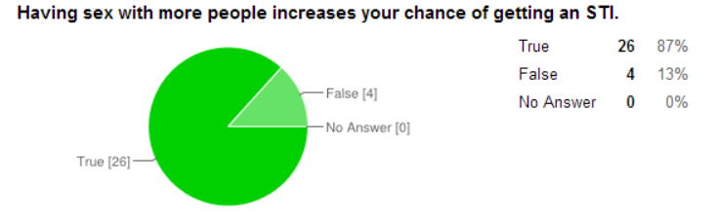
(Figure 16)
When students were asked again on the post-test after the training was complete to indicate whether they agreed or disagreed with the statement, 87% indicated that the statement is true and 13% said that the statement is false (Figure 14).

Both the pre-test and post-test also included the statement, “STIs usually go away without treatment.” On the pre-test, 33% of the respondents indicated that they believed this statement was true and 67% indicated that they believed it was false. The post-test showed that 23% of the students believed the statement to be true while 77% thought it was false.

These two questions were meant to evaluate if the students understand how STIs can be spread and the proper way to address an STI if you contract one. Our hope was that students would indicate that they recognize that engaging in sexual intercourse with more people will increase you chance of getting and STI and that if you do get an STI, it is important to seek treatment as quickly as possible. When students were asked on the post-test if they thought that “having sex with more people increases you chance of getting an STI,” 87% indicated that the statement was true, while 13% indicated that the statement was false (Figure 16). Although the majority of students, 87%, were able to recognize that the more sexual partners you have the higher your chances of getting an STI are, only 77% of respondents indicated on the post-test that they knew that STIs usually don’t go away without treatment (a 10% increase from the pre-test). During the training, the lesson on STIs was taught by a GROW Intern in English; however, after the lesson the students had a lot of questions about the material that was covered, indicating that they weren’t able to fully understand all of the information that they were taught. As a result, the lesson was re-taught by an HDI staff member in Kinyarwanda in order to clarify some of the remaining confusion. These communication barriers could have had an effect on the data if the students were not able to receive a thorough lesson on STIs. Overall, these questions revealed that most students were able to increase their level of knowledge on STIs through SHARE training.

Lesson 5 | Decision Making, Respect, and Gender Based Violence

The purpose of this lesson is to encourage the attendees to think about the reasons why people choose to engage in or abstain from sex, inform them about what makes a good or bad decision, and enable them to think about the potential consequences of the decisions that they are making. We hope that through this lesson, students will feel like they have the knowledge and confidence to make strong decisions when presented with difficult situations.

On the pre-test, students were asked to identify whether or not they know someone who has been affected by Gender-Based Violence (GBV). Of the 27 students who responded, 52% responded yes, and 48% responded no.
On both the pre-test and the post-test, attendees were then asked whether or not they felt like they could identify the types and consequences of GBV.
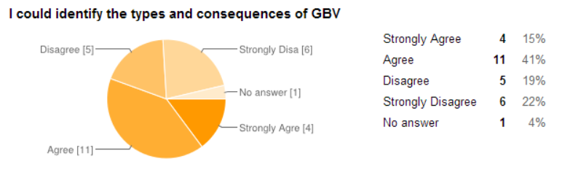
(Figure 17)
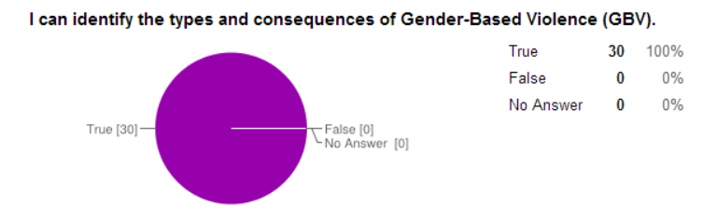
(Figure 18)
Figure 17 represents the results from the pre-test while Figure 18 represents the results from the post-test. Based on the data collected from the pre-test, only 56% of respondents indicated that they “Strongly Agree” or “Agree” that they would be able to identify the types and consequences of GBV. The post-test data revealed that after the training, this number jumped to 100%. It’s important to recognize that the question went from being a scaled question in the pre-test to a true/false question on the post-test, which may have had some effect on the data.

As a result of the Gender-Based Violence lesson, our hopes were to empower young people to make informed decisions regarding personal safety and sexual activity, encourage them to think about alternative solutions and the long and short-term consequences of their actions, and to illustrate the many ways in which GBV can present further barriers to living a healthy lifestyle. During the training the lesson was taught by an HDI staff member. We tried to highlight that while GBV mainly affects women and girls, men and boys can also be found as victims. Noting that over half (52%) of the respondents on the pre-test indicated that they know someone who has been affected by GBV, it seems increasingly important that the students understand and can identify the four main types of GBV (sexual violence, economical violence, physical violence, and emotional violence). While only 56% of respondents on the pre-test indicated that they “strongly agree” or “agree” that they could do just this, those figures jumped to 100% on the post-test administered on their last day of training, which we celebrate as a great success.

Lesson 6 | Support and Care (Relationships)

Lesson 6 is the last lesson in the SHARE Manual, but one of the most important regarding information on healthy relationship choices and treatment of peers. The aim of the lesson is to explore what fosters a good or bad relationship, enable students to think about the consequences of disrespect, to expand on the complications of HIV/AIDS in any relationship, to provide knowledge about how to respect and assist those with HIV/AIDS, and to go into detail about important values in relationships.

While there were not any specific questions on either the pre-test or post-test that directly asked the attendees about these topics, below we include an analysis of a question regarding suggardaddies and sugarmommies.

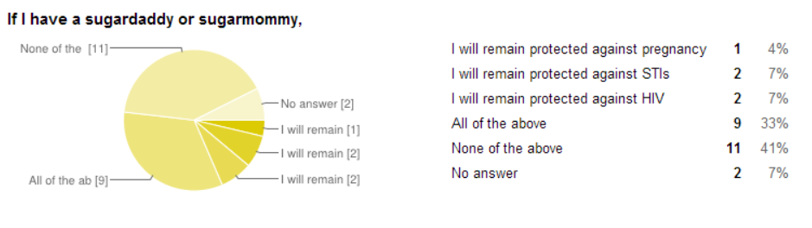
(Figure 19)

Figure 19 represents the results from the pre-test where the attendees were asked to respond with what will happen if you have a sugardaddy or sugarmommy. Four percent of respondents indicated that if they have a sugardaddy or sugarmommy they will remain protected against pregnancy, 7% indicated that they will remain protected against STIs, another 7% said that they believed they will remain protected against HIV, 33% responded with “all of the above,” 41% stated “none of the above,” and the remaining 7% did not answer the question.
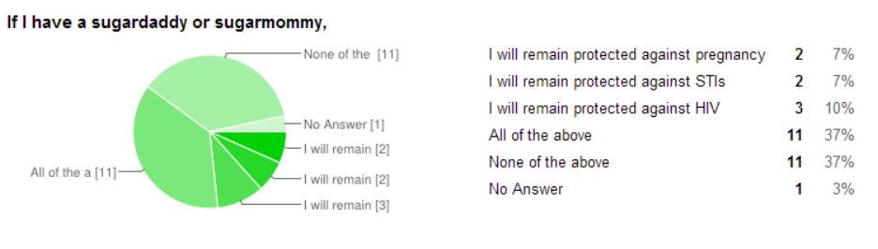
(Figure 20)

Figure 20 represents the results from when the students were asked to answer the same question after the training in the post-test. Seven percent of respondents indicated that if they have a sugardaddy or sugarmommy they will remain protected against pregnancy, 7% indicated that they will remain protected against STIs, another 10% said that they believed they will remain protected against HIV, 37% responded with “all of the above,” 37% stated “none of the above,” and the remaining 3% did not answer the question.
Our desired goal is that every student would be able to recognize that having a sugarmommy or sugardaddy will not protect you again pregnancy, STIs, or HIV. The percentage of students who were able to indicate just this decreased from 41% on the pre-test (Figure 19) to 37% on the post-test (Figure 20). Based on the data that we collected, there appears to be no clear picture of what students believe about sugarmommies and sugardaddies. Therefore, it may be helpful to have a short lesson on the danger of getting involved with a sugardaddy or sugarmommy in order to equip them with the knowledge to make safe choices regarding their personal lives and personal safety.

Conclusion
After analyzing the data, we have concluded that there is a clear, overall increase in the student’s level of understanding of the content between the pre-test and post-tests administered at the SHARE training program. While this is the desired outcome, it is also evident that there are a lot of weaknesses in the program’s overall effectiveness and long-term sustainability of the training. We recommend for the leaders of the SHARE program to administer a more frequent evaluation regimen, at the beginning of each school term and at the conclusion of each term, in order to provide a better portrait of progress. In this way, the program will be able to track changes in not only student knowledge, but also in attitude and behavior, which is crucial for long-term sexual health programs like SHARE.

Works Cited

State of New South Wales. "Why Is It Important to Teach about Sexuality?" NSW Department of Education and Communities. Accessed August 19, 2014. http://www.curriculumsupport.education.nsw.gov.au/primary/pdhpe/growth/sexed004.htm.

