
Educates. Empowers. Activates.
www.globalgirlmedia.org

FOOD FORWARD

An Original Webisode Series by GlobalGirl Media

LINK TO YOU WEBISODE SERIES

Place and race determines how healthy you are. Whether it’s access to affordable fresh fruit and vegetables, or a safe place to exercise, there is definitely a link between where you live, your racial background and rates of obesity, diabetes, and overall community health. Health also doesn’t just happen in a doctor’s office. It happens in a community.

BACKGROUND ON SERIES: Food justice is the notion that everyone deserves healthy food and that the benefits and risks associated with food should be shared fairly. Food Justice has become a rallying cry that points to serious disparities in food access, nutrition and overall health facing many residents of Los Angeles today. According to data from the 2009 California Health Interview Survey, 3.8 million adults in households with incomes at or below 200% of the Federal Poverty Level (FPL) could not afford enough food at least once in the previous year.

Follow the Los Angeles GlobalGirl Media reporters in this four-part webisode series as they explore local issues that relate to food and food justice.

Hot button issues like nutrition and obesity, diabetes, food deserts and access to organic food, food trucks, community gardens, famers’ markets, are explored in this series, the first of its kind produced entirely by young minority women in LA.
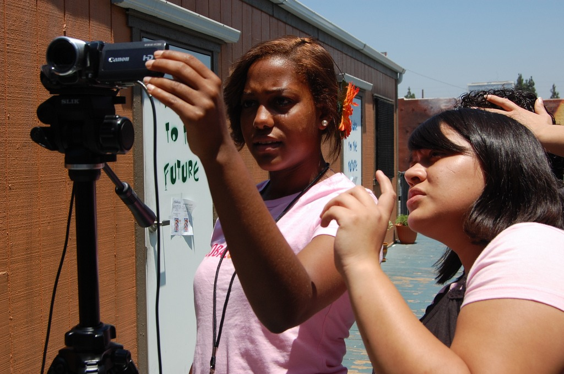
OUR STORIES:

1. GROCERY LIST: Follow the GlobalGirls as they make a list and go grocery shopping, But there’s only one problem: they can’t find a decent grocery store in their neighborhood.

2. A TALE OF TWO FOOD TRUCKS: The Food truck industry in Los Angeles is a huge business, but it is also segregated by geography and income levels. GGM follows two food trucks, one that serves hi-end clientele, and one that is a regular for downtown working residents.

3. EAT YOUR VEGGIES: Why are more teenagers becoming vegetarians? Follow one GlobalGirl as she talks about her decision and the researches the benefits of following a vegetarian diet.

4. SEED LIBRARY: Fascinating look at the Seed Library of Los Angeles, a depository of seeds held in trust for the members, who come to the library and borrow seed for their garden. They grow the plants in their garden and at the end of the season, they let a few plants ‘go to seed.’

5. FRESH FRIDAYS: Report on the closing of Ralphs in West Adams, where the lack of access to good grocery stores and healthy food drives up obesity, diabetes, etc. Also profiles the Community Coalition and their First Fridays Program, where food activists bring fresh produce to food deserts.

6. COMMUNITY GARDENS: A report on the Union Garden, on Cesar Chavez Avenue, which is helping low income residents grow healthy food, plants for medicinal purposes and the overall transformation of a community through gardening.

“The voice and perspectives of these young community reporters provides us with fresh needed alternative programming,” -- Juan Devis, Director of Production, KCET.

“The girls who worked on this series and the communities in which they live are often left out of the dialogue...which are under siege in this country, and unfortunately women of color bear the brunt of the struggle for healthy food…this is why I am thrilled about this series.” –DuVergne Gaines, Feminist Majority

ABOUT GLOBAL GIRL MEDIA (GGM) develops the voice and self-expression of teenage girls in underserved communities by training them to become citizen journalists, harnessing the power of new digital media to inspire self-empowerment and social change. By linking young women internationally with seasoned reporters, educators and filmmakers, GGM empowers girls to make media that matters, improves media literacy, and encourages the promotion of healthier media messages about girls and women. GGM works to ensure that today's new media systems contribute to a better-informed citizenry, encourages public participation in civic life, and offers an inclusive and accessible space for women and girls. We have active projects in South Africa, Morocco, Los Angeles and Chicago. www.globalgirlmedia.org, @globalgirlmedia,

