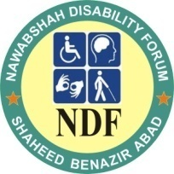
PROVISION OF MOBILITY AIDS TO 300 DISABLED PEOPLE

Pakistan is one of three remaining countries that has not stopped the transmission of polio (World Health Organization). Facing a range of challenges such as insecurity, weak health systems and poor sanitation, failure to control the spread of polio and other debilitating causes have resulted in more than 5,000,000 individuals with disabilities in Pakistan. Poverty is a major problem throughout the country--a person must earn less than $ 1.00 per day to be considered poor! Lacking resources for necessary adaptive devices, people with special needs are often confined to their homes. Poor families living in remote and rural areas of Pakistan have the largest ratio of people born with disabilities. Consequently, these families lack both funds and access for mobility aids that will promote independence for their loved one.

The Nawabshah Disability Forum (NDF) was established in 2002 by a group of young persons with disabilities to address the overwhelming needs faced by individuals in Pakistan who have a handicap or special need. NDF is an internationally recognized non-profit organization that advocates for the rights, safety, and dignified access to services for individuals with special needs. We are currently operating a pilot program that purchases and distributes mobility aids to individuals with disabilities that live in rural areas Nawabshah, Sindh Pakistan. It is estimated there are over 225,000 people with special needs living in isolation in this remote and rural province of Pakistan. To date, we have provided mobility aids to 213 of men, women and children with disabilities but there are still hundreds of children in the Nawabshah and surrounding areas on waiting lists for wheelchairs, tri-cycles, crutches, white canes and hearing aids. NDF’s goal is to get these people the mobility aids needed to live independent, productive lives.

NDF is seeking support from you to help us reach our goal. With US dollars, a little bit can go a long way toward helping us achieve our goal. For example, wheel chairs in Pakistan cost the equivalent of 50 US dollars. By raising $5000, NDF will provide 100 wheel chairs to disabled youths making it possible for them to go to school on their own. They will be able to lead a normal life and contribute to the development of our country because disability is not inability. Please make a donation to the Nawabshah Disability Forum and change someone’s live today!
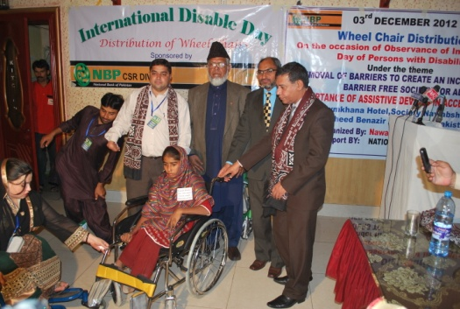
Send your checks/cheques to:
Nawabshah Disability Forum (NDF)
A/C No. 10174-5 SWIFT Codes NBPAPKKAXXX
Name of Bank: National Bank of Pakistan (NBP)
Branch: Main Branch Sakrand road Nawabshah,
District Benazir Abad, Pakistan.

Community Foundation of any state may facilitate your donations to reach us. For RENO people may contact Mr. Chris. 775-762-1932, email with request to send funds to NDF: caskin@cfwnv.org, www.cfwnv.org,

CHART FOR REQUESTED FUNDS FOR MOBILITY AIDS

S. No. | Description | Beneficiaries | Rate $ | Total
01 | Wheel Chairs | 200 | 50 | 10000
02 | Tri-Cycles | 200 | 120 | 24000
03 | Crutches | 40 | 10 | 400
04 | Walkers | 40 | 15 | 600
05 | White Canes | 60 | 10 | 600
06 | Hearing Aids | 60 | 300 | 18000
Total |  | 600 |  | 53600

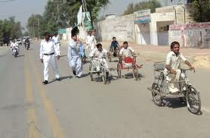
Thank you for your help.

Abid Lashari, President
Nawabshah Disability Forum
USA Phone Number: 7753357037,
Pakistan: +923003211876,
www.ndfpakistan.org

