GlobalGiving February 2022 Report
Extending happiness and wellbeing to the community
The Provide safe and clean water for 1500 children and women Project aimed at improving water supply and sustaining it to serve the Mutulani community in Makueni County, Kenya has made considerable progress within this reporting period (November 2021-February 2022).
The Mutulani Dispensary, a critical infrastructure and health services provider for the community, is now connected to a continuous and sustainable source of water, the water being the borehole drilled at the Mutulani Secondary School. This water will be used to enhance service provision at the dispensary with the maternity wing, being a consumer of the highest amount of water being the biggest beneficiary.
“Our maternity wing requires constant cleaning after each of the delivery. Having adequate water means that we will be able to maintain the very high standard of sanitation required of such a medical facility,” says the Nurse-in-Charge of Mutulani Dispensary Mr. Martin Ngulu.

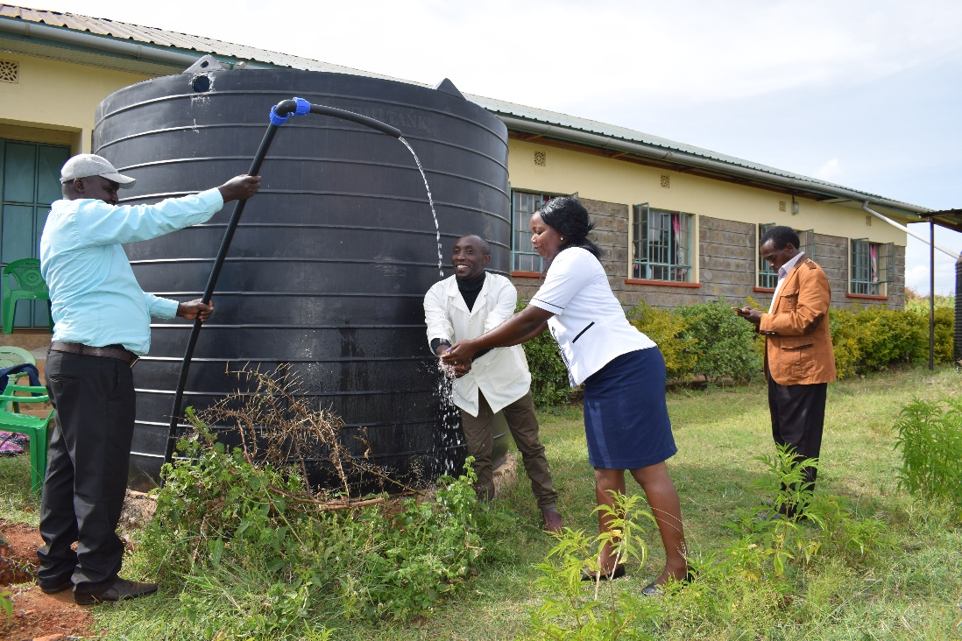
Staff at the Dispensary washing their hands after the water was connected at the Mutulani Dispensary (PHOTO CREDITS: PEN)
The availability of clean water at the school has also seen a new trend on water usage emerge. The pupils are now carrying drinking water home as compared to before when they carried water, which was muddy thus not safe, to school.
“It was surprising for us to note that the pupils now carry water from the borehole to drink back at home. They state that it is sweeter than the water they would fetch from other sources and we now have to let them fetch the water using their drinking bottles at the end of the day,” notes Madam Justina Kamuya, Head teacher of Mutulani Primary School.

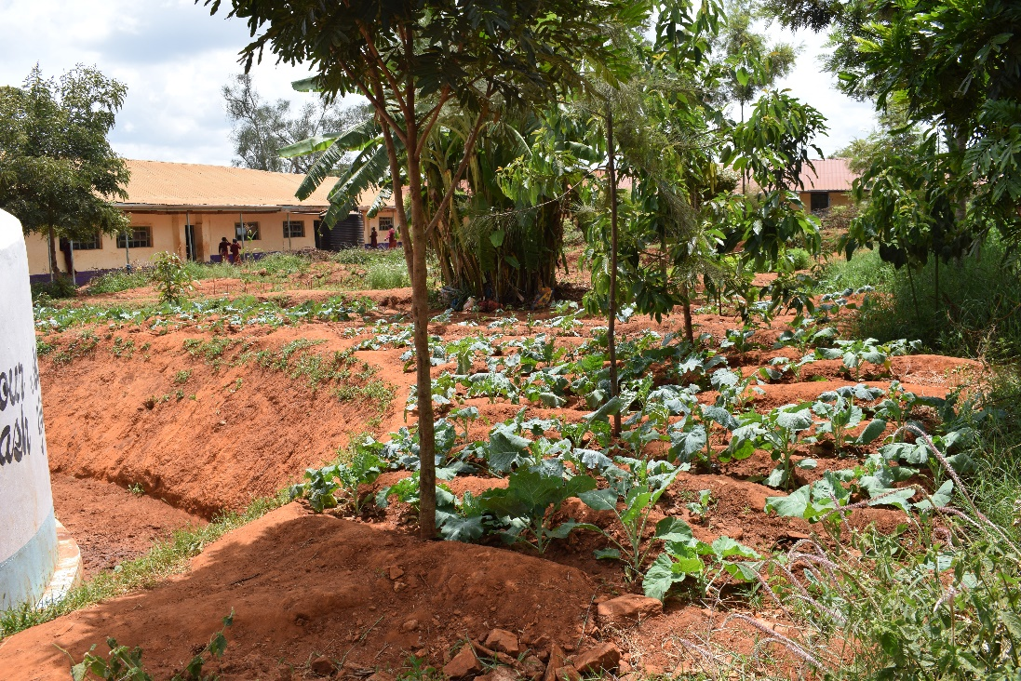
A garden planted by the students of Mutulani Primary School with water from the borehole as part of curriculum requirements (PHOTO CREDITS: PEN)
The Nurse-in-Charge of the Dispensary affirms the possible reason for this shift in behavior.
“The water from the borehole contains good levels of minerals (sodium + chloride) that are good for the development of the children and iodine that helps balance the electrolytes in the human body. This makes the water tastes sweeter and has possibly led to the reduction of water-borne diseases as salty water leads to rehydration and maintaining body fluid balance,” says the Nurse-in-Charge of Mutulani Dispensary, Mr. Martin Ngulu
In terms of sustainability, the Mutulani Welfare (MAWE) CBO, the Mutulani Schools and the Government officials are currently working of a Memorandum of Understanding (MoU) to cater for the sustainable sharing of the water and the maintenance of the borehole beyond the project lifespan. A Water Users Committee is also being drafted to constitute representatives of the schools, MAWE CBO, Local administrators and community members.
“It is important that we guarantee the continuity of this project to ensure that those who will come long after we leave continue to share this resource and that likelihood of conflicts arising on its usage are minimized,” says Mr. Julius Mutwii, Principal of Mutulani Secondary School.
During this reporting period, a video documentary (available HERE) and a shorter clip (available HERE) that shows the progress made so far by the project was done.
The next steps in this project are to connect water to the community at a water point located at the local market, to construct a modern toilet for the schools that can produce biogas and help in recycling the water, and to create a water recharge system for the borehole through initiating tree planting exercises.

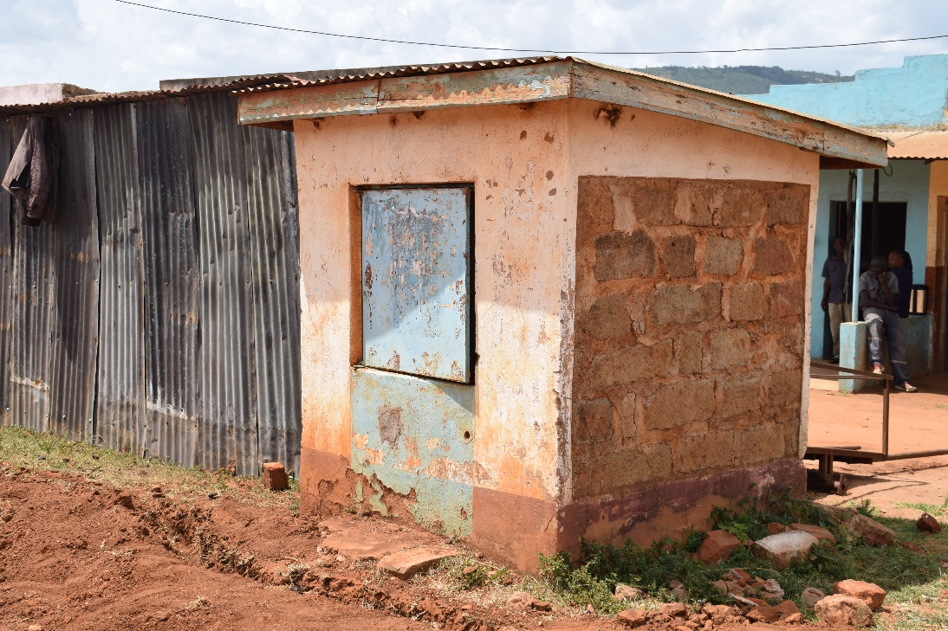
A water point at the local market to be renovated and connected to the water pipe to the dispensary to serve the community member (PHOTO CREDITS: PEN)

We sincerely thank our donors and still make a humble request for continued support to this noble cause of transforming Mutulani area towards achieving sustainable water for all. We also extend our appreciation to the GlobalGiving Program Team for the continued support so far.
Attached is a is a testimony written by a beneficiary student, Ms. Sharon Ngovi, a high school finalist at Mutulani Secondary School who has received school fees support drawn from the savings after the High School stopped purchasing water.

Thank you
Photo gallery
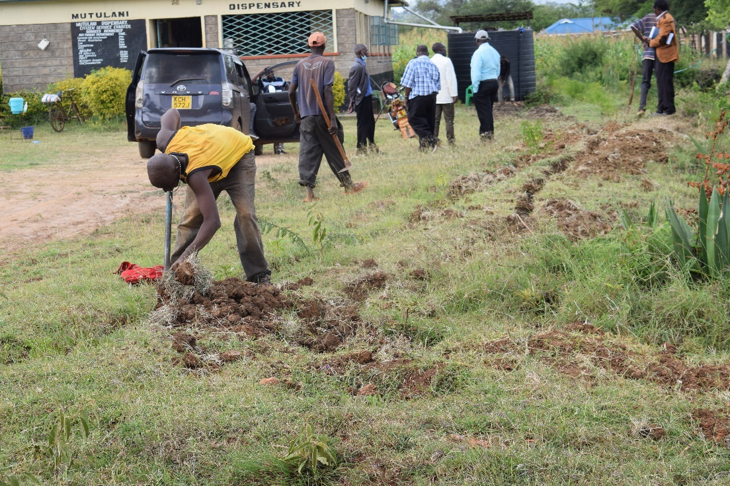
A community volunteer filling up the trenches after connecting water at the dispensary (PHOTO CREDITS: PEN)

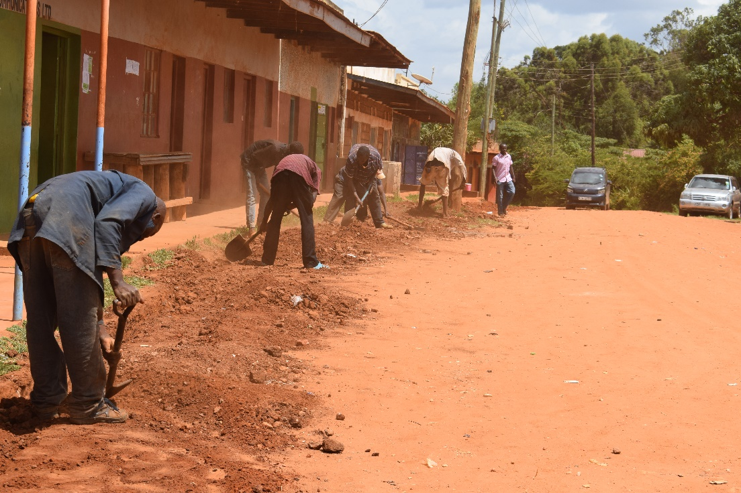
Community volunteer filling up the trenches after laying of the pipes to the dispensary (PHOTO CREDITS: PEN)

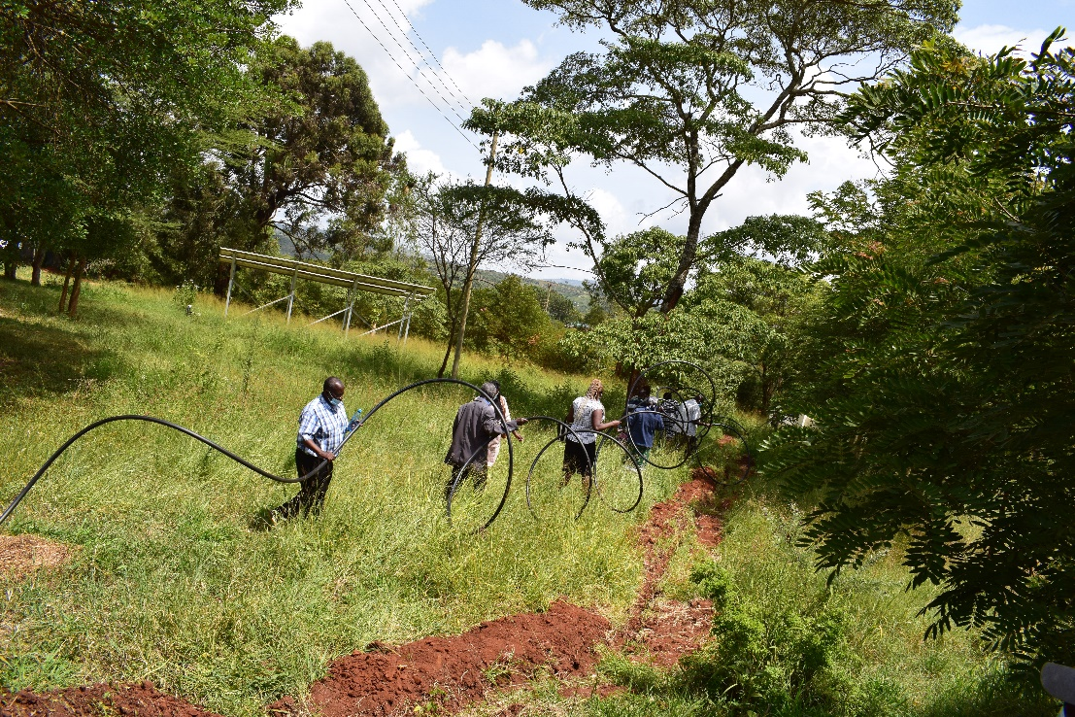
Community members, staff from the Mutulani Schools and the team from PEN join hands to lay the pipe along part of the stretch from the borehole to the dispensary (PHOTO CREDITS: PEN)

