Vidya Poshak Activities Report -2015-16

During the year 2015-16 with the grant through Global giving donors a total of 367 Students were supported with Financial Assistance, Library, Residential Bridge Camp , Skill training & Value education classes during their studies in nonprofessional & Professional courses.
Grant Utilization
 | Amount | Total Students
Total Grant Received | 7,11,407.91 | 367
Grant Utilized | 6,94,263.91
Financial Assistance | 2,88,100 | 64
Residential Bridge Camp | 48,349 | 16
Library Books & Services | 22,251 | 17
Skill Training & Value education Program | 3,13 418 | 270
Program Support | 22,145.91 | -
Balance grant Carried Forward for next year | 17,144 | -

- Financial Assistance
This year with the support of Global Giving a total of 64 students were provided financially assistance a sum of INR 2.88 Lakh to pursue their professional & nonprofessional course. Out of the 64, 30 students are newly inducted & remaining 34 are renewal students. This includes students opting for Arts, Commerce, Science and Diploma, B.Sc. Agri & Engineering courses. ( List of all supported students for continuing their education is attached)
- Skill Training & Value education Program

- IIT Training: Vidya Poshak & Avanti Fellows joined hands to provide free IIT / JEE Training for Meritorious, Low-income Students. Overall 30 students are now being trained focusing on JEE Mains and Advanced. Everyday 3 hours of classes are conducted in VP office. We sincerely thank Global Giving for supporting the program.

- Value Education & Supportive Classes: A key success criteria for any youth is good values. Vidya Poshak is offering values education to high school students in order to sow the seeds of good values early. We cover aspects of Life Skills, Interpersonal abilities etc in the Value Education. About 270 students are attending our VE classes.

- Vidya Poshak is also supporting rural students by providing supportive classes in Science, Math and English subjects for 8th, 9th and 10th class students. In our last year (2014-15) our classes aided the students to improve performance in their 10th class final exams. Two students who were part of the support last year are pursuing their dream to join IIT under VP IIT training.

- Library & Youth Center Activities

- More than 17,000 books were issued and 11549 students got assisted from Vidya Poshak library and youth centers. Out of this 17 students were Global giving supported students

- 8000+ books were issued to students for home use.

- 3227 new books were procured & 1385 books were received as donation. Now we have more than 70,000 books worth INR 10.0 Million.

- Under youth program, library/youth centers have organized programs like career guidance session, Study skill techniques, education counseling’s etc., for the benefit of student community.

- Residential Bridge camp

- Residential bridge camp is an important component of the training package offered to the student community by Vidya Poshak. It, in fact, is a bridge between the student and his dreams

- During the year, 12 residential bridge camps and four college training programs were organized at various places covering a total of 1000+ students. Out of 1000 students 16 were Global giving supported students.

- Sample students profiles
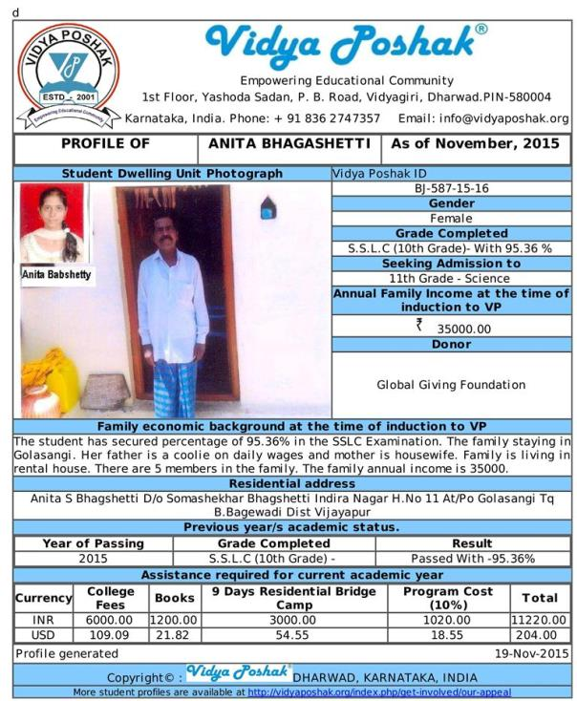

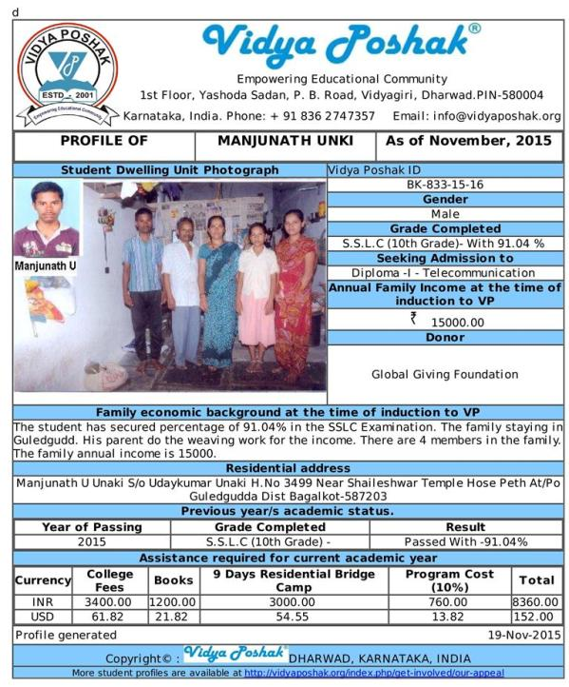

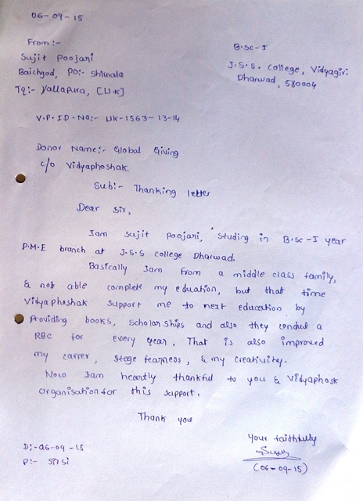
- Feed Back from Students

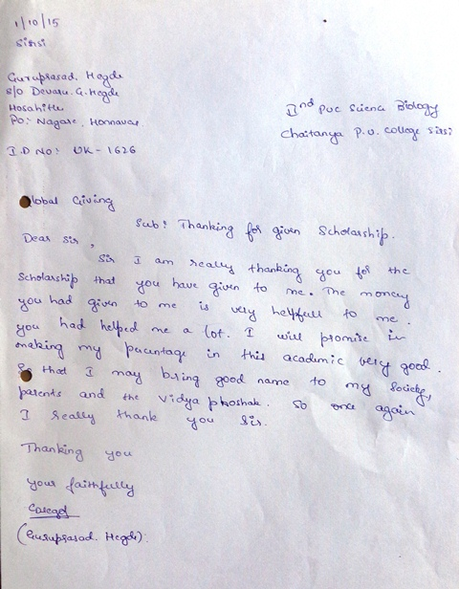
Photo Gallery

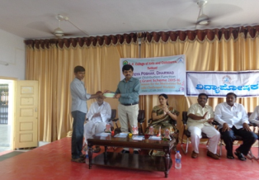 | 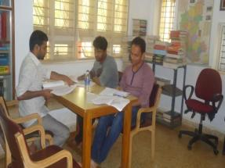
Financial Assistance Distribution | Students in Library
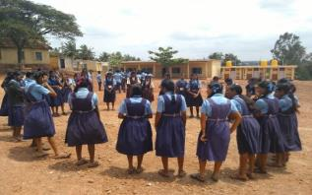 | 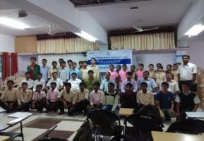
Activites at Value Education Class | IIT Training group photo
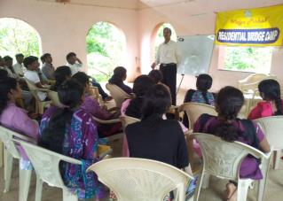 | 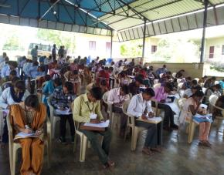
Residential Bridge Camp | Employment Readiness Program

