

Helping Food Processors Achieve Their Potential in Cajamarca, Peru

TechnoServe/Peru was awarded a $450,000 contract by the International Finance Corporation (IFC) to assist local farmers and agricultural businesses to become food suppliers to Minera Yanacocha, Latin America's largest gold producer. The initiative, which began in July 2003, is designed to generate jobs and drive economic growth in Peru's northern Cajamarca Province. Minera Yanacocha currently operates four gold mines and a processing facility, with more than 4,000 employees working directly for the mining company or its subcontractors.

This initiative is based on a TechnoServe/Peru analysis commissioned by the IFC in October 2002. Until then, the international catering company responsible for supplying the mine's canteen had sourced most foodstuffs from suppliers in Lima. TechnoServe's study found that, with technical assistance and training, small-scale producers in Cajamarca Province have the potential to supply the food needs of Minera Yanacocha and access other markets, thereby creating new jobs in the surrounding province, increasing the incomes of small-scale farmers and driving growth in the local food processing sector.

In 2004, TechnoServe helped 14 businesses – ranging in size from $1,000 to a half million dollars and in industry from bottled water to poultry – to:

- improve their production processes
- meet hygienic standards
- implement accounting and administrative controls
- identify market opportunities
- redesign plants or points of sale
- develop or expand new product lines
- develop sales and distribution plans
- link to new buyers and financing

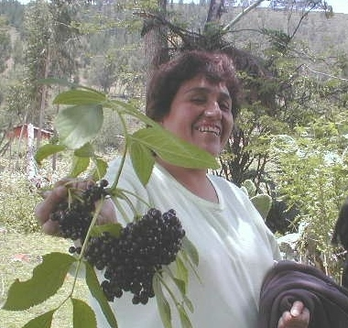
The businesses embraced TechnoServe’s recommendations and succeeded in exceeding projections, generating $1.6 million in sales and benefiting 164 producers. With additional sources of funding, by the end of 2005, TechnoServe expects to have assisted a total 22 Cajamarca businesses and helped them generate over $2 million in incremental revenue for the region.

One example of this success is Rosario Silva’s Ecoserranita, a small jam-making operation that uses native Peruvian fruits. At the onset of TechnoServe’s assistance, Rosario’s business was not large or profitable, but it did provide 30 cents a day on which she and her son could survive.

Rosario knew that her business could be much bigger, but the risks were too great for her to proceed. She lacked the business skills to develop a growth strategy. And with interest rates at 30%, there was little margin for error for an entrepreneur living on less than a dollar a day with a family to support.
Rosario Silva

TechnoServe soon recognized Rosario’s entrepreneurial potential and worked with her to develop a business plan, improve operational procedures, secure financing and increase profitability. The business boomed, and within two years, Rosario was earning net profits of $20,000 per year.

Rosario’s business success has had far-reaching effects in Cajamarca. Sixty-eight small-scale farm families are now receiving an income supplying native fruits for her business. “I have a responsibility that extends beyond my own family now,” Rosario says with a smile. “There is a network of farmers who depend on my business.”

What will happen when TechnoServe leaves? Rosario doesn’t seem worried. “I am now exploring export markets and have sent samples overseas. I’m also analyzing new product lines and retail opportunities in Lima. TechnoServe has opened a world of possibility.”

