Help Provide Safe Birthing Kits to Women in Haiti
Join the effort to assemble safe birthing kits!

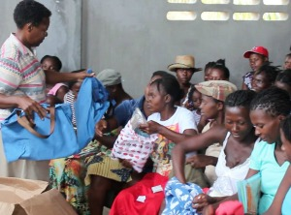
Konbit Sante staff members are distributing 300 birthing kits per month to pregnant women as part of mobile clinics in Cap-Haitien conducted in partnership with Haiti Hospital Appeal and the Haitian Ministry of Health. And we need more! Join individuals, school clubs and other groups already assembling these valuable kits for us.

Very simply, a birthing kit is a fabric bag that contains a few essential items for a safe home delivery plus several comfort items for the new baby. Expectant mothers in Haiti are eager to have the nice bag and its helpful contents.

Many women in Haiti do not have access to nor the money to pay for delivery at a hospital. We support the Haitian Health Ministry's plan to expand access to skilled deliveries, but in the meantime as part of our work in family planning and maternal health, we also support expectant mothers to have the safest births possible for themselves and their babies when they give birth at home.

To assemble a bag, start with a small store-bought canvas bag or make your own. Then pack the following items into a zip locked plastic bag placed in the fabric bag:

• a small bar of soap
• a piece of clean plastic sheeting (4 feet wide by 5 feet long)
• a piece of clean string, 24 inches long
• a packet of alcohol wipes
• a pair of sterile exam gloves (size large)
• a packet (or travel container) of hand sanitizer like Purelle
• a newborn cap (if you wish to make it yourself, you can make one easily and directions are at: http://www.ehow.com/how_6216024_make-newborn-baby-hats.html
• a small receiving blanket (about 36 inches square)
• infant clothing ( non gender specific)
• a small infant-safe stuffed toy
• a box of Maxi pads

Please mail your assembled bags to:
Konbit Sante Cap-Haitien Health Partnership
362 US Route 1
Falmouth, ME 04105

Questions? Need assistance? Contact us at (207)- 347-6733/safebirths@konbitsante.org

