Nepalese Youth Opportunity Foundation’s (NYOF)
Business Plan for Nutritional Rehabilitation Homes

- The Background.

More than half the children under five years of age in Nepal are malnourished, and this is one of the leading causes of death in this age group. The cause of the problem is as both ignorance and poverty.

Most malnourished children fall ill because, as a result of malnourishment, their immune systems are compromised and they are prone to all kinds of diseases, particularly infections. If they are fortunate enough to get to a hospital and receive antibiotics or other treatment they need, they are discharged as soon as the infection is under control, without regard to the state of their nourishment. So their underlying condition is not addressed. When they return to their villages they sometimes die and often grow up stunted physically or mentally.

This project is one of our most successful and exciting programs. What began as a pilot project in 1998 to address the serious problem of severe malnutrition in children in Nepal has now branched out to include satellite facilities in various parts of the country.

Its goal is to restore severely malnourished children to normal weight and health, educate their mothers in all aspects of child care, and train them to impart their knowledge to other mothers when they return to their villages.

NYOF devised a simple but effective method to address this problem. The children and their mothers come to stay at our nutritional home right from the hospital, after their active illness is under control. At the NRH, the children are built up to normal weight and health, while their mothers are trained in how to take care of their children. We have on staff doctors, nurses, a nutritionist, and support staff to help in this effort.

And we use only food readily available throughout Nepal, so that the mother can follow the program after she returns home with her child. We have an organic garden on the premises of our Kathmandu facility, where the mothers are shown how to harvest vegetables and cook them to retain their nutritional value. (Traditionally, young children are not given green vegetables in Nepal and if they are the vegetables are cooked to a pulp.) Following discharge, a field worker visits the children at regular intervals to be sure that they are maintaining their weight and health.

It takes an average of five weeks to restore these kids to health, and educate their mothers, at a cost of $250.

- Impact of the Nutritional Rehabilitation Homes.

We started this as a pilot project in 1998, and in the years since, more than 1500 children have been treated at our Kathmandu facility and their mothers trained. We have just opened our fifth nutritional home in an area where malnourishment of kids is endemic. Our sixth home will open this fall.

I do not exaggerate when I say that the NRH works miracles. Most of the kids are babies or toddlers, and often they come to us looking half dead – without the spark that defines a child, their heads down, often crying uncontrollably. Really miserable little beings. In the space of a five to six weeks, they are transformed into bouncy, healthy little kids.

The mothers learn how to properly care for their child; how to feed their child on nutritious locally grown foods; and how to provide their children with hygienic health care. These mothers are then able to return to their villages and instruct other mothers on nutrition and proper childcare.

- The cost.

The project has been so successful that the Ministry of Health of His Majesty’s Government in Nepal (which has little money for social programs because most of the budget is spent for defense against an insurgency), urged NYOF to open such centers around the country so that the vast majority of mothers who cannot come to Kathmandu with their sick children can also get help.

We have opened such facilities in east Nepal (Biratnagar), west Nepal (Nepalgunj), south east Nepal in Bhadrapur, and one in a very poor community in the south of the country, near the border of India in Birgunj. We will open one more NRH this year, in the southwest city of Mahendragar, for a total of six Nutritional Rehabilitation Homes.

These satellite facilities are designed to be self-sustaining. They are built on the grounds of a zonal hospital, near the pediatric ward, under an agreement with the hospital management board that the hospital will take over the project after five years. NYOF builds the facility, trains the employees at its Kathmandu NRH, and pays all expenses for three years, 75% in the fourth year, 50% in the fifth year, and thereafter, the hospital is required by the agreement to continue to support it. It is our goal to build an NRH at each of the 12 zonal hospitals in Nepal, thereby establishing nutrition wards in hospitals throughout the country.

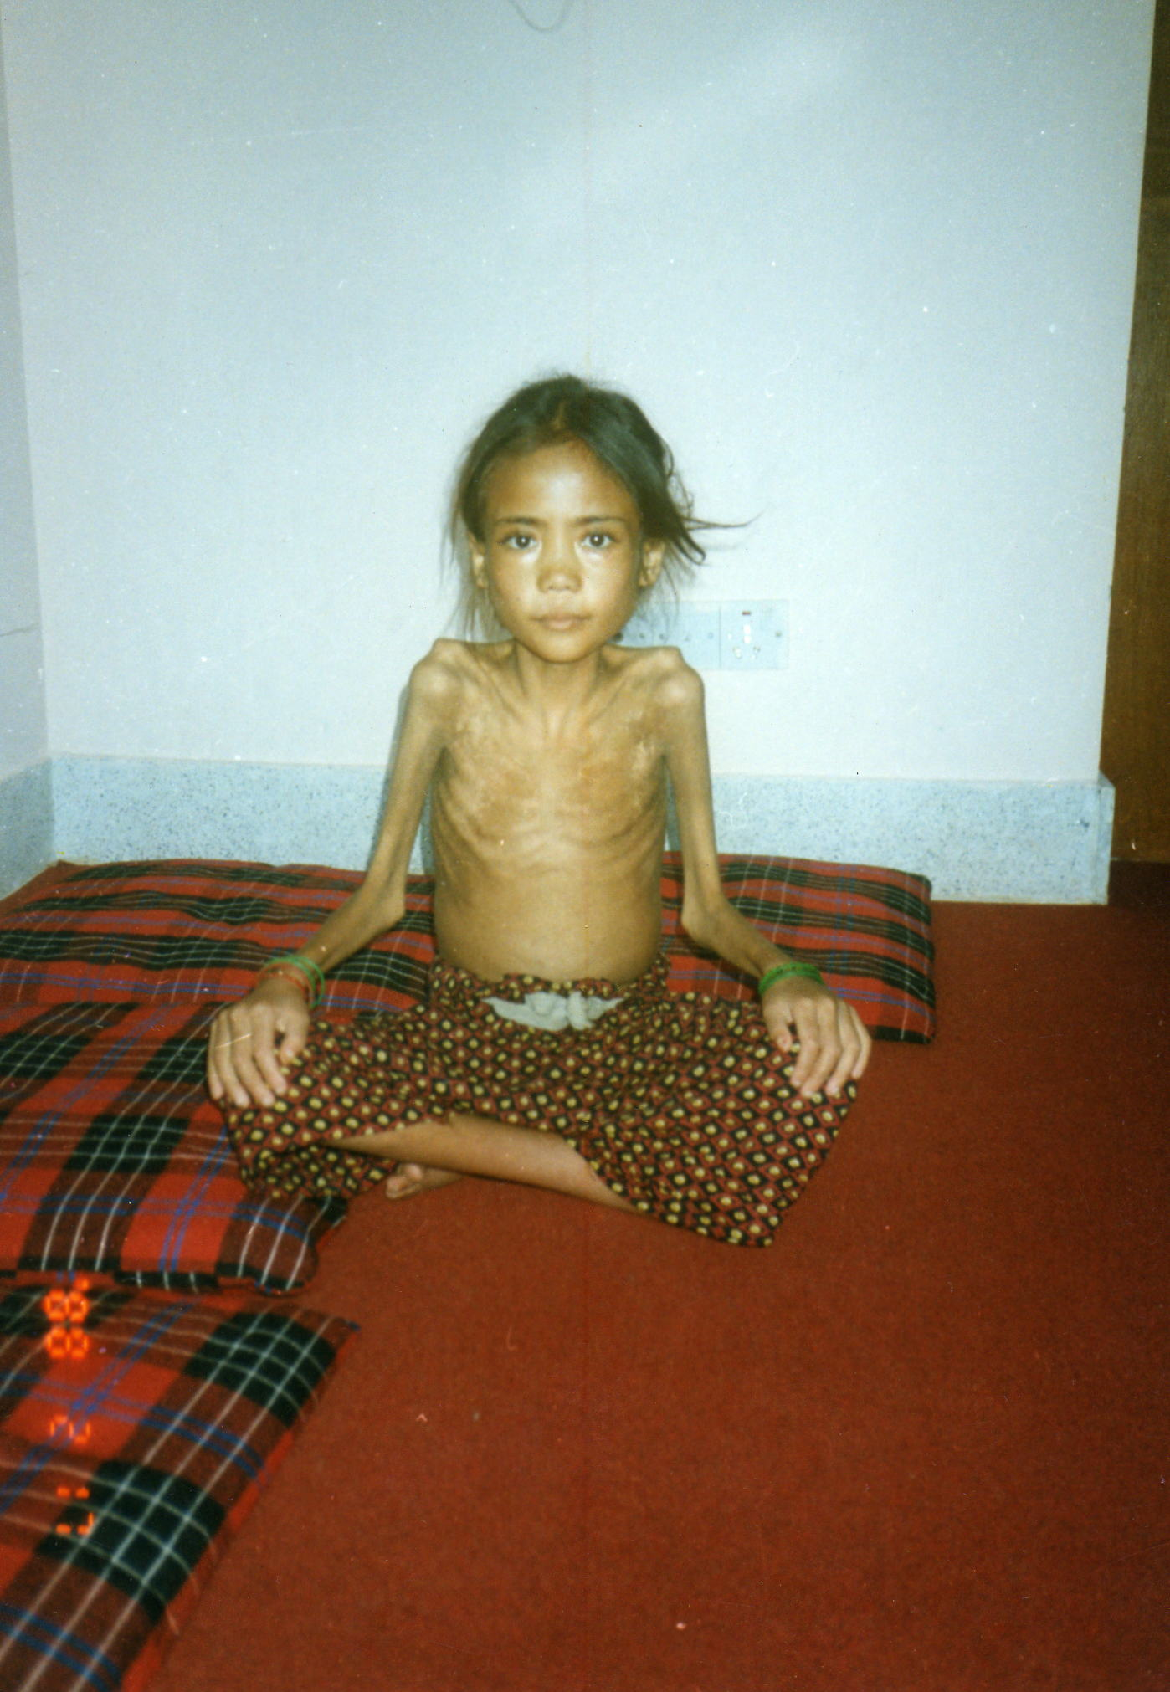
Because dollars go far in Nepal, we are able to accomplish a great deal of good with a relatively small amount of money in U.S. terms. It costs only a little over $250 to restore a child to health and educate the mother at our Nutritional Rehabilitation Homes.

