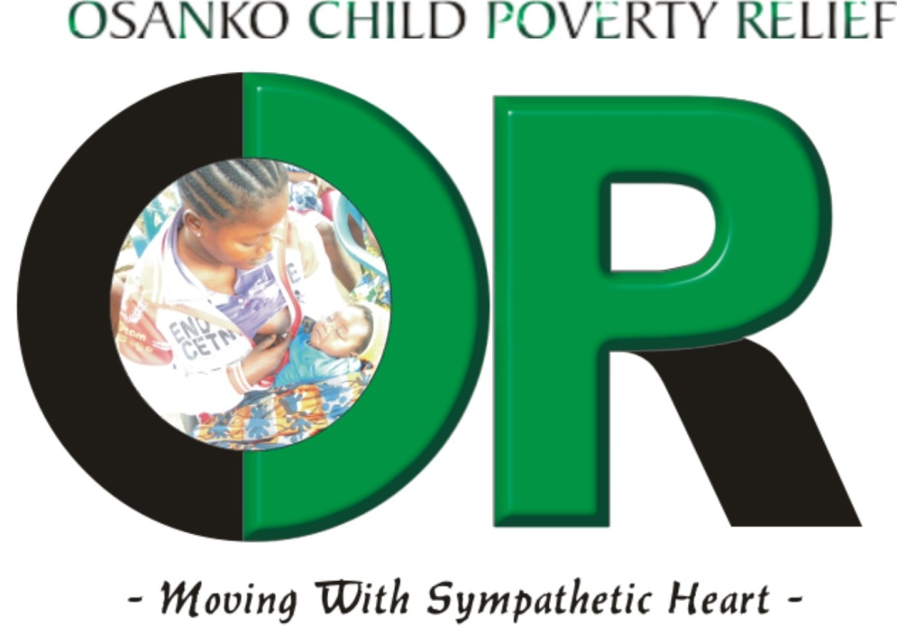 OSANKO BUSINESS PLAN

Osanko’s three core program categories are summarized as follows:
- Osanko House – a transitional home for 20 pregnant teenage girls and their unborn children
- CatchNet Program – supporting teenage mothers who are nonresidents of Osanko House but are provided Osanko resources including post-natal counseling, access to childcare services, vocational training, and preferred work schedule at Osanko Farms
- Osanko Farms – an income-generating farm owned and operated by Osanko

Rationale for Program and Activities
When a 10 year old girl got impregnated by someone she thought was being fatherly to her, she did not know that the secret things the man was doing to her could result in pregnancy. Osanko is interested in establishing a group home that will provide comprehensive assistance for such a naïve child to reclaim her life and reverse the downward spiral that could extend to her unborn child and generations of children to come. We are also interested to help existing teenage mothers to get vocational and other skills that will enable them to take care of their children and grow as self-sufficient women in the community.
A family must have its basic needs of food, shelter, and clothing met before they can address other significant challenges in their lives. As a result, OSANKO House will be the place where a combination of housing and supportive services will provide the pregnant teenage girls in the Nyanyano and environs of Gomoa East the environment for transitioning into smart, successful mothers determined to achieve education, vocational skills, and resources to step into womanhood. Osanko is interested in establishing a group home that will provide comprehensive assistance including training in mothercare, sexual awareness. We are also interested to help existing teenage mothers to get vocational and other skills that will enable them to take care of their children and grow as self-sufficient women in the community.

We will begin with 50 girls in 2 programs that will be scalable as funding enables our expansion:
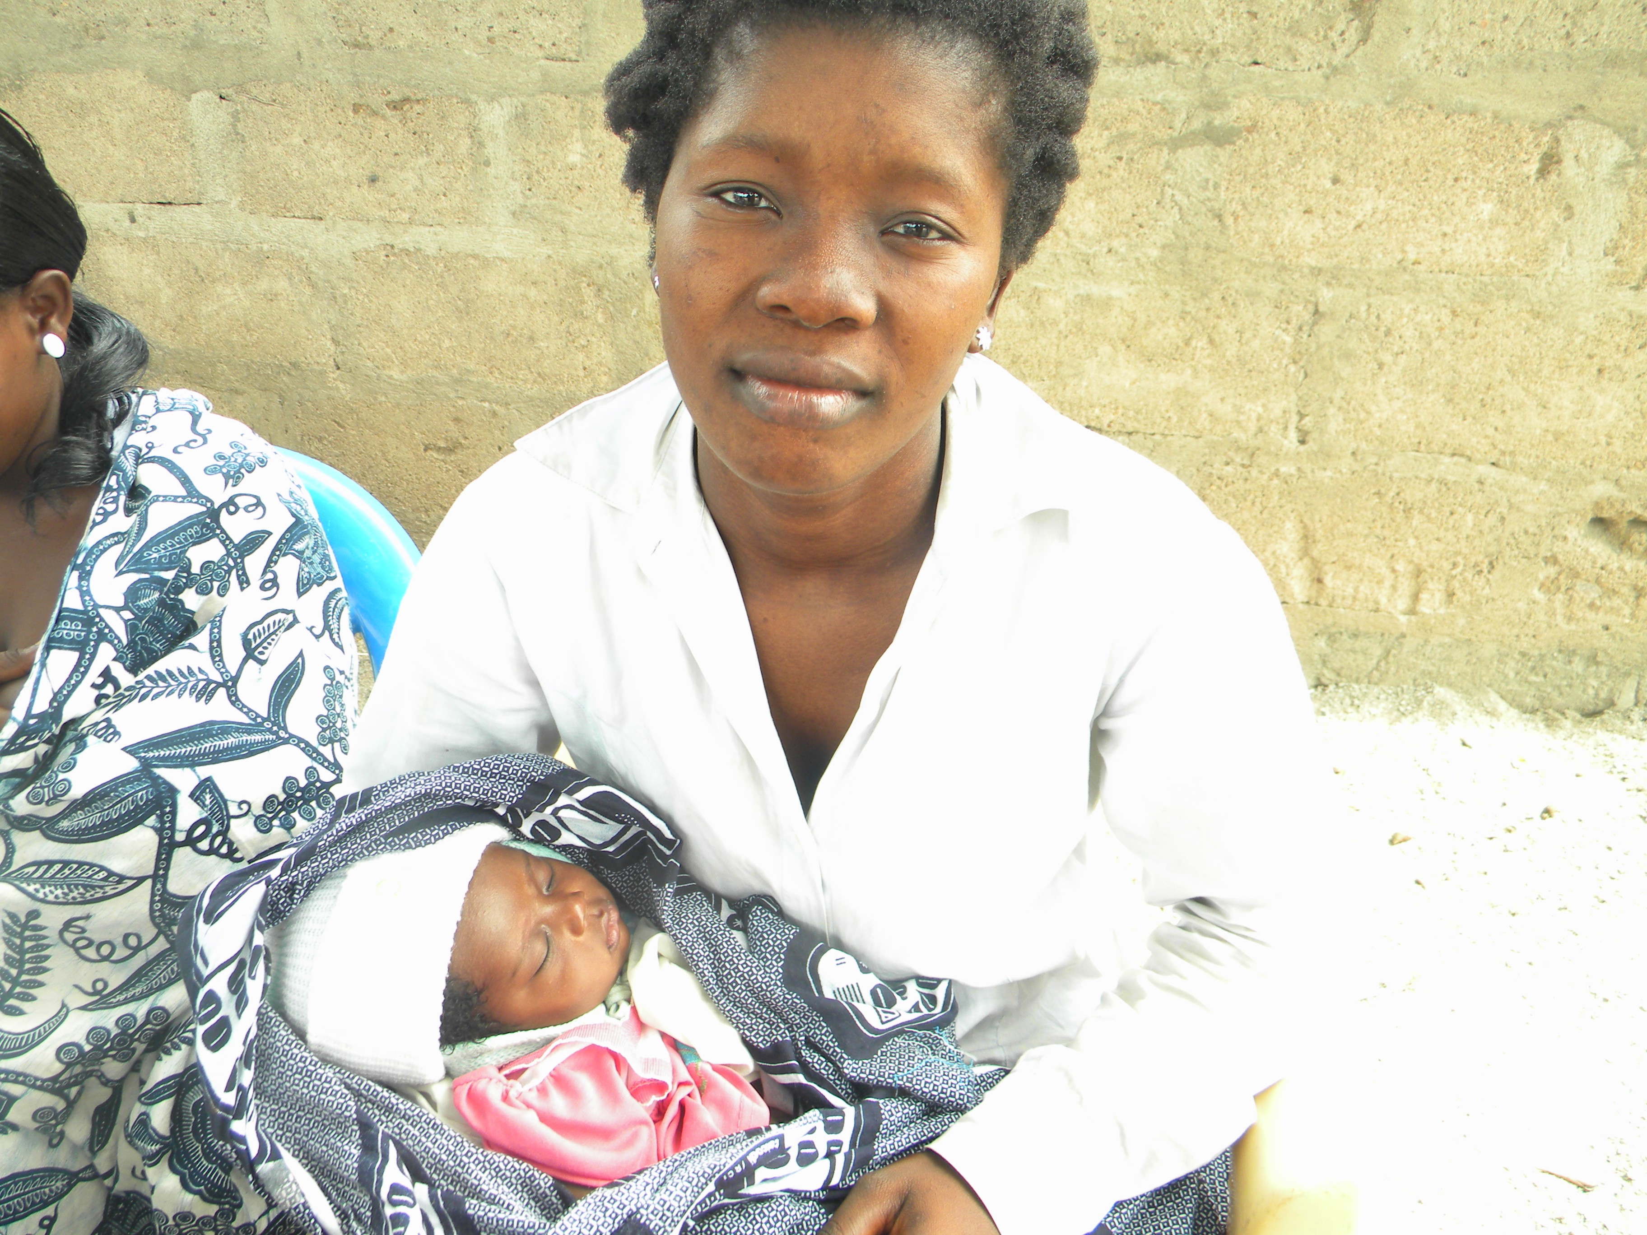
20 pregnant girls are in urgent need for a stable environment and will be admitted to Osanko House for a period of 1-2 years. They will receive pre-and post-natal support to help them deliver healthy babies. In addition, 30 girls who have already given birth but live with their relatives under poor, unsanitary conditions will be admitted into the CatchNet program whereby Osanko social workers will assist them with home visits and access to resources. All the beneficiaries will be supported with health and educational resources to enable them to understand their reproductive rights and family planning. Osanko programs will also empower the girls with practical skills and basic literacy to propel them toward adulthood. We ultimately want them to become independent providers, able to provide good nutrition and improved lives for themselves and their children.
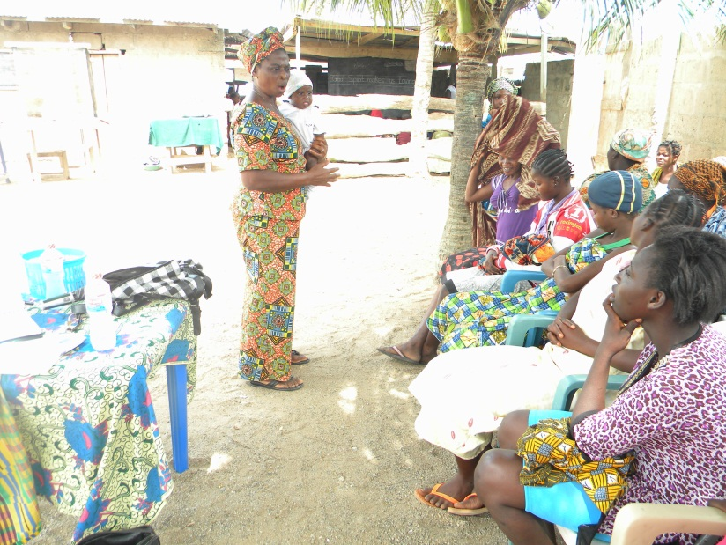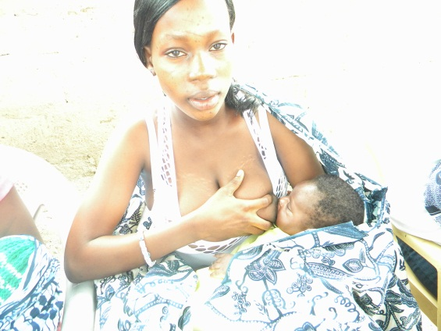

The following programs and past activities are developed for delivery in the near future:
OSANKO House
OSANKO is committed to supporting an initial 20 of the most vulnerable teenage expectant girls by providing them a transitional home where they will feel welcome, safe, and unafraid either for themselves or for their unborn children. By and large, these mostly inexperienced girls between ages 10-19 have fallen prey to sexual predators and in some cases, by their own ignorant and poor choices. They now find themselves impregnated by adult males in their communities that they either know or not. In addition to the lack of food, shelter, maternity clothing, these “children having children,” are also burdened with shame and blame by their families who are poor themselves. The girls feel alone, neglected by the men who lured them to their beds with food, money and friendship, only to defile and sexually extort the girls into single-motherhood. We currently assist a number of girls who have delivered babies in the Gomoa-East communities with out-of-pocket support to barely keep themselves and their children surviving. We are also counseling other teenage girls who need information about prenatal care so that they can deliver healthy babies. Some of them are in their second to third trimesters of pregnancy and no family support or parenting skills for the impending births. The girls, by and large, have endured dysfunctional or abusive family settings all their lives and OSANKO House will provide the stable environment where they can begin to build trust, interact with their peers, and take care of their children.
Although young mothers and their children may live at OSANKO House for up to two years, the average anticipated stay is one year which would be adequate to fully prepare the new mother and child for independent lives. While living at OSANKO House, each young mother will be supported to return to school or participate in a job-training program. An in-house Daycare Center will Girls must be out of the house by 9 am and ensure their children are in day care before heading off to work, school or training for the day. Because of its size, OSANKO House will provide individual support and attention to each resident for a minimum of 12 months, with ongoing follow-up and support systems to sustain their independent lives after they go on their own. This focused attention will become the bedrock for the continued success of OSANKO House. To the extent possible, we anticipate that 100% of our participants will have completed basic education programs, attend job- readiness training, develop marketable skills, and commit to taking good care of their children, with a newfound awareness for their bodies and sexuality that will help them make better choices and prevent second pregnancies.

OSANKO CatchNet for Older Teenage Mothers
The CatchNet Program is designed as a response to the epidemic of teenage girls in the Gomoa-East and its environs who have already given birth to fatherless children and are having difficulties making sense of their lives. Osanko is committed to support 30 teenage mothers in the CatchNet program with emergency nutritional and financial support, and access to vocational training that will prepare them with employable skills. Three girls who were awarded vocational scholarships chose fashion design and dressmaking. In addition to the initial investment in sewing machines, tuition, dressmakers’ toolkit, patterns, food and toiletries, ongoing fees and expenses for supplies, notions, fabric, buttons and trimmings, made the CatchNet program difficult to continue without external funding. This important program will be revisited for all the change it can effect in the lives of a growing population of women without prospects, skills, and income.
Throughout the central region, the demographics of adolescent to teen girls who are being impregnated are getting younger and younger. A 10 year old is currently pregnant and she does not know who the father of her child is. She did not know that what the men were doing to her could result in pregnancy. Osanko is interested in establishing a group home that will provide comprehensive assistance including training in mothercare, sexual awareness. The word OSANKO means "woman" for the sele traditional Santrokofi people of the Volta Region. It is also commonly accepted in Ghana, that a girl becomes a woman the minute she reaches puberty. This is because no matter her age, she can become pregnant and give birth at puberty. It is in this spirit that we will embrace the young mothers and their infant children and provide the helping hands needed to lift them out of poverty.
OSANKO House will function as a highly successful transitional housing program for about 20 of the teenage pregnant girls, with plans to expand as soon as funding is available to do more. Located in Gomoa Nyanyano, OSANKO House will provide life skills training program for homeless teen parents, is one of the few places where teen parents can live and be supported while they acquire the education they need to be literate, and relevant skills to provide for their children. OSANKO residents will be provided a balance to education and life skills, with child-care, counselling, and steady encouragement for restoring their self worth and dignity, and strength for facing future challenges. We are one stepping stone from moving pregnant teenage girls from a life of poverty to self-sufficiency.

OSANKO Farms
Economic Development in Gomoa-East through Sustainable Agriculture
Through Osanko Farms, Osanko Child Poverty Relief NGO will use agriculture as an income-generating mechanism for building sustainability and opportunity for a future endowment. We currently own about four acres of unused land, ready for farming as soon as we can invest initial seed funds into the project. The farm provides an instant opportunity for the pregnant teenage residents of Osanko transitional home to embark on productive activity that develops the discipline and work ethic for future lives. The opportunity to have a safe haven for their babies and themselves and participate in useful activities will be manifest in the fresh food and vegetables that appear on their dinner plates daily, and on the stipends they earn during the transitional period. We will leverage the natural advantages of the arable land for growing both seasonal and perennial products that would include pineapples, garden-eggs, peppers, tomatoes, yams and tubers, plantains and bananas, coconuts, sugarcane, corn, mangoes, herbs, just to name a few. In a world with increasing demand for agricultural foods, the opportunity for Osanko Child Poverty Relief to own and manage its own yield for both consumption at Osanko House and for sale, presents a ready response to the crippling poverty that is the current experience of our wards.
The Osanko Approach – a hybrid Model
This hybrid model that bridges subsistent farming with a scalable business opportunity enables Osanko to operate as an NGO that is self reliant through an income-generating activity while ensuring that supportive services and resources to our beneficiaries also continue and expand. We want to ensure that we provide the education, training, micro-credit loans, and cottage industries for our pregnant teenage girls to transition into safe motherhood when they move toward independent lives. The hands-on experience and discipline for productive activity during their stay at Osanko House will add value to launching all kinds of small businesses for their families. If necessary, they can also exercise the choice to stay on as employees of Osanko Farms. Food cost at Osanko House will be offset by the ability to deliver fresh produce daily from “our own farm” and the pride that goes with the girls knowing that they had everything to do with the production of the food on their plates.
We will hire an Agronomist to oversee the local production of fresh produce and experienced farm hands to supervise the processing of dried, pureed, juiced, and powdered herbs and spices, and for pickling, canning, cooking and bottling of packaged farm products for distribution value chain. Osanko Farms will be known for producing fresh products with the highest quality, delivered to our customers with the best care from our farmers. The increased prosperity of Osanko Farms would provide jobs for the entire community in Gomoa-East but most favorably, it will enable the organization continued ability to expand all our programs and operate effectively.

Some of Osanko’s sample products will look like this:
- 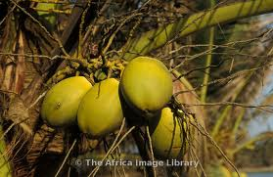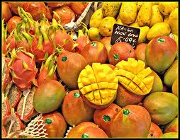
500 × 391 - reddesastres.org

Osanko’s Past Activities and/or Programs
As indicated earlier, the road to registering a formal organization has been a progression of one family’s efforts to help young girls in need, and as such, we simply helped out-of-pocket with no intention of itemizing how much we spend and no real plans to design specific programs. In hindsight, the current approach has a better chance of success, both from lessons learned the past couple of years by trial and error, and also from experience gained to inform our refined approach for formal implementation.
Some of the past out-of-pocket achievements of Osanko Child Poverty Relief include but are not limited to:
- Previously assisted a handful of single mothers with some capital with which they are trading and taking care of themselves and their children.
- Osanko also put three needy children in school, providing the essential materials for them to remain in school.
- Presently paying the levies and providing school materials for 10 pupils in school at Gomoa-Nyanyano to help them to remain in school. Although their needs are so much more, it is difficult to meet all of them from limited family funds.
- Counseling of young girls once a week at the beach where they are often seen working when they skip school.

