Project: Books for kids who need them the most
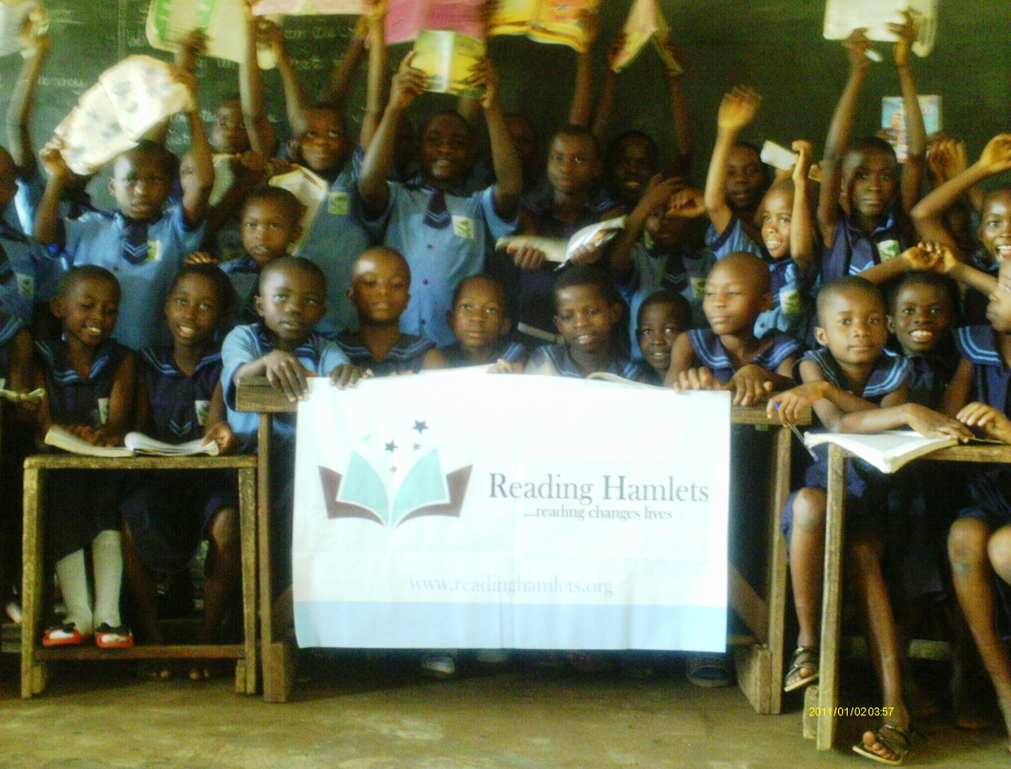
Sadly, children living in villages and low income communities in Nigeria have little or no access to books they can read. Access to books is one of the most important factors affecting literacy. Our goal is to provide books to schools and young children. Books provided to schools would be used to establish libraries in schools that are situated in low income communities. How would a library enrich a student's life? Well, it’s simple- the more you read, the more you know and the only way a student can learn more is to have books to read, either at home or at a school library. Children living in low income communities in Nigeria only utilize their textbooks which aren't sufficient. A variety of books in a library would enrich a child's life.
Libraries are more than just a place, they are buildings equipped with books that can make a significant difference in one's life. Research has shown that school libraries have a positive impact on student achievement yet nothing is being done by the government of Nigeria to provide school libraries in low income communities. Libraries have an important role in empowering student learning. They provide a range of learning opportunities to students. The school library also serves as a place for children to do their homework, read different books that will broaden their horizon and host special events like book clubs. In short, they play a major role in helping children to read. A major goal of libraries has always been literacy for all.
Reading hamlets wants to provide libraries because we believe that libraries play a major role in fostering literacy in a nation. Libraries are overlooked yet have a greater influence on the life of a student especially young ones. We have a fantastic opportunity to really change the lives of young people. We strongly believe that school libraries can, indeed, play an important role in providing environments and opportunities for young people to develop their strengths, pursue their interests, and express their own voices.

Objectives of the project
1. To provide students with a place to read books other than textbooks and gain new insights on issues that matter to the student that would ultimately helps them to have a better understanding of the world.
2. To provide resources for students that can foster educational development.
3. To provide an environment for students to meet and interact with peers who have similar education goals.
4. To provide a place where students can build upon the knowledge that already encompasses their minds and enrich their lives.
5. To foster stronger connections between teachers and students.
6. For students to read more often, acquire better literacy skills; do better on test, exams and in school.
7. To provide books so that students can gain knowledge. Books are so many things, they are informative, tangible, contain knowledge, inspire and have a profound effect on society. Books have the power to benefit a student in a myriad of ways.
Detailed Budget
Container of books | $14,300
Clearing container | $2,000
Furniture for libraries | $1,000
Travel cost to villages | $1,000
Storage before transporting books to schools | $500
Restoring rooms/Painting/Arts | $700

