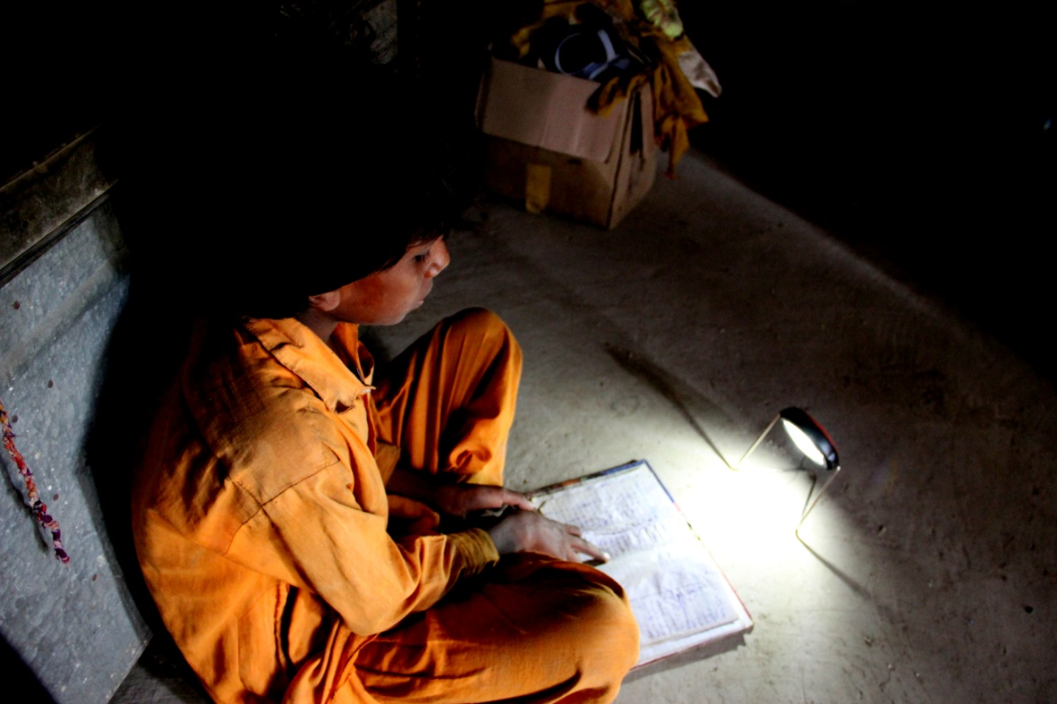
  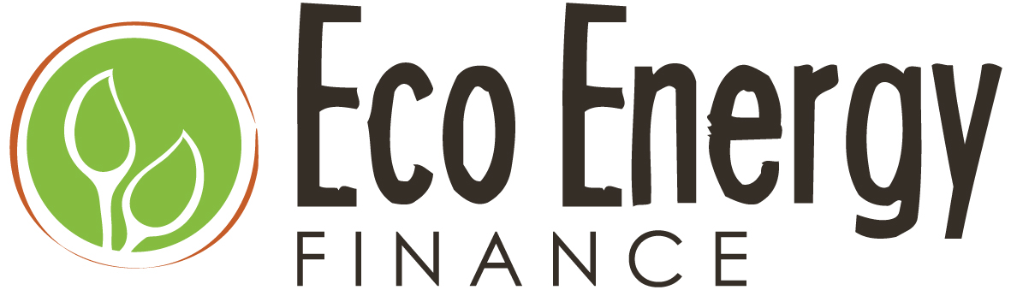
  Newsletter
    - December 2013
Solar energy for POVERTY ALLEVIATION and a sustainable Future |  | Issue 1

EcoEnergy Update

The discovery of fire was a major turning point in human evolution. It allowed humans to harness energy to cook food and obtain warmth and protection. It also allowed activity into the dark and colder hours of the night, and provided protection from predators and insects.

Despite the astounding technological and cultural advancement humanity has achieved since the discovery of fire, for the world’s poorest inhabitants, time has stood still…

125, 000 years later 1.6 billion people across the world still have no access to basic energy to meet these fundamental needs of warmth, light, and protection. For thousands of years they have ravaged the planet daily for fuel to burn- trees, dung and since the 1800s, a hazardous and toxic fuel which replaced whale blubber- kerosene.

Pakistan is prime example. Over 40% of the population is not connected to the energy grid. Most of those people live in rural areas and in extreme energy poverty. Heavy reliance on firewood has contributed to the world’s second highest rate of deforestation. We at EcoEnergy believe that we must harness the technological innovations of the 21st century to combat climate change and to improve the lives of these people. And we are not alone in this belief.

According to the World Economic Forum, "Access to energy is fundamental to improving quality of life and is a key imperative for

economic development.” In 2010, the U.N. launched a global initiative led by Secretary

General Ban Ki-moon called Sustainable Energy for All, to achieve universal energy access, improve energy efficiency, and increase the use of renewable energy. 2012 was designated as the International Year for Sustainable Energy for All.
Launched in 2009, EcoEnergyFinance is proud to have been at the forefront of the effort to implement a real solution to this massive and pressing global problem. We share our work through the U.N. Energy Access Practioner’s Network.

2013 has been a big year for EcoEnergy. We hired our amazing team last winter and launched our pilot in March. Throughout the year we have been conducting market research and building an extensive retail and direct sales network to provide solar lanterns, home systems and solar phone chargers to the rural poor in Sindh, Pakistan. As a social enterprise, whatever profits are made are not for shareholder value, but rather are reinvested back into the organization and recycled to meet a larger number of people. In essence, we seek to provide a superior product at the lowest cost possible, while remaining sustainable. We hosted a Fundraiser in July and a Global Giving campaign this fall. Thanks to our donors we were able to reach over 600 families and achieve an extraordinary amount of progress.

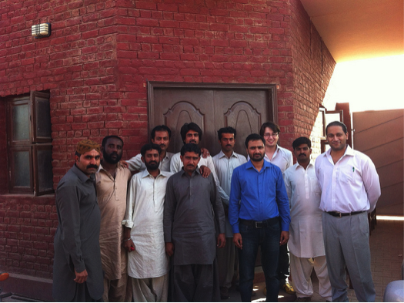
In November 2013, Executive Director Shazia Khan was given the distinct honor of representing the voice of the un-electrified rural poor in Pakistan. Shazia was a vocal participant at an intimate roundtable discussion with the Minister of Power and Water in Pakistan, Khwaja Muhammed Asif, hosted by the US-Pakistan Business Council and the US Chamber of Commerce. In mid-January she will attend the UN Investor Summit on Climate Risk at the United Nations Headquarters in New York. The Summit aims to mobilize the actions necessary to close the current gap in clean energy investment and accelerate the shift to a sustainable global economy.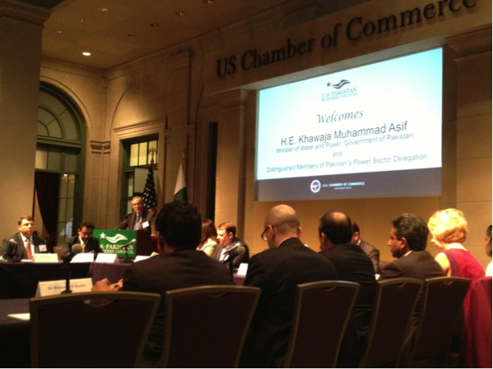

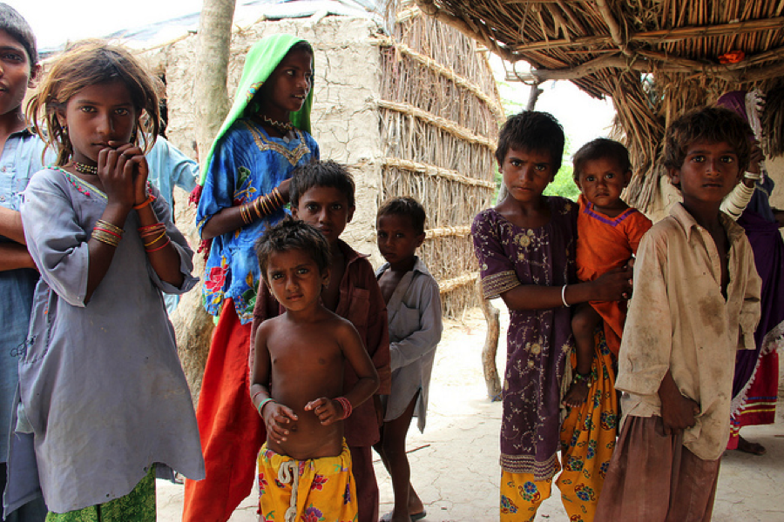
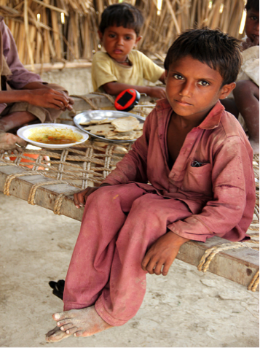
One of the biggest hurdles we have been facing is that, though there is a huge demand for our solar energy in rural Pakistan, the product costs of $10, $15, and $40 are still very high for villagers to pay in cash. Last month we finally implemented an installment system allowing people to pay in 4-6 months. Our sales shot up from 25 lanterns a week to 200! As you know, people in these villages desperately need energy. If we can make it affordable for them there is no limit to the improvements they can make in their lives and the lives of their children.
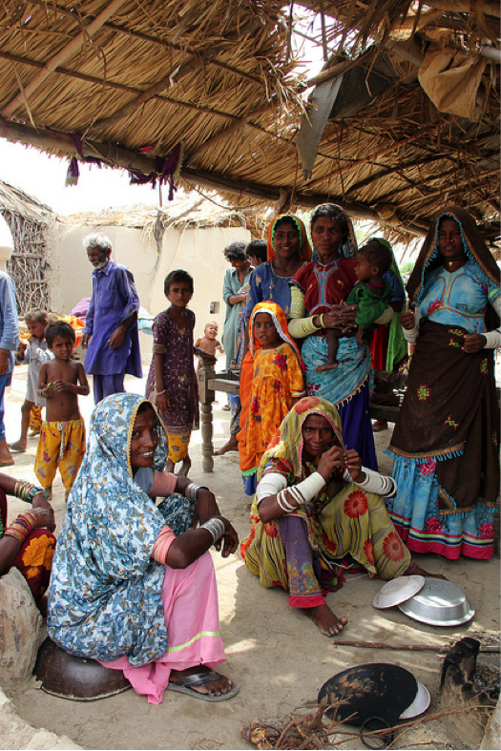
EcoEnergyFinance: Transforming Lives through Energy Access…

Sahib Khatoon, of Mirpur Sakro, Sindh, used kerosene lanterns to light her home, but found it expensive and hazardous. One night while giving milk to her young baby, she knocked over her kerosene lantern. His mosquito net caught fire and he was burned. In 2012, she purchased a solar-powered light and now she uses it to do embroidery and teach her children at night.
“We used to spend Rs. 20 to 50 per day on petrol (kerosene) and now we don’t have to pay that as sunlight is free”

Sameena Lashari, of Taluka Mirpur Sakro, Sindh, uses the light produced by a solar lantern purchased from Eco Energy to study for 2 hours a night. She is the first girl from her village to complete higher secondary education and she has been accepted into a B.A. program.
“Women over here don’t know any work other than karhai (embroidery) and working in the fields. During the day they work in fields and they can spend extra time on karhai now in the evening because of these lanterns.”

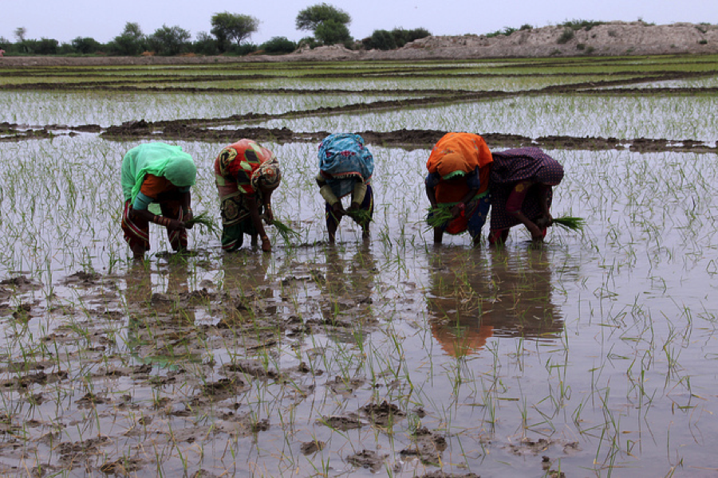
Our Best Ally: Word of Mouth
A lot of marketers might think that it is not possible to reach the target audience without using the conventional advertising and promotional techniques. There are no crazy budgets for investing in mass media advertising campaigns and getting brand activation agencies to work for you. You have to be extremely creative in the way you reach your audience and you heavily rely on the referrals of your existing customer base. It is an amazing feeling to know that your customers are satisfied with your products and service. And even better, it is a satisfying feeling to know that your existing customer is the one who is bringing you more customers.
Meet ‘Sher Muhammad’ who bought a solar lantern from one of our retailers. He used this lantern at night while he was busy harvesting his rice fields. He liked the lantern so much that he went out and brought our retailer two new customers.
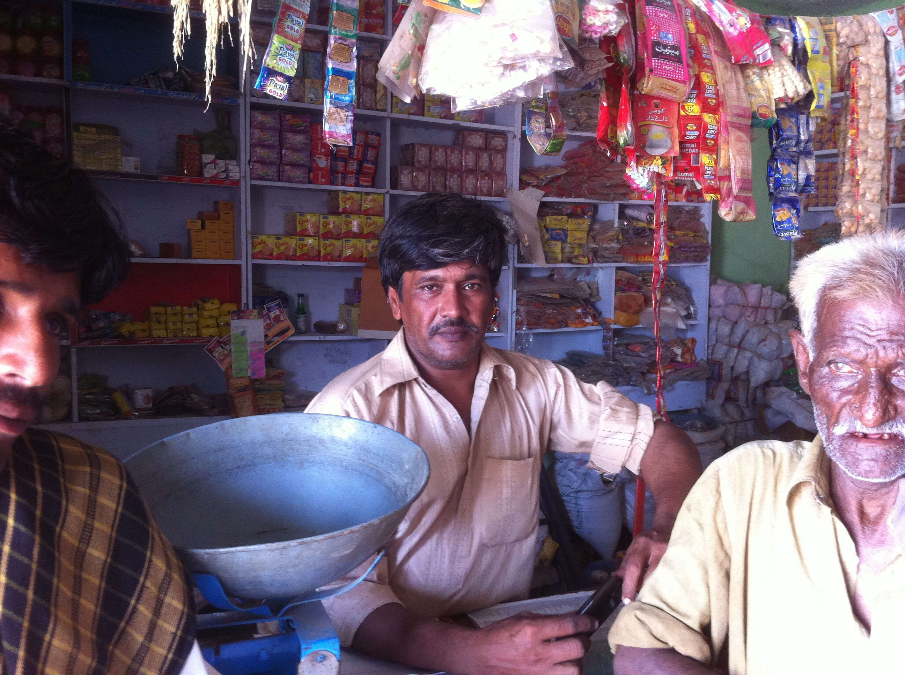
Spreading our message of energy access has been mostly word of mouth and it has worked really well for us. Iqbal, for instance, is a young man who lives in village Murad khaskheli in District Thatta. His village is completely off grid and has no electricity access. Iqbal runs a small tea stall in his village where villagers gather, have tea and talk. A few days ago his uncle bought a solar lantern from EcoEnergyFinance on installment. Under our installment program we are assisting villagers to buy solar lanterns by offering monthly payments for as little as 200 rupees ($20) over 4-6 months.
Iqbal was thrilled. Previously, he was using cheap lights that ran on batteries. Iqbal told us the lights came without a warranty and would break every 3 or 4 months and that he needed to replace the batteries regularly. Realizing the savings and the value of a warranty right away, Iqbal ended up buying 4 lanterns! He puts one lantern in the mosque where everyone can use it while praying. He uses the other lanterns at his house and his tea shop. People in these areas are part of a closely knitted community and the news travels fast among them. That’s what we are banking on as we continue to engender the trust of communities to improve lives through energy access.
Want to help more families like Sameena's?
We need to raise $10,000 this December to reach 4,000 people.
You help by enlisting 3 of your friends to donate $100!
Please visit
www.ecoenergyfinance.org/donate-to-the-cause
or send a check to 129 Pleasant St. NW Vienna, VA 22180"

