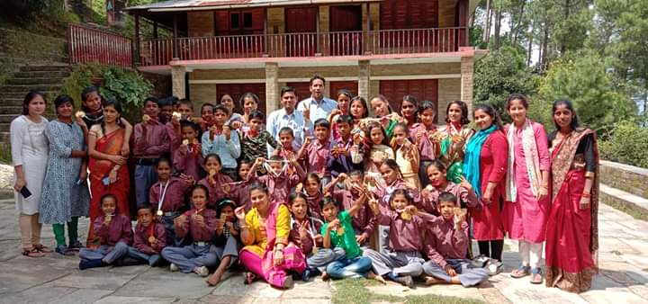

Here are highlights from our school, Aarohi Bal Sansar:

Uttarayan, The Spirit of the Mountains

A group comprising of class 8 students, teachers of Aarohi Bal Sansar and other staff of our organisation went for an educational cum fun three-day tour to Delhi, during this quarter.

The children presented a lovely medley of Kumaoni and Garhwali folk songs and dances, a humorous skit, and a patriotic song cum dance for a select audience at the beautiful premises of Sanskriti Kendra. A delicious Kumaoni lunch was served after the show. People also shopped for our local produce on display.

Our team of children and adults enjoyed the magnificent dance-drama at the Kingdom of Dreams in Gurugram. They visited Qutub Minar, India Gate, and had a fun filled evening at the adventure park - World of Wonders over the three-day trip.

In all it was a thrilling experience for the children, most of whom had never been to Delhi or even travelled on a train or the Metro.

We thank everyone who graciously supported this tour by way of funding, arranging tickets, local travel, and especially the management of Sanskriti Kendra for hosting the group.

National Science Day

This year Aarohi Bal Sansar celebrated National Science Day on 28th February 2020 engaging the entire school. Groups of students prepared and presented the fun experiments under the supervision of STEM teachers. Students were seen having fun explaining the concepts to visitors and junior kids. Some of the experiments conducted were- equilibrium, the law of inertia, fire balloon, electric motor, magnetic lines, circular motion and capacity of paper, the origin of pie, wind occupies space, etc.

Academic Progress 2019-20

The annual examinations could not be held due to the Covid-19 pandemic. The results of the semi-annual exams for all students from classes 1 to 8 are hereunder:

Hindi- 52 out of 119 students are those who have scored 80% and more. 49 students scored 60% to 79%, 17 students scored 40% to 59% and a single student scored less than 40%.
Mathematics - 31 students who scored 80% and more, 41 students scored 60% to 79%, 31 students scored 40% to 59% and 16 students scored less than 40%.
English - 38 students who have scored 80% and more, 29 students scored 60% to 79%, 32 students scored 40% to 59% and 20 students scored less than 40%.

Online Teaching- From the month of April 2020, all the teachers of the school are teaching their subjects using mobile phones. Since we are based in a rural area, where technology is relatively new it is encouraging to see that nearly 85% are participating actively in the online classes.

