Global Giving Foundation
Report for the period ended December 31, 2019
Support a Rural School in the Himalayas

Introduction:
Aarohi Bal Sansar (ABS) has made accessible quality education to the children from marginalized families, making it possible for these families to live in their own region and not migrate to bigger towns or cities for better education for their children.

Clubs formation:

We started four clubs at ABS from November 2019 with the following objectives:

1. The idea of creating 'School Clubs' originated while discussing solutions to aspects of Creative Teaching-Learning at ABS.

2. These School Clubs shall provide a free and open platform to kids in fields of their choice and interest. Through these clubs we look forward to witness 'learning outside Classrooms'.

The clubs we formed and the activities we carried out are given as follows:
From the STEM CLUB:
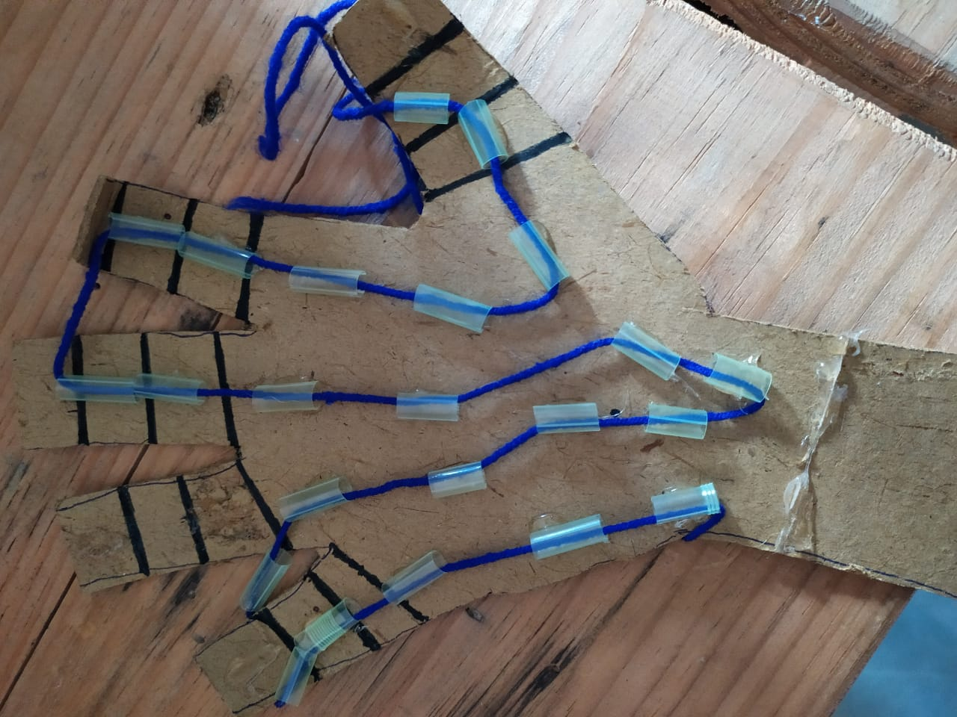
STEM (Science, Technology, Engineering and Math) - This club is related to research, developing stuff using waste materials. The club promotes the interest of science among students. It engages its members with hands-on experiments and a supportive environment to bring their ideas to life. The aim of the club is to apply science not just within the curriculum as it connects students to the science community outside school. The children have so far tinkered successfully with making a ‘’robotic hand’’ and a ‘’ light bulb’’.
Movie – In this club, the children watch inspiring and informational movies and then discuss the highlights of the movie. Movie clubs improve young children’s imagination and creativity as it also improves speaking, listening discussion and social skills. The children then write their own review of the film and this can really help their analytical skills. They watched movies such as ‘’Madagascar’’, ‘’Nil, Battey Sannata’’ and ‘’Coco’’.
Theatre - This is the club for all theatre enthusiasts. The club envisages developing the self-confidence of the child, improving his/her presentation skills, enhancing his/her public speaking abilities and providing an insight into various characters which he gets to enact. It provides much more than just academics and fills his/her life with imagination and dreams.
In this club, the children did role plays of characters in a hospital, railway station, bus stand, school – they learnt nuances of emotions, speech and acting. They entertained their audience with funny skits and drama!
A THEATRE CLASS IN PROGRESS
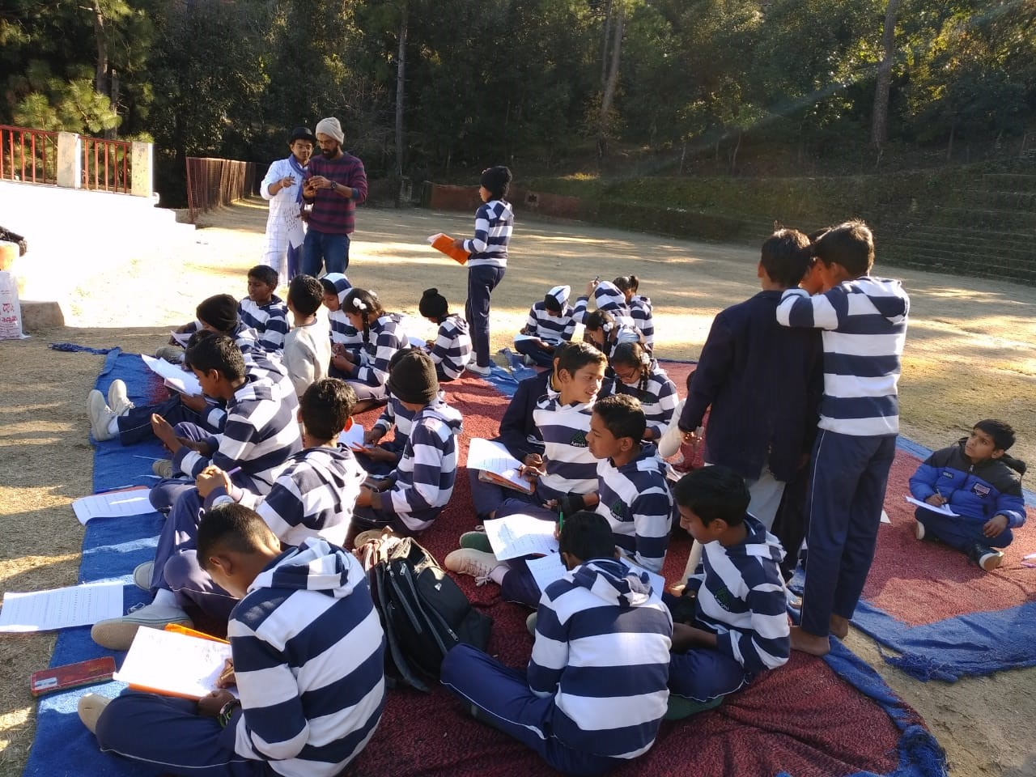
Cooking – A variety of food dishes have been created in this club to teach children names of pulses, herbs, spices and nutrition. Cooking with kids is a great way to educate them about good nutrition, what’s in season, planning and preparing meals, and reading food labels. It can encourage them to eat healthy foods, especially ones they may normally refuse to try. The children made a variety of dishes including soups and omelettes.

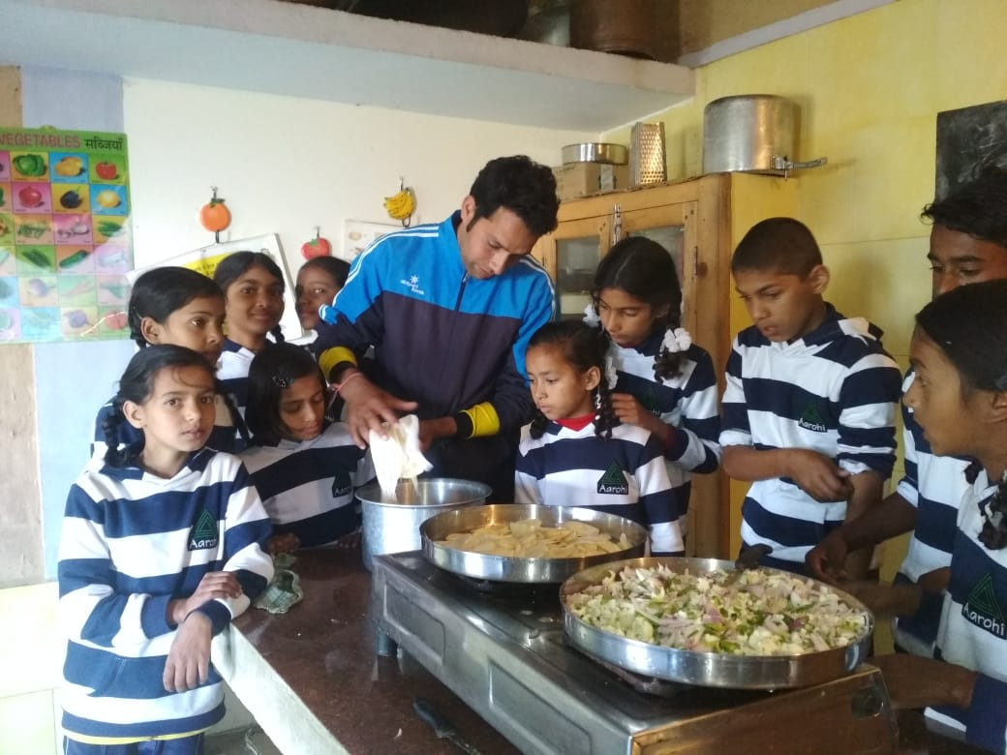
A BUSY COOKING CLASS!

