Send a Vulnerable Child to School in Malawi Report
Greetings from Namwera, Malawi
Namwera Aids Coordinating Committee (NACC) is pleased to share with you our invaluable donors and supporters the progress report of “Send a Vulnerable Child to School Project”

Many thanks should go to Global Giving and individual donors for the technical and financial support rendered to the project. We would also like to thank the local leaders, teachers, parents, school management committees and the pupils themselves for the support given to the project. Send a Vulnerable Child to School in Malawi is marvelous because of you.

In the provision of school fees, the project has supported 11 children (4 girls and 7 boys) from Namwera, Majuni and Masuku High Schools, among them, 3 children are new. Volunteers in collaboration with local leaders, extension workers from Ministry identified, assessed and approved the new beneficiaries using the vulnerability index established by the community.

In the provision of school uniforms, the project has supported 10 children from Primaries schools and 8 From High Schools. As usual, the uniforms were made by other vulnerable children who were trained in Tailoring by NACC. This empowers child headed households economically and socially. With the earnings they get from the contract of sewing machines, they are able to buy food, beddings, clothes and medication for their siblings and grandparents.

The project has provided educational counseling and psycho social support to 142 Children and 94 primary caregivers. This component was very vital during the quarter because of the floods that we experienced in Malawi. Children were displaced, houses were washed away, properties were damaged many bridges and roads were impassable, schools and churches turned into camps and shelters for the affected households. During that trying moments psycho social counseling was crucial for the kids and family members who either lost their beloved ones or properties. We are thankful that the situation is normalizing.

During the quarter, the project mobilized the community to protect the children from adversaries that comes with floods; from abuses that others might take advantage of the floods situation. The damaged school blocks are being renovated to be suitable for learning. Local leaders and the district assemblies are championing and funding for the renovations while the project is sensitizing and mobilizing the communities to actively participate and own the developments.

The Namwera community has decided to provide solar power to Chingwenya Primary school to complement the efforts of teachers and the pupils. The idea came out during the cerebration that NACC organized to recognize the hard working pupils, teachers and the School Management Committee.

In performance and completion, the project has facilitated the completion of 1 boy and 5 girls in their high schools. The project has also witnessed the increased number of pupils selected to high schools which was not there before the project. Congratulations to these hard working girls and boys.
Simple solution Huge Impact the story of Amina
Amina was a student at Majuni Secondary School (High School). She comes from Mwamadi village, 15 kilometers from her school. The school has no boarding facilities. Therefore, Amina used to walk 30 km daily to and from her school she was always tired and could not concentrate in class. During rain, she could not go to school because the roads were not passable and had no raincoat. She was missing classes and that contributed to her poor performance in class.

She was brought up by a single parent; a grandmother, who struggled to fend for themselves. The grand mother could not afford school fees and other scholastic materials. No one from her village gone to school and excelled to secondary school level and many people felt graduating from the primary school was enough. “I wanted to marry her off because I could not afford her fees, thank you for coming in with the support” said her grandmother.

The project used simple human centered design to understand her situation, walked with her and the grandmother to find simple solutions to address the challenges. We empathized; observed, engaged, and immersed. The project provided education counseling to motivate her and work hard. The biggest issues that she wanted to be addressed first were school fees and long distance to school.

The project in collaboration with school management committee, the grandmother, the village headman and Child protection Worker from the Ministry of Gender and Community Development identified a simple house where she moved in to stay near her school. The project talked to the landlord; Mrs. Kandulu to provide maximum protection. “This girl is genius she works hard, has good manners and I decided to give her free shelter to support her efforts” said the Landlord.

The project discussed with her class teacher, to provide with part time sessions to cover the missed sessions. By stay near the school she could no longer miss classes. Had more time and energy for home work and reading. Amina completely changed she started doing well in class. Come final Malawi School Certificate Examination which is equivalent to O level, she has done pretty well with 17 points. Indeed she is a College material.

“I want to be a medical doctor, I want to give back to the community for what they have done to me.”

We would like to thank you our donors for your generosity and the kind heart and the global giving for the financial and technical support. Amina will not be the same she has hope for the great future.

Simple solutions huge impact

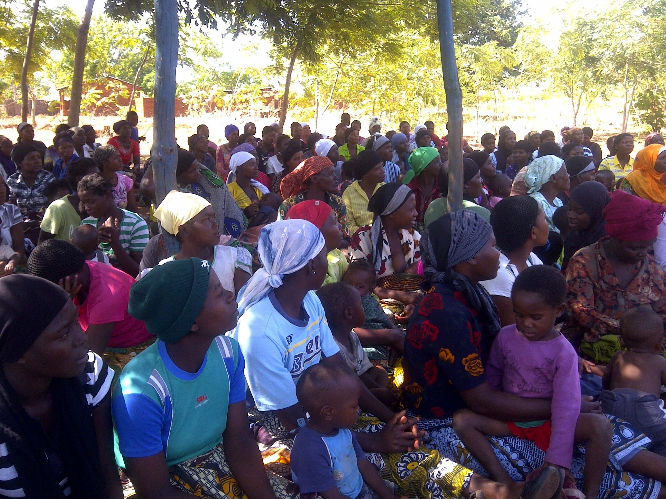
Meeting with primary care givers to discuss about importance of education
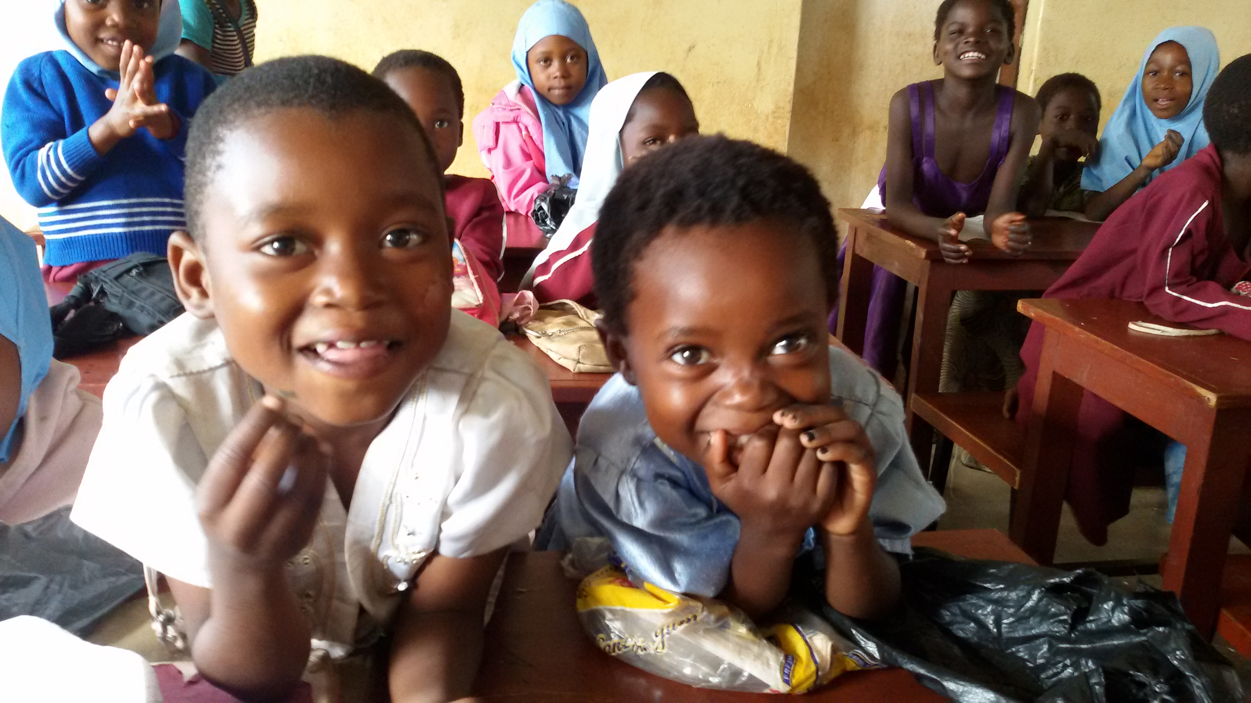
Kids needs early learning and stimulation
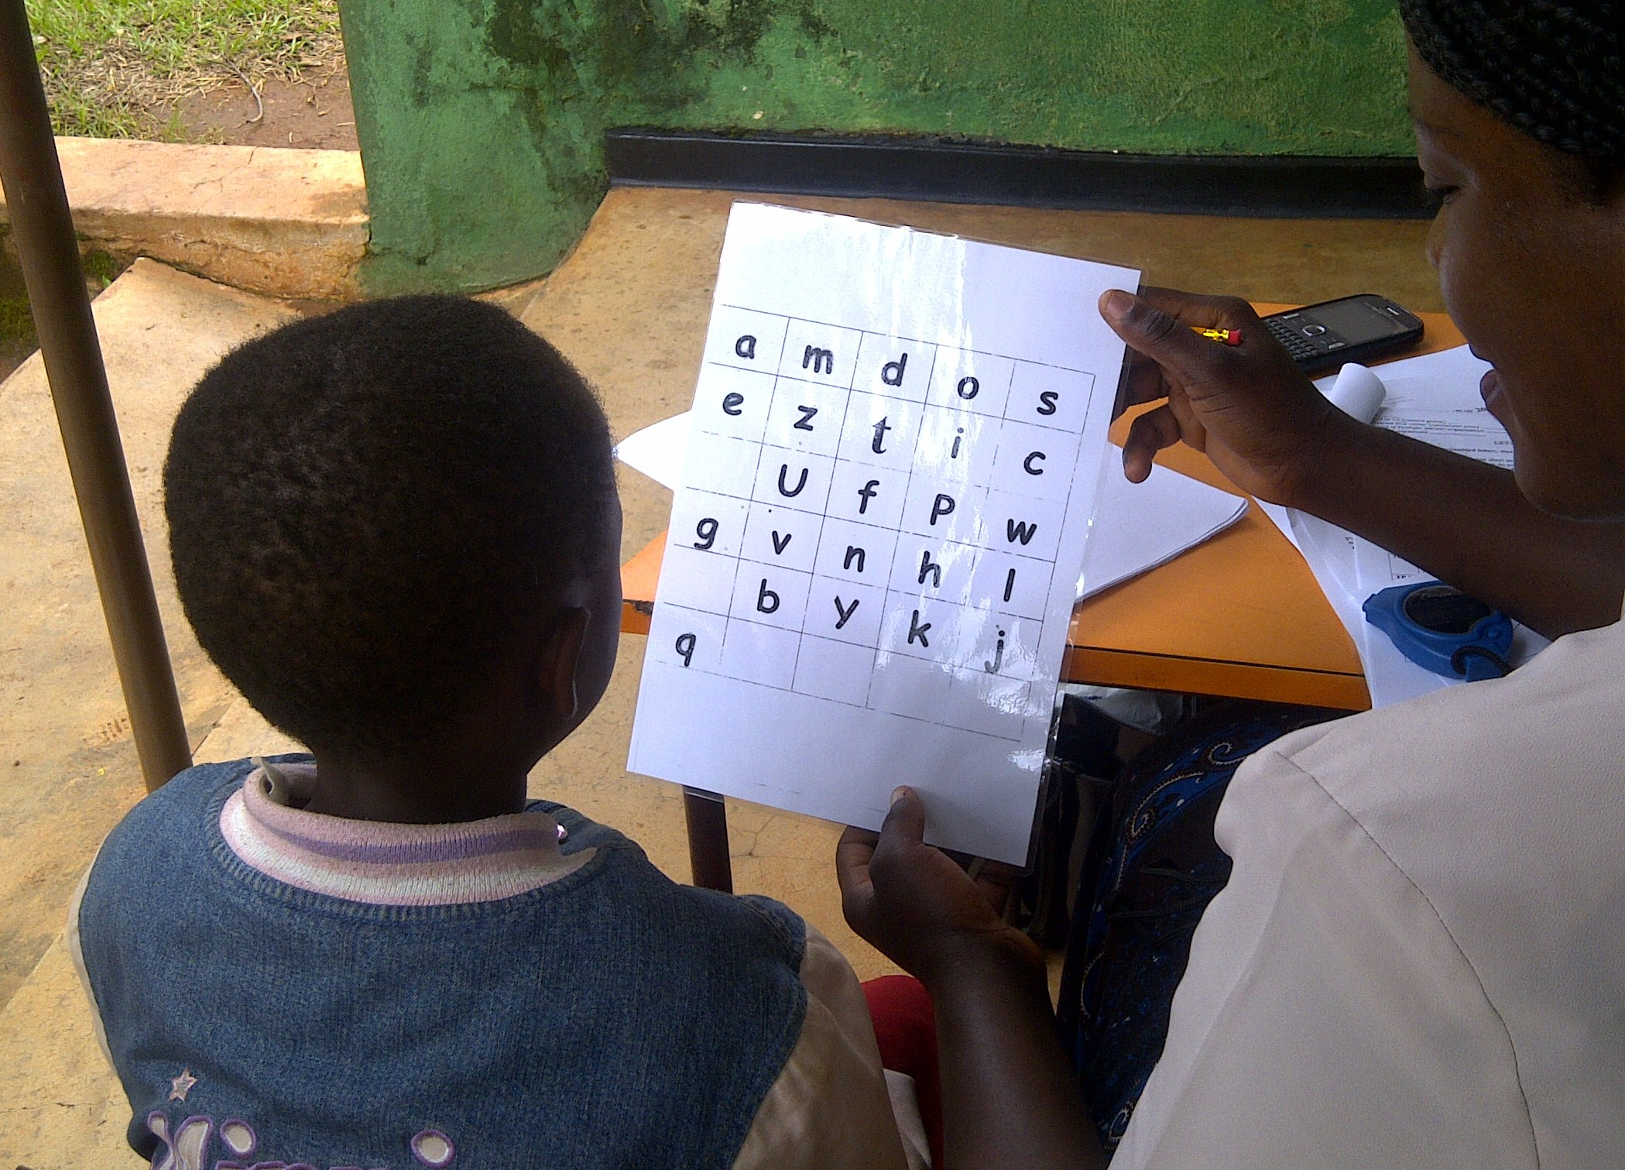
Primary Caregiver supporting a child at home
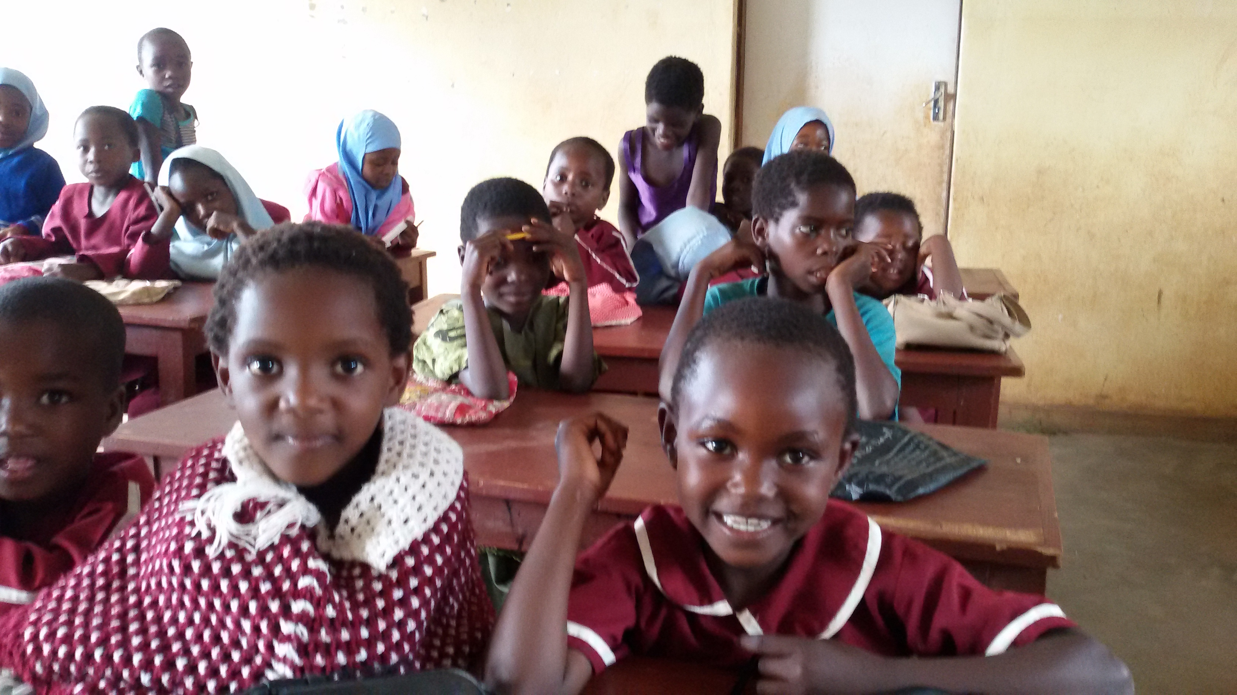
These kids have potential to grow into potential adults if natured and supported well.

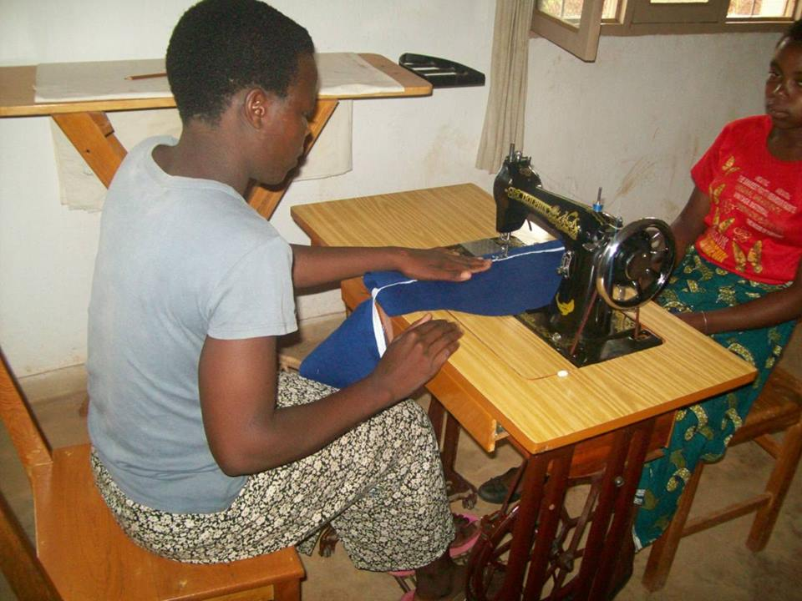
Child headed household leaders sewing uniforms for school kids as part of their Income Generating Activity to support themselves and their siblings

