Dear Friends,
Warm and tender greetings from Namwera, Malawi, the warm heart of Africa
Namwera Aids Coordinating Committee (NACC) would like to express her profound gratitude to the Global Giving and its donors for the wonderful support rendered to “Send a vulnerable child to school in Malawi” Project.

In the rural and underserved communities where literacy rate is 47% education should be given priority because it is not a privilege, it is a basic human right. Many thanks should go to all individuals who donated to this project. Your donation has supported 48(21girls and 27boys) from 5 high schools namely Namwera, Masuku, Mdinde, Majuni and Chowe with school fees and uniform and also 25 (14girls and 11boys) children from Primary schools with school uniform and writing materials.

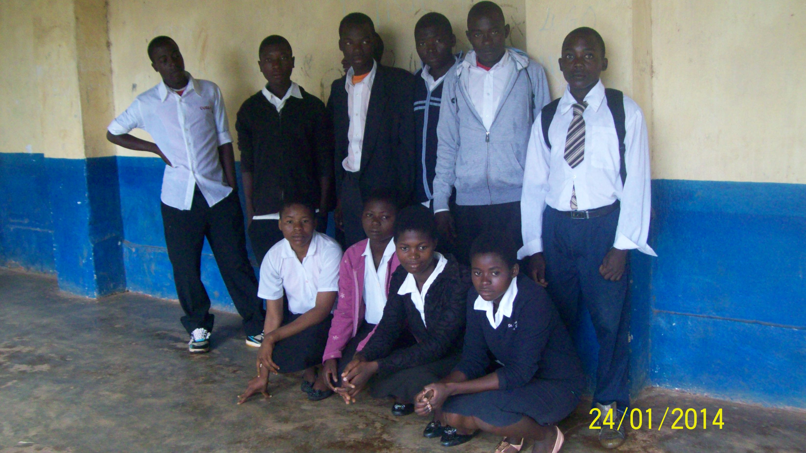 NACC in collaboration with community leaders, head teachers, volunteers and Representatives from the Ministry of Gender, Children and Community Development identified the children who benefited from this project. This exercise was done in collaboration with other stakeholders to promote transparency and accountability. The children were selected using vulnerability index developed by the community. Only the most vulnerable children were selected, they either lost one or both parents, coming from child headed household, woman headed household, old aged headed household or disabled headed household, chronically or terminally ill or poor parent who cannot manage to meet the basic needs of children like food, education and health care.
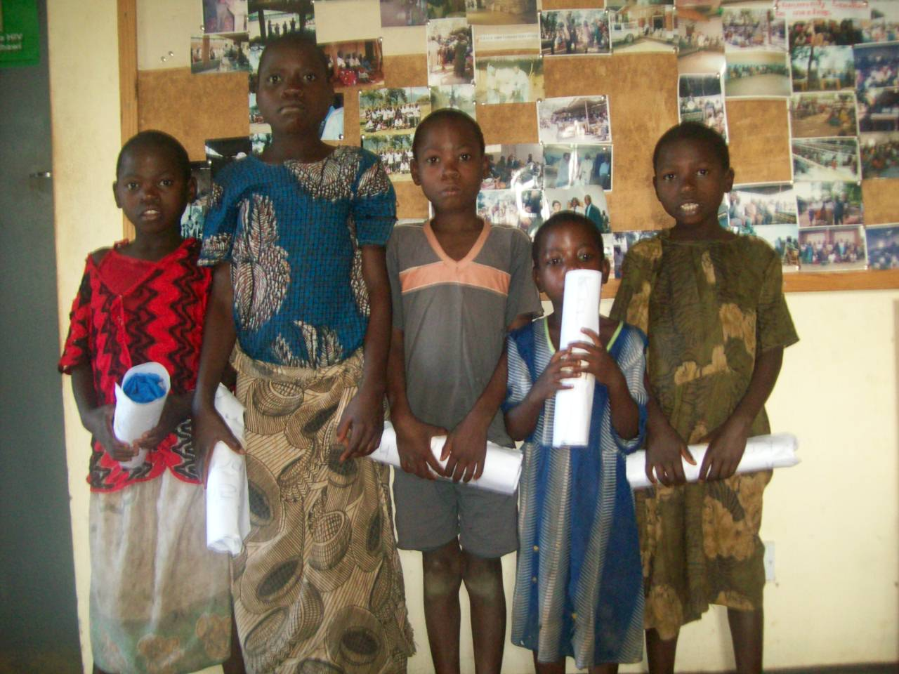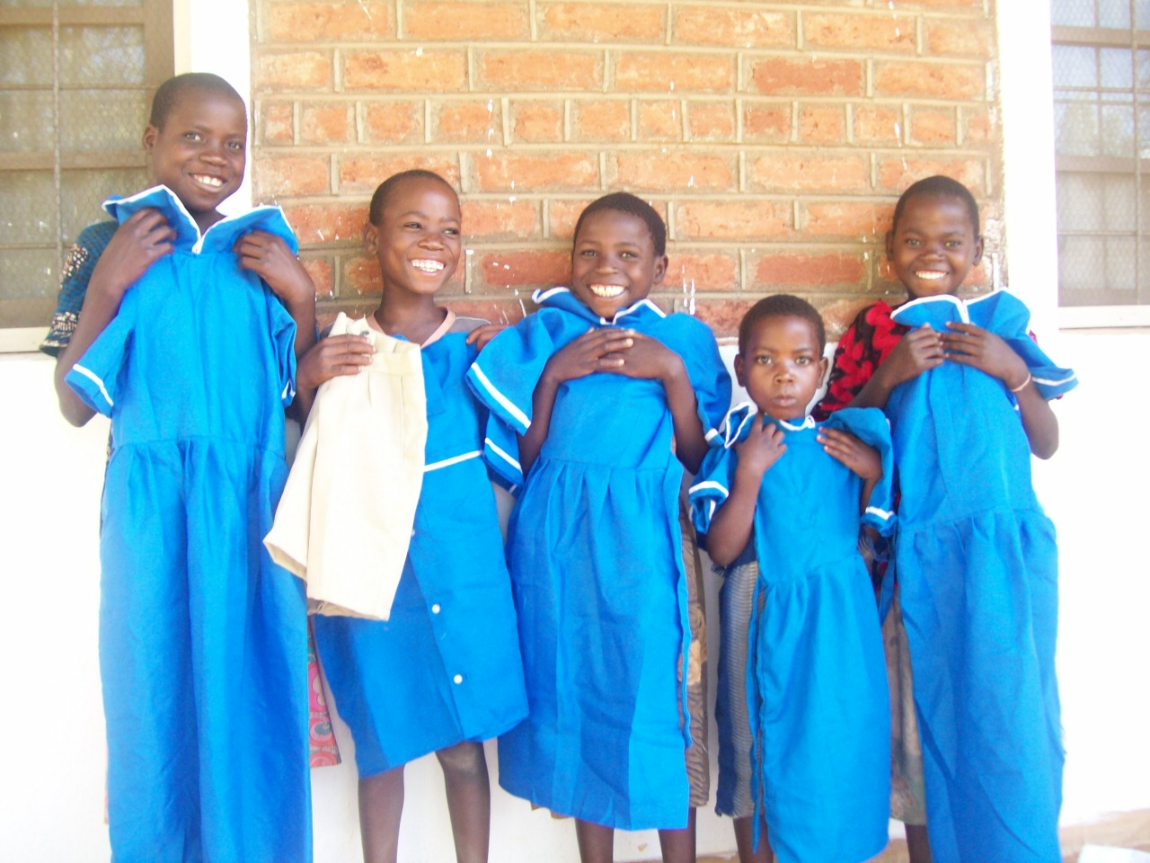
Other achievement
Apart from improving access to education for 73 vulnerable children, the project gave contract of supplying school uniform to 3 (2girls and 1boy)Child headed household leaders who are caring for their siblings, they all lost their parents due to Aids and are playing the parents role. There are 11 children from these three households. These Primary caregivers were trained in tailoring and were given tools and start up materials by the previous project. “I thank NACC, the Global Giving and its donors for the gesture, you empowered me economically, Am happy because I was able to provide my siblings three meals a day even during the months of January and February for the first time after losing my parents” said Patuma James from Chiwina Village.
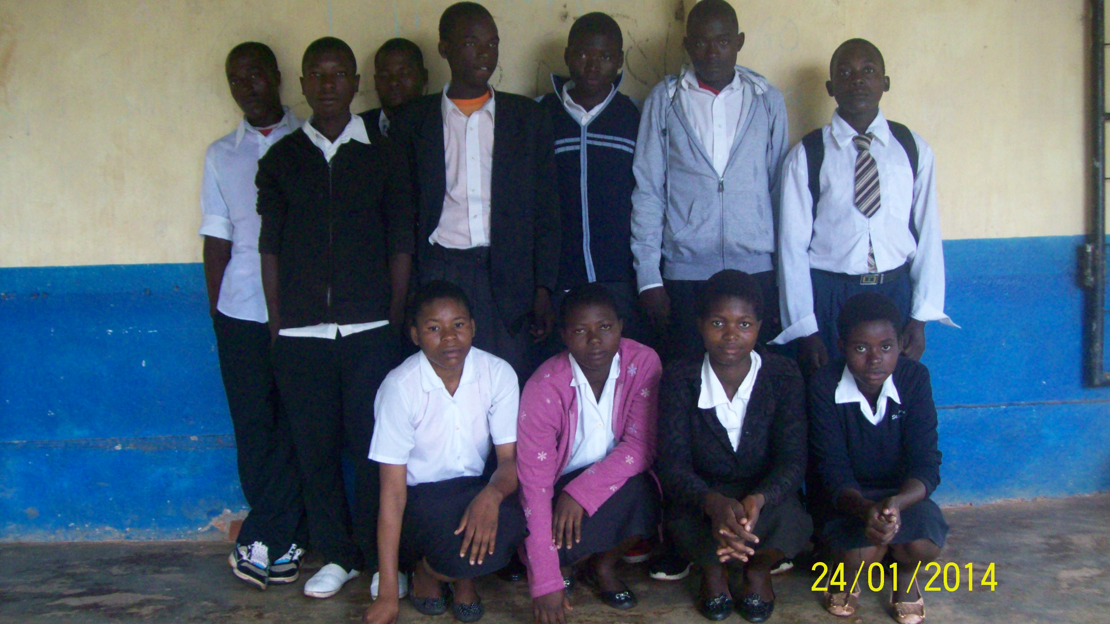

NACC will be updating you every three on the progress, challenges and lessons learnt.

Once again on behalf of the Namwera Community I thank you for the timely financial and technical support you provide to the “Send a Vulnerable child to School in Malawi” Together we can create enabling environment where a child can grow and learn. It can start with me and you.

Yours faithfully

Saeed Wame
Executive Director
NACC

