SOUP KITCHEN FOR CHILDREN

DEVELOPED BY

TIEMPO DE PAZ FOUNDATION

LOCAL GOVERNMENT OF MEDELLIN

August 2013

TABLE OF CONTENTS

Page
INTRODUCTION 3
DESCRIPTION OF THE PROBLEM 5
CHARACTERISTICS OF THE SECTOR – LOCATION 7
MODEL FOR INTERVENTION 11
WORK METHODOLOGY 12
SERVICES OF THE FOUNDATION 13
RESOURCES OF THE FOUNDATION 14
FINANCING OF THE FOUNDATION 15
OBJETIVE AND BENEFITS OF THE PROJECT 16
VALUE OF THE DONATION AND IMPACT 18
TESTIMONY 19
PICTURE GALLERY 20

INTRODUCTION
Nourishment, Nutritional and Educational Security must be engaged as a substantial aspect of human dignity and as a fundamental right established in The Universal Declaration of Human Rights and other declarations, pacts and commitments acquired internationally by the Colombian State and society.
The Colombian Political Constitution of 1991, in its article 44 consecrates the children’s rights in our country: “Life, physical integrity, health and social security, a balanced nutrition, one’s name and nationality, having a family without being separated from it, care and love, education and culture, recreation and freedom of speech. These will be protected against all forms of abandonment, physical and moral violence, kidnapping, sale, sexual abuse and work and economic exploitation. Family, society and the State are in the obligation of assisting and protecting children so as to guarantee their harmonious and holistic development as well as the full exercise of their rights.”
The project we will develop will be defined within the policies of the Ministry of Social Education, the Colombian Institute for Family Welfare, and consists of the care of children from age zero and on, since the care given to early and second childhood is conceived as an effective strategy to reduce iniquity, since it contributes to diminish the disadvantages inherent to children who live in contexts of poverty, and helps level some economic and social differences that affect the country today. The meaningful learning that takes place in the first years favor human development, a sustainable development, the achievement of piece and the stability of the nations.
The Tiempo de Paz Foundation has been working with a Soup Kitchen in the 8th Commune of Medellin for approximately two years now.
Our focus of community work in the different areas lies with children in process of school tutoring. The need to establish a space in the community to develop a field work with children in this process, from the standpoint of community assistance in nutritional strengthening, has been seen; by being fed, children will be better able to assist to school, preventing dropouts. Through this work, we also want to walk with the parents, because the social risk situation children are in is very high. The children are being affected by different issues, among which are found security, violence within the family, consumption of psychoactive substances, sexual abuse, economic and financial scenarios, fear and insecurity. We want to lessen the risk of children tied to their families through a Soup Kitchen and a non-formal formation, based on conflict resolution, peaceful co-existence and Human Rights formation workshops.
All of this process of community work is coordinated by a highly qualified interdisciplinary team.

DESCRIPTION OF THE PROBLEM
According to the World-Health Organization, health is a complete state of physical, mental and social wellbeing, and not only the absence of sickness or pathology. Good Health has been the fundamental object of all cultures and many are the rites, rules and practices developed to this end throughout the centuries.
Child malnutrition is a problem that goes beyond the need to feed minors. It begins with the ill care of women during pregnancy, which generate a chain of conflicts in the development of the child, which in some occasions result in death. Added to this, the growing flow of displaced population from Antioquia and other regions into Medellin, settles in the peripheral areas and deprived sectors of the city, such as is the case of the 5th Commune. This rises the level of poverty and the lack of opportunities to access social services such as education, social security, decent housing, and therefore a good nutrition.
Currently, the environments in which the children of Antioquia are developing and the grave socioeconomic and political conditions our region is going through, constitute a limitation for a healthy holistic development and protection. This gives room for the confrontation of large population groups in grave danger, because of the lack of a fixed income, of adequate living conditions and more often than not, a lack of the care of the State.
There are many programs in the process of being set in place to help all the children below the poverty line in Medellin and in the 13th Commune, but there is still a great effort needed on the part of civil society, which just like Tiempo de Paz Foundation makes itself present in the 13th Commune, and so reach those forgotten corners of our city, where hunger combines with other great issues such as violence, sexual abuse and drug addiction among others.

DESCRIPTION OF THE SECTOR WHERE THE SOUP KITCHEN FOR CHILDREN WOULD BE LOCATED
What we today know as “La América” sector, was considered a co-regiment from 1869 until 1938, and the adjacent tracks of land were San Javier, La Puerta, La Loma and El Corazón. As most neighborhoods in Medellin, they began to be populated through invasions, such as is the case of the sector El Corazón, where the neighborhoods of Belencito, Betania and el Salado were born, the same ones that in 1910 were declared as early invasions. Today we know it as Belencito, but formerly it was a settlement of the Madre Laura community, which was also a populating factor of the commune.
In the year 1946, the estate of Mr. Pepe Angel, located in the San Javier neighborhood, becomes a residential sector, through the Housing Co-operative. Later, from the year 1950 on, an illegal lot sale took place, giving birth to the neighborhoods of La Pradera, Santa Rosa de Lima and Los Alcázares. By the ends of the sixties, the illegal taking of some lands in the Belencito sector took place, which among the most relevant were La Colina, Las Misioneras de la Madre Laura. Later, these invasions were approved, giving legal backing for the invaders to inhabit the area.
Between the years 1978 and 1980 the neighborhoods today known as La Pradera, Antonio Nariño and 20 de Julio, were populated. After this, in an illegal manner were risen the neighborhoods Las Independencias I, II, III and Los Nuevos Conquistadores. Through the invasion, other neighborhoods such as La Divisa, Juan XXII, El Socorro, among others, were populated, becoming nowadays what we know as the 13th Commune.
All of these invasions and settlements were acquired without any kind of planning and the total abandonment of the State. Due to this, some houses were built in high-risk zones, with no water services, sewerage or electricity. With high ingenuity, its inhabitants figured out ways to procure water through nearby streams and a community septic tank located in the neighborhood 20 de Julio.
This situation of poverty, abandonment on the part of the State and the lack of employment, generate in the 80’s the influence of micro-traffic, hit-men and illegal armed groups, which resulted in the wave of violence the commune is under today.
The 13th Commune has been and continues being a place of refuge for many immigrants from sub regions of the state, the country and the city. This is why we find multiculturalism in it, and it now occupies 37.6% of zone four of the city of Medellin.
The 13th Commune of San Javier is one of the 16 communes of the city of Medellin, Capital of the Department of Antioquia. It is located west of the center-west zone of the city. It borders with Comuna n.º 7 Robledo to the north, with Comuna n.º 12 La América and Comuna n.° 11 Laureles - Estadio to the east, with Corregimiento de Altavista to the south, and with Corregimiento de San Cristóbal to the west.
The Commune is conformed of 21 neighborhoods which are:
- El Pesebre  - Blanquizal  - Santa Rosa de Lima  - Los Alcázares  - Metropolitano  - La Pradera  - Juan XXIII  - Antonio Nariño  - San Javier n.º 1  - San Javier n.º 2 | - Veinte de Julio  - El Salado  - Pablo Escobar  - Nuevos Conquistadores  - Las Independencias  - El Corazón  - Belencito  - Betania  - La Divisa  - Eduardo Santos  - El Socorro.
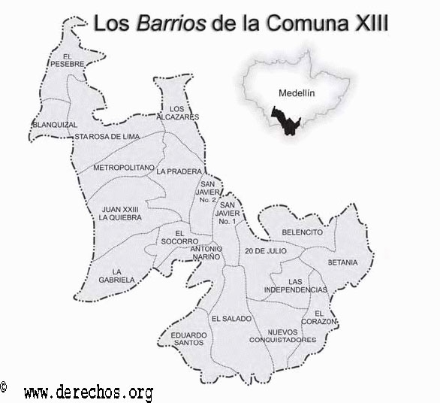
The Soup Kitchen would be located in the San Javier n°1 neighborhood, with address Carrera 96 no 47 to 110.
The population corresponds to the lower social levels 1 and 2, meaning that this sector of the city is not foreign to the social issues the city of Medellin is going through. Poverty, unemployment, malnutrition, drug addiction, yield families in this zone that see each other as trapped in a difficult economic, political, cultural and psychosocial situation, to which they are exposed or are victims of.

Population
The 5,89% of people are between 1 and 4 years old. This sector of population is being taken care of by the State, through a program called Buen Comienzo / Good Start.
The 15,82% of people are between 5 and 14 years old. This is our target population: the so called second childhood, that currently has not enough coverage from the part of the State.

Socio-economic level
37,87% of people live in houses level 1 (Low status)
37,26% of people live in houses level 2 (Low status)
20,55% of people live in houses level 3 (Medium-low status)
4,32% of people live in houses level 4 (Medium status)

Displacement
25.53% of the people who live in this commune, came to Medellin due to issues of public order.
The families in this sector live mainly of Food Security:
8,93% of homes are always lacking money to purchase food.
44,77% of homes are almost always lacking money to purchase food.
46,31% of homes are sometimes lacking money to purchase food.

It is because of the above mentioned that Tiempo de Paz Foundation with its services wants to reach this population, so as to be a part of the weaving of the social fabric, help lower the malnutrition in boys and girls, and better the quality of life not only of those boys and girls, but also of their families and the community in general, generating this way a cohesion for a better result.

MODEL FOR INTERVENTION
The model for intervention proposed by the Foundation consists of three phases:
First Phase: Approach the population to identify the children under some level of malnutrition or at high risk of being malnourished, who find themselves in psychosocial risk.

Second Phase: Select the initial beneficiaries and connect them with the Soup Kitchen.

Third Phase: Nutritional follow-up, academic performance, psychological attendance and educational workshops.

WORK METHODOLOGY

It’s a participative methodology among boys, girls and parents, with the objective of boosting participation in the beneficiary communities, assuming roles of leadership for the development and strengthening of the project, so as to guarantee its continuity over time.

SERVICES OF THE FOUNDATION

Food Service: Will provide a daily lunch and snack.

Academic tutoring: will bring counseling in the solution of assigned homework given by the institutions of education.

Formation: will be given to the families of the beneficiary boys and girls on preventing sexual child abuse, norms, values, citizen coexistence among others.

Psychological attendance: provide psychological attendance to the children benefitted by the program.

RESOURCES OF THE FOUNDATION

Human Resources:
We have a group of professionals and interns trained to carry this project.

Financial Resources:
They come from the Sponsor Plan and Product dispensers.

Physical Resources:
The private company provides the seed capital for the start of the project.

FINANCING
The sources for financing the project are the following:

Own Resources of the Foundation: They come mainly from the sponsor plan, which consists of natural or legal persons who contribute $ 60.000 pesos monthly per child. Other resources come by grant management in species. Those resources would be destined for settlement of public services and human resources, rent and food.

Resources of the private company: monetary contributions in species for the seed capital for the start of the project. This requires:

Community Resources: Each child contributes an amount of $2.000 pesos monthly. This is the equivalent of one dollar monthly.

BENEFITS OF THE PROJECT
GENERAL OBJECTIVE OF SOUP KITCHENS
To be an answer to a problem of hunger and poverty, one that is a decisive factor of dropouts.

SPECIFIC OBJECTIVES OF SOUP KITCHENS
To offer food security to 60 boys and girls between 4 and 11 years old in school.
To bring academic tutoring to the boys and girls that will be benefited by the soup kitchen.
To form the families of the children in the promotion of healthy and nutritional life habits.

Direct Children Goals
In one year reach the goal of recovering the children’s Body Mass Index, weight and height for their respective ages.
Better clinical signs of malnutrition.
Prevent dropouts.
Form the children in universal principles and values, thus generating a culture of peace.
Prevent sexual child abuse.
Protect the children from being used in the traffic of narcotic drugs and incorporation into armed groups.
Promote a holistic development in children.
Psychological and social attendance.
Provide clothing.
Promote the adequate use of free time.

Direct Family Goals
Connecting the families of the children in the process of their development.
Form parents in work skills.
Promote the development of productive projects, that they may be generators of their own income.
Psychological attendance to parents.

Indirect Family Goals
Develop health promotion and prevention campaigns
Generation of employment.
Form parents to become builders of peace.

VALUE OF THE DONATION AND IMPACT ON THE PROJECT
2 U$S donation: we provide one child one food daily.
15 U$S donation: We provide one child two foods daily for 20 days a month from Monday - Friday.
35 U$S donation: We provide one child two foods daily for one month from Monday – Friday and we bring psychological attendance, academic tutoring, English classes, computers and sport and cultural activities.
420 U$S donation: We provide one child two foods daily for one year from Monday – Friday and we bring psychological attendance, academic tutoring, English classes, computers and sport and cultural activities.
12.600 U$S donation: We provide 30 children two foods daily for one year from Monday – Friday and we bring psychological attendance, academic tutoring, English classes, computers and sport and cultural activities.
25.200 U$S donation: We provide 60 children two foods daily for one year from Monday – Friday and we bring psychological attendance, academic tutoring, English classes, computers and sport and cultural activities.

TESTIMONY

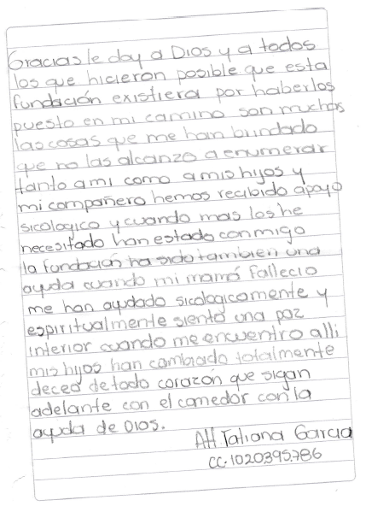
PHOTO GALLERY

HOLISTIC DEVELOPMENT

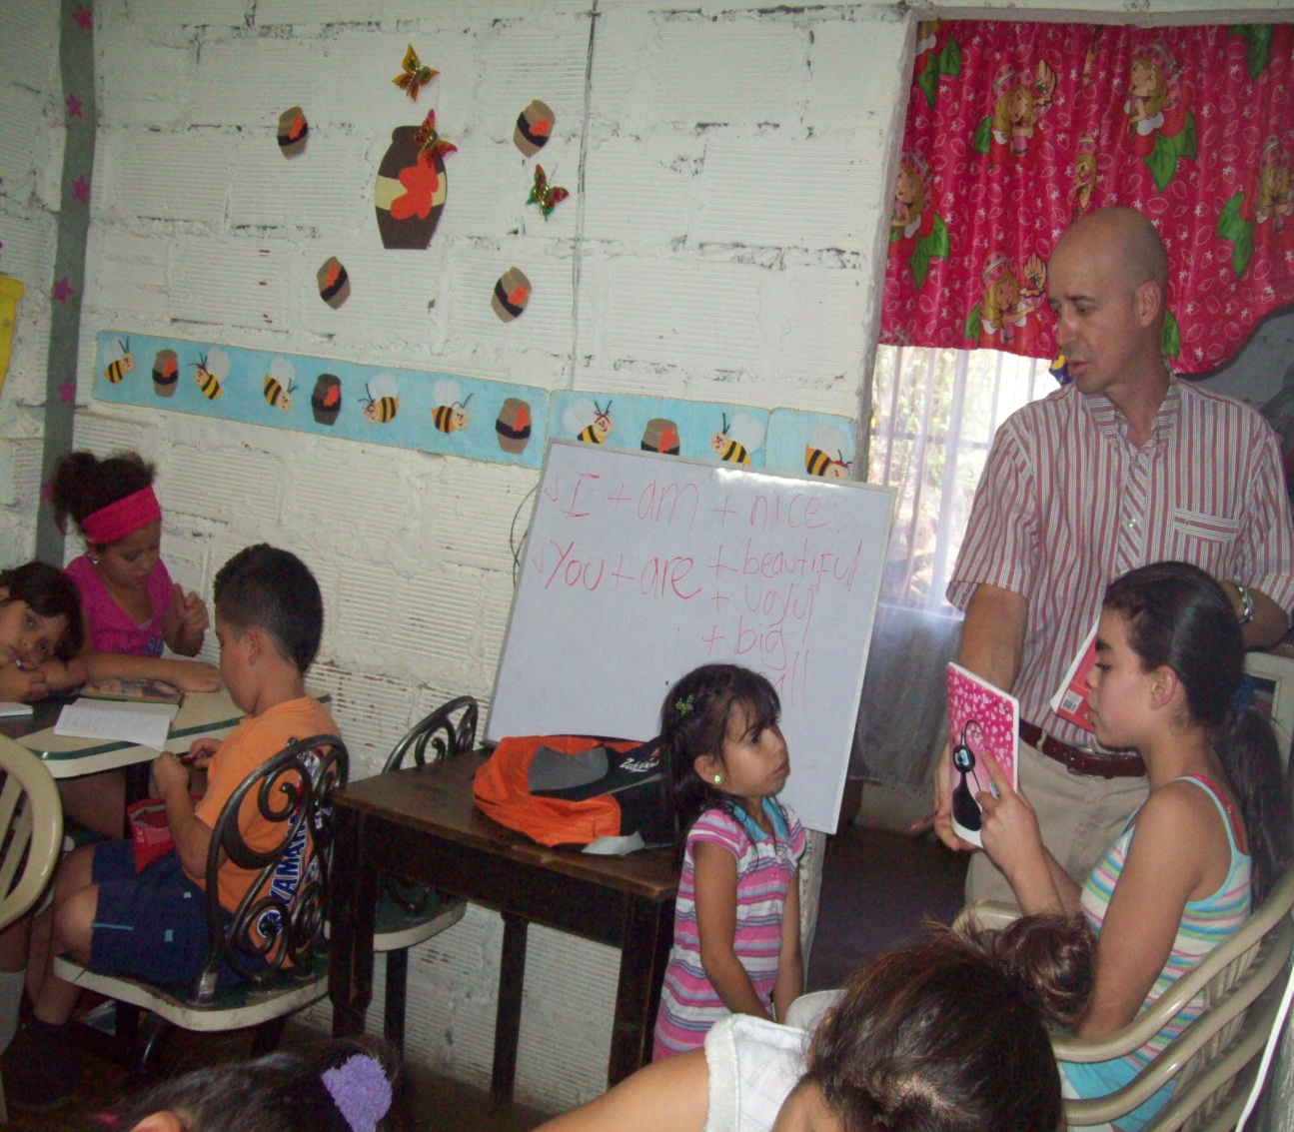

ENGLISH CLASSES
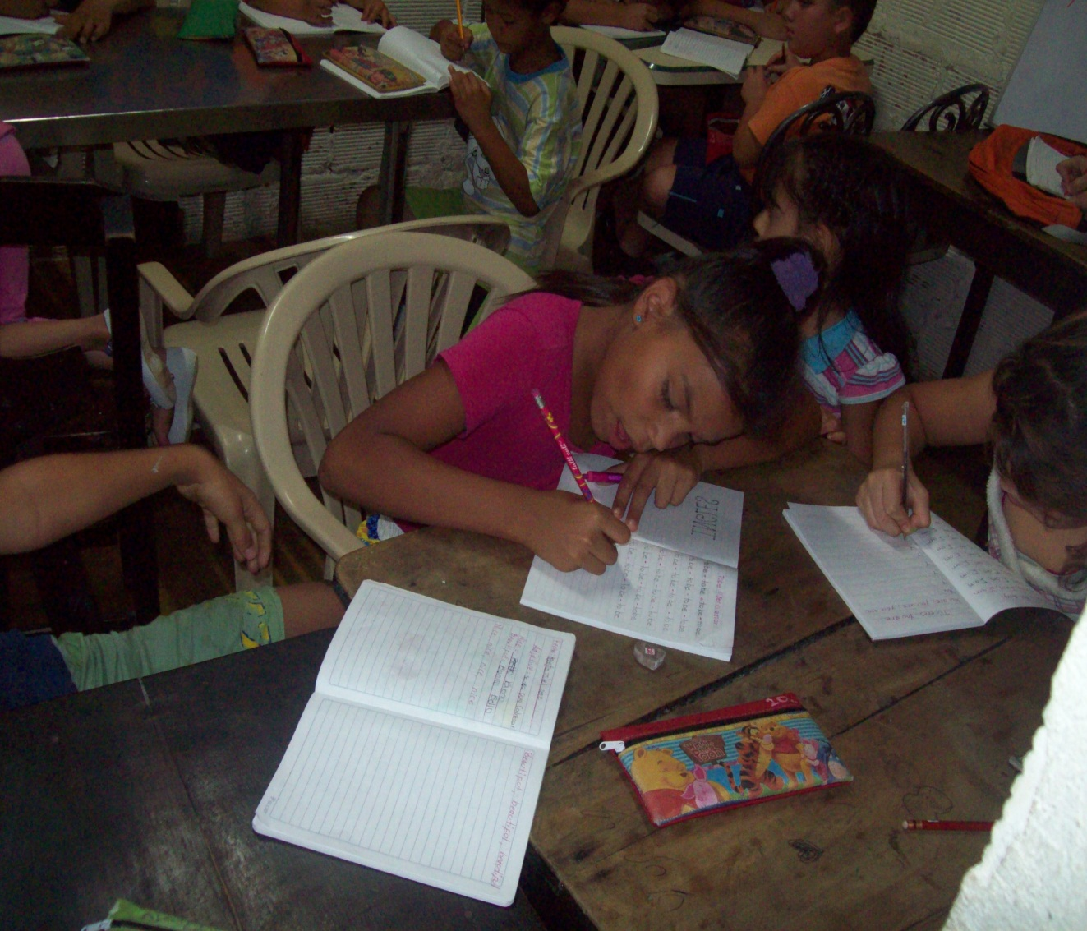

ACADEMIC TUTORING
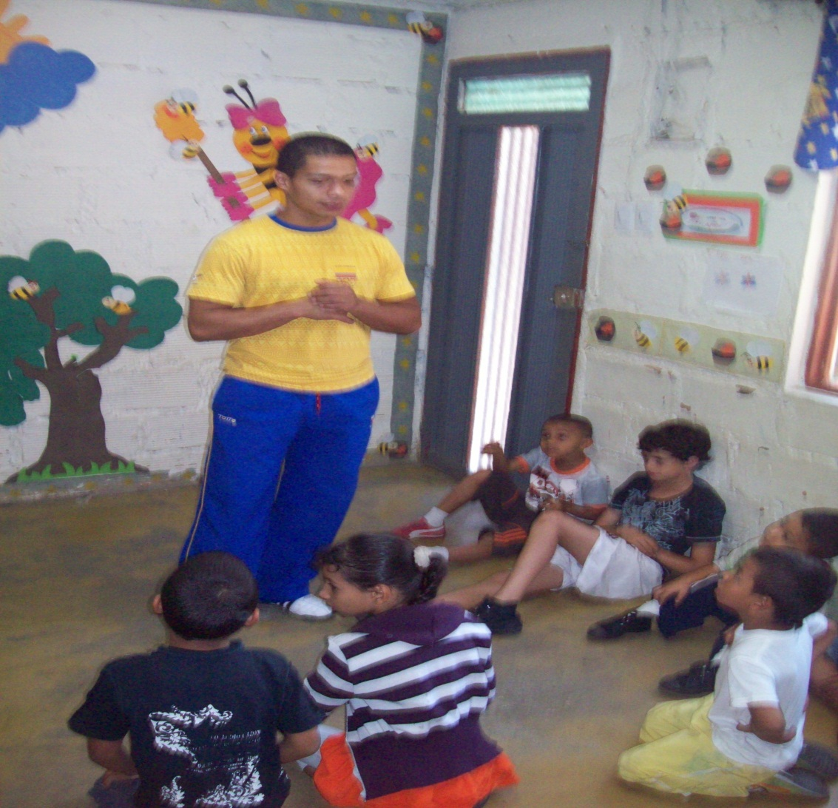

KARATE CLASSES

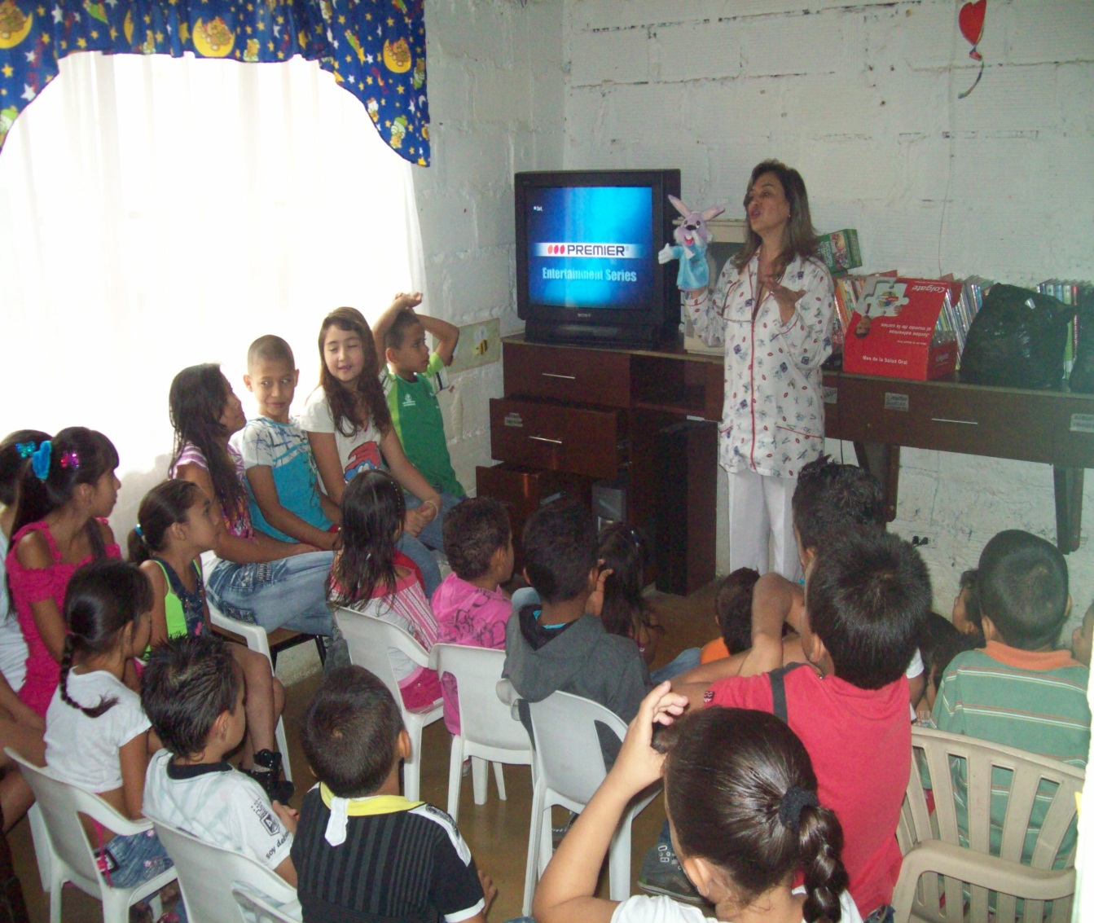

TALK ON ORAL HEALTH - COLGATE
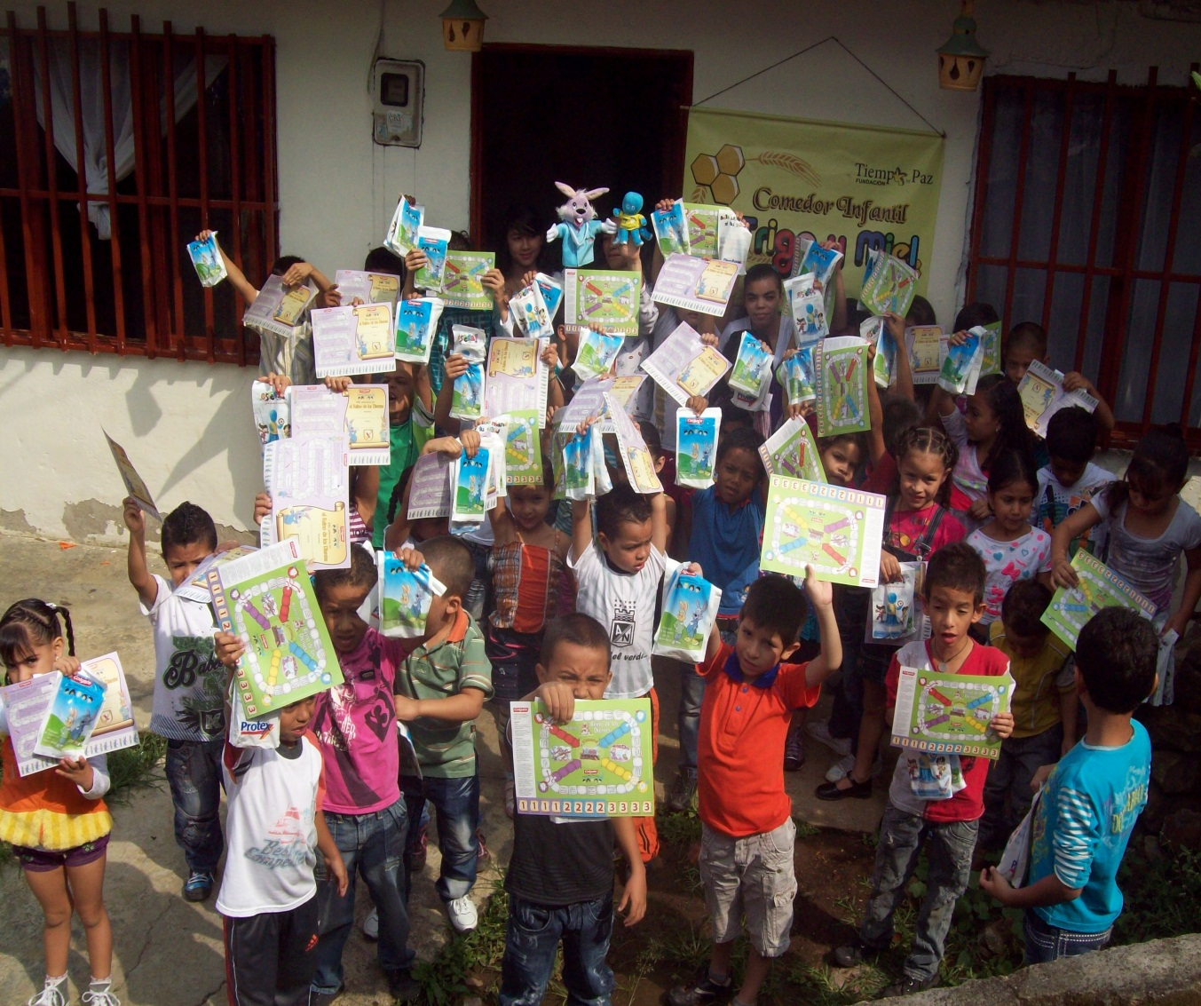

TALK ON ORAL HEALTH - COLGATE

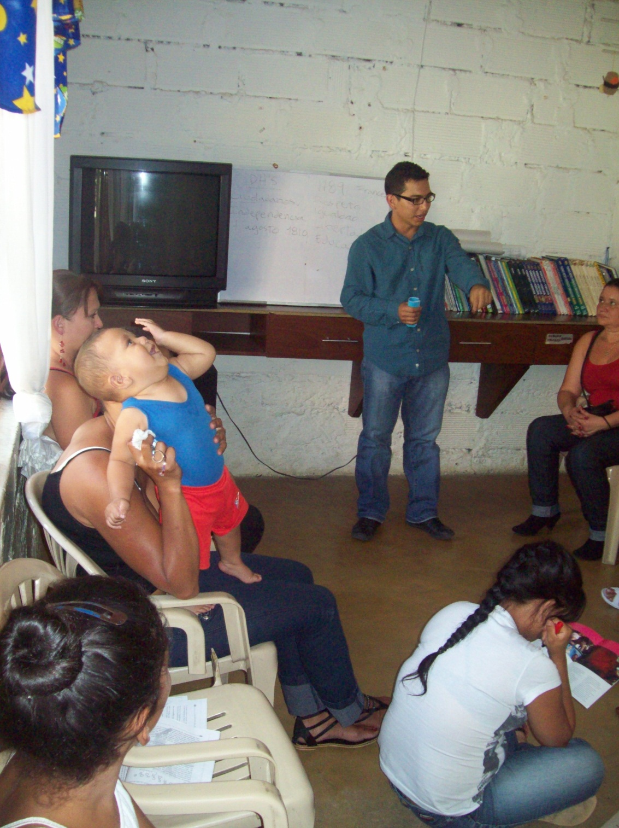

SCHOOL FOR PARENTS – HUMAN RIGHTS

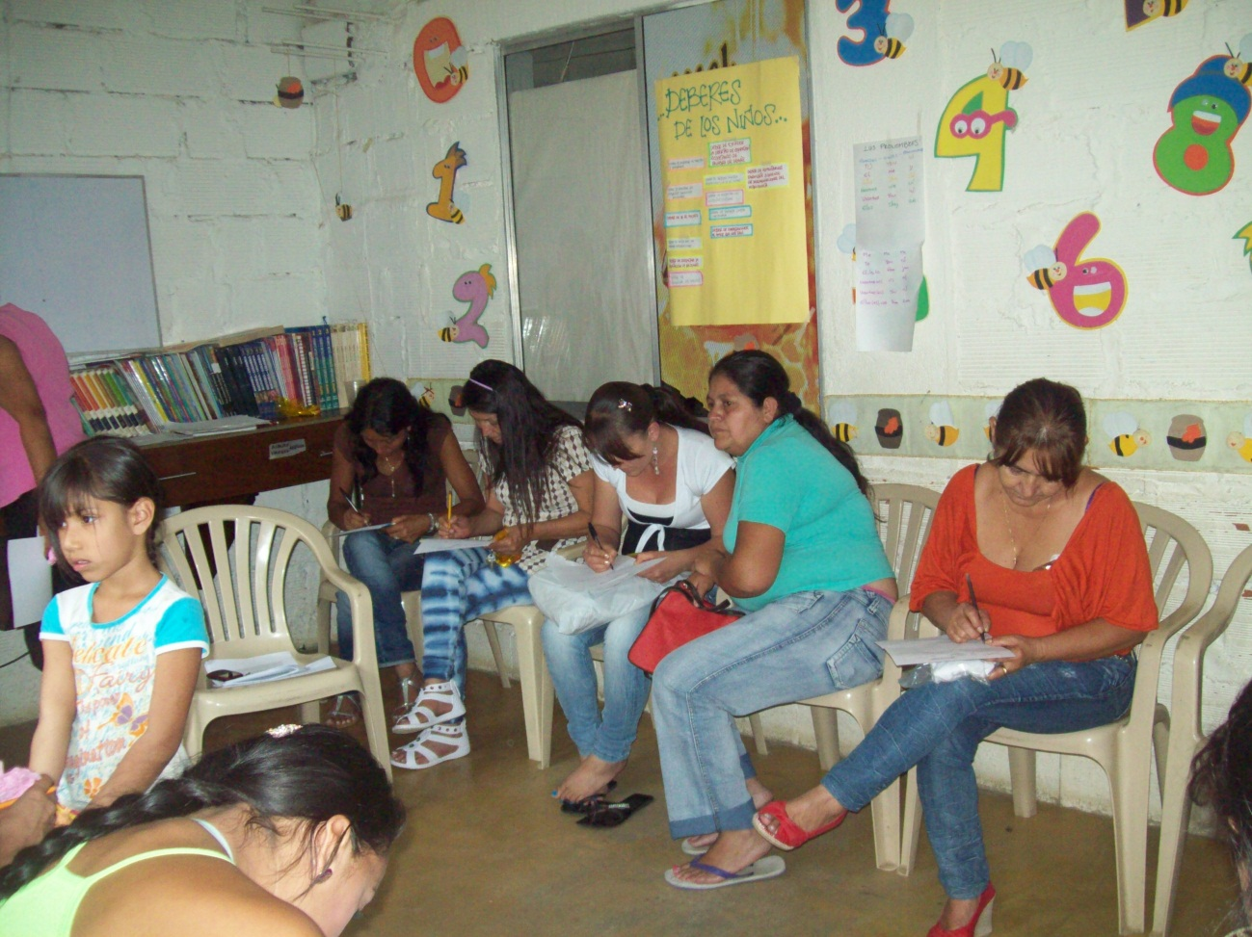

SCHOOL FOR PARENTS

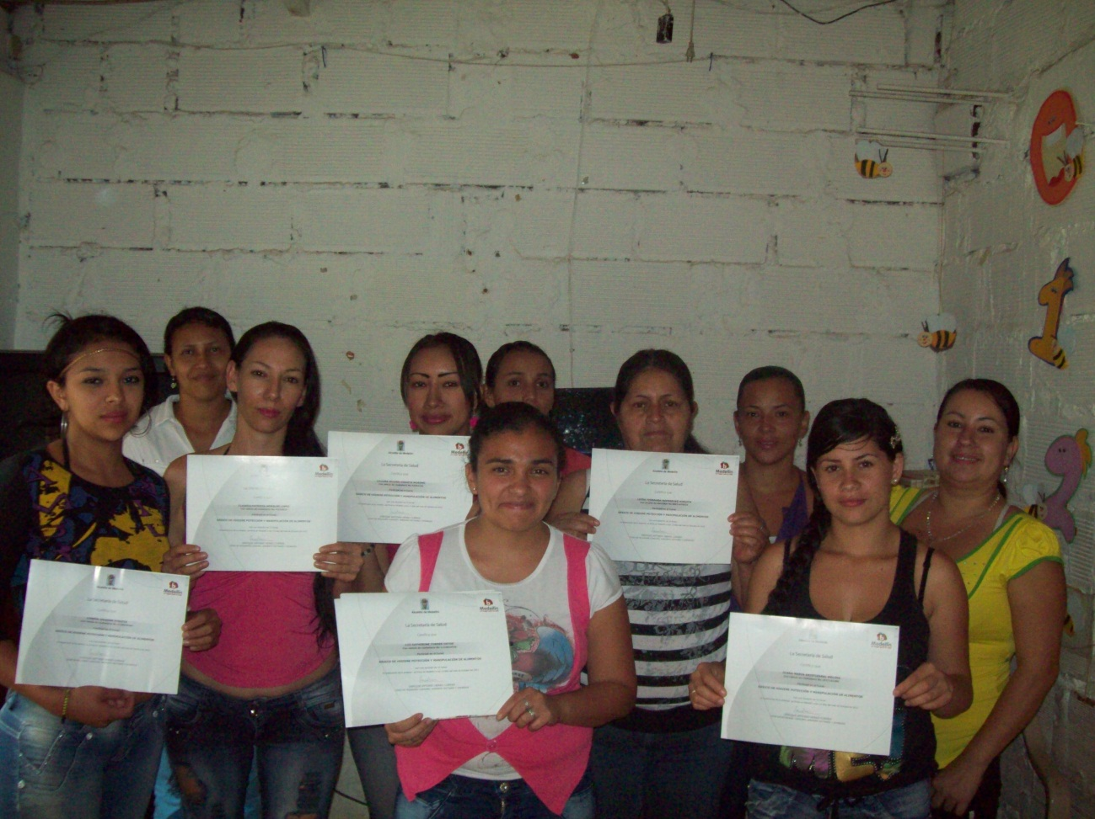

FOOD HANDLING FORMATION

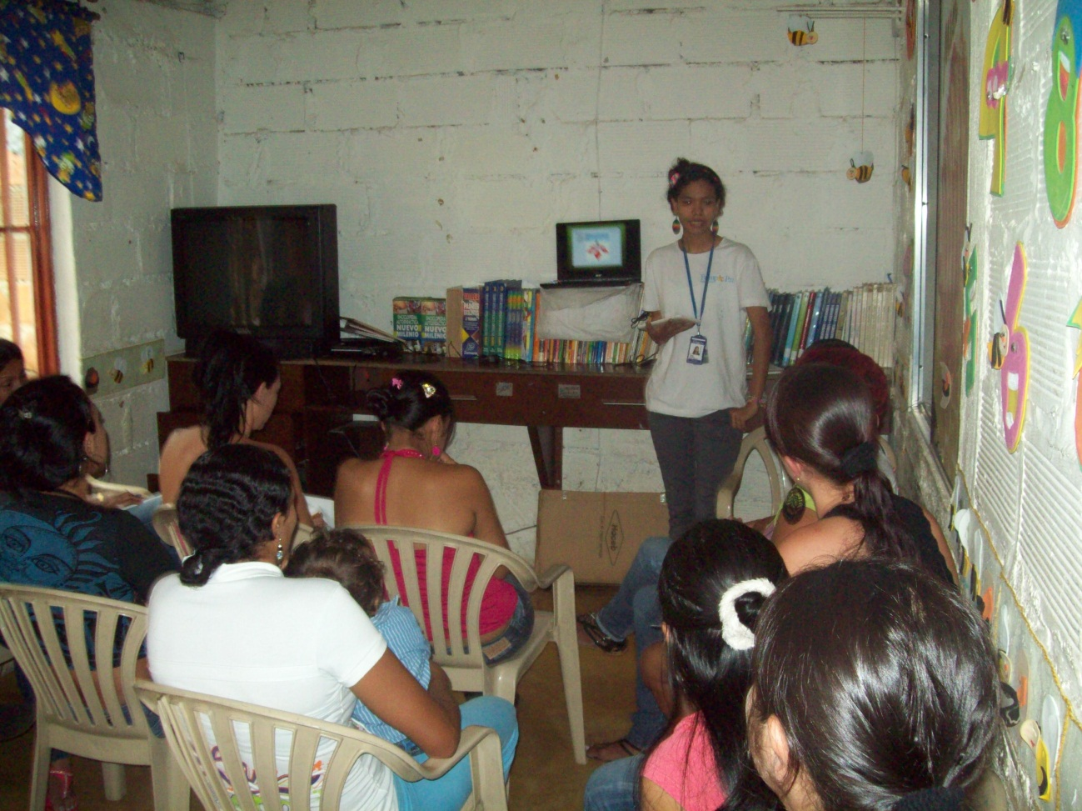

TALK ABOUT RAISING PATTERNS WITH THE PSYCHOLOGYST

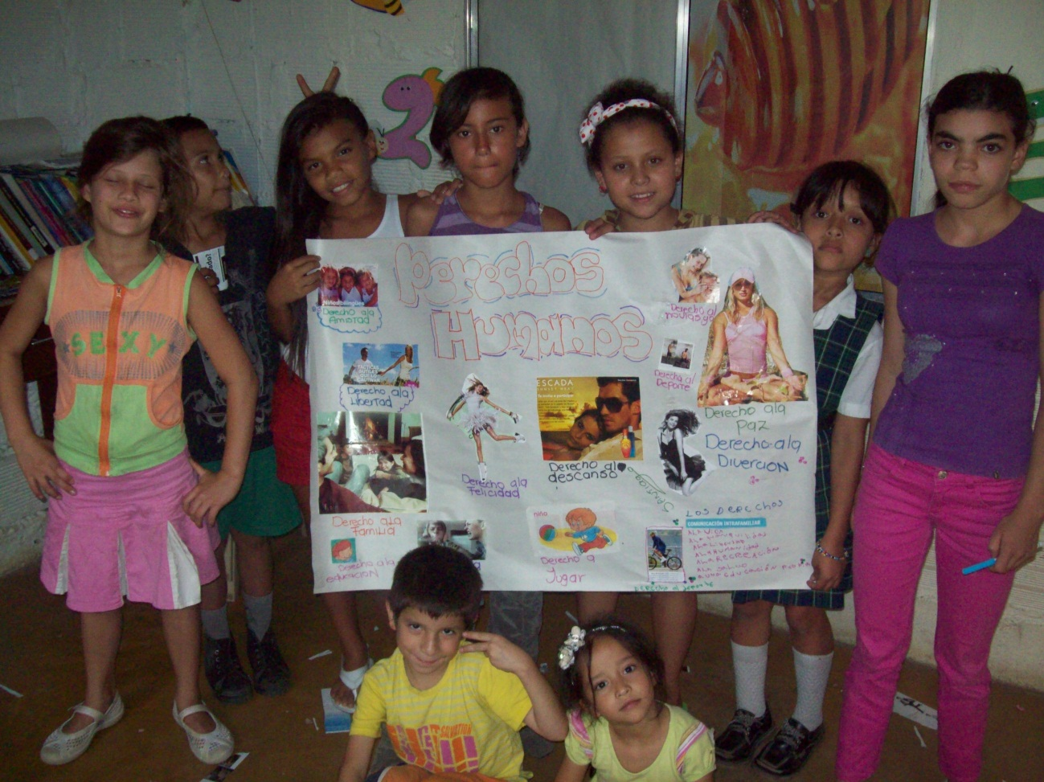

EDUCATION WORKSHOPS

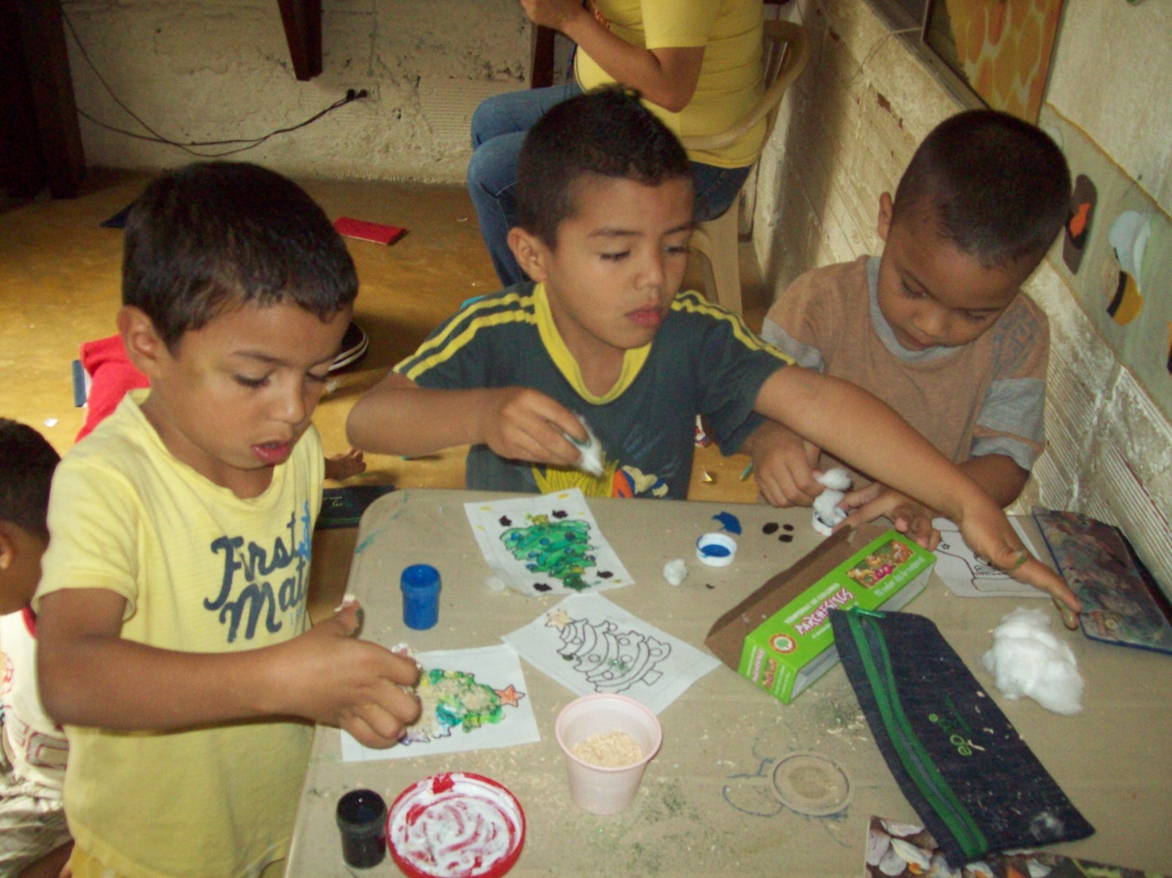

ARTS AND CRAFTS

LILIANA ISAZA MARIN
EXECUTIVE DIRECTOR
TIEMPO DE PAZ FOUNDATION

