TAHA

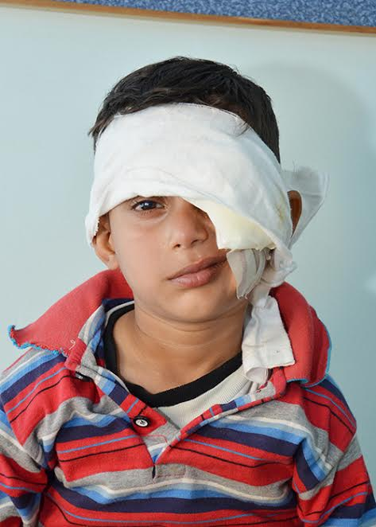

Name of Patient : M.Taha

Name of Father : M.Kashif

Age : 6 years

Address : Orangi Town Karachi

MR No. : 50161592655

Date of Operation : 04/03/2017

Surgery Performed : Left Eye penetrating Keratoplasty

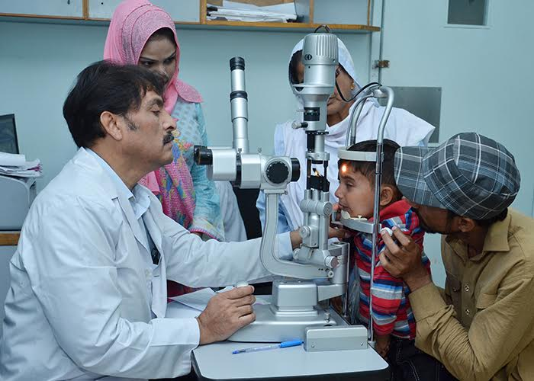
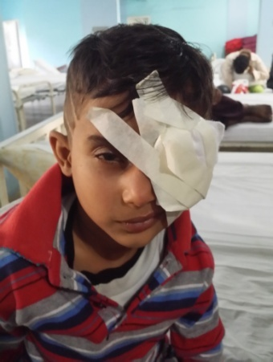

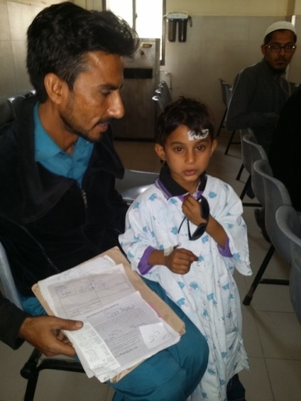
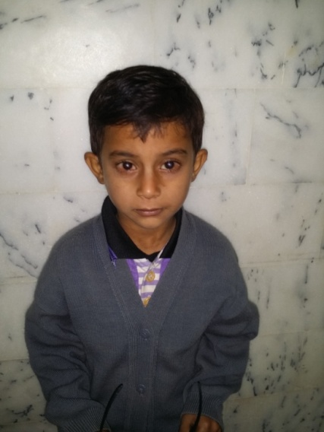

THANKS

