
Reaching High for the Wessex Haven:
The Matterhorn Challenge.

In August, five friends and I are climbing the Matterhorn to raise money for the breast cancer charity, “The Haven”. When I tell you that the group has a combined age of more than 300 years old, you can see that this is not an average Matterhorn team!
The team: Andrew Bentley, Kevin Bespolka, Will Hellier, Malcolm Le May, Andrew Wheeler and John Woodman,

This will be the most extreme challenge most of us have ever done. The Matterhorn has been described as “the most difficult climb that an ordinary person can do” – and we are all very ordinary people! Much of the ascent is rock and ice climbing, of which we have very limited experience. It is also a very steep and long climb requiring considerable stamina. As if that were not enough, you can see from the pictures that the terrain is very exposed, so we will have to deal with climbing with massive drops around us and at heights where altitude sickness is a real threat.

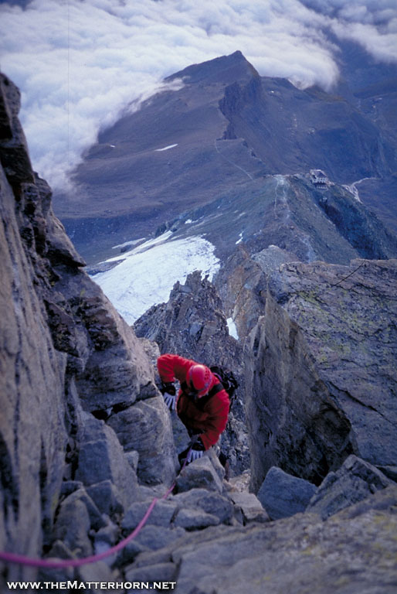
When we first mooted the idea of the climb at the end of last summer, I don’t think any of us realised what an immense task we were undertaking but, having just spent a week-end in Chamonix learning to rock-climb and scrambling with crampons and ice-axes on the Mont Blanc glacier, the reality is just sinking in. We are aware of the number of deaths on the mountain each year and will each have a guide on our climb. They say guides don’t lose people: it’s bad for business! However, our chances of success will also depend on our own individual fitness and stamina. You need to be very fit to cope with the 10 hours that it takes on average to climb to the summit and back down on the final day: much of it through snow that gets more treacherously slippery as the day wears on. Long-forgotten gym memberships are being revived and hours spent on rowing machines or bikes out on the road are beginning to pay dividends in the pursuit of our fitness goals.
At this point you are probably thinking we are all mad and asking why on earth we are doing this. The reason is that The Haven has undertaken to build a new centre in the Wessex Area and has launched its fund-raising with the slogan “Reach High for The Wessex Haven”. So, just as we are aiming to reach really high on our climb, we hope that, with your sponsorship, we will help The Haven to reach high in Wessex.
So why is The Haven worthy of all this effort and the sponsorship we hope you will give us? The Haven provides free one-to-one emotional and physical support and therapies to improve the lives of anyone affected by breast cancer. They also provide an invaluable opportunity for those with breast cancer to meet others going through the same experience in a nurturing and supportive environment. The Haven currently operates from three centres in London, Leeds and Hereford. These centres have been a tremendous success but are not accessible to the many sufferers who live elsewhere in the country. With an average of over 2,500 people being treated at any one time for breast cancer in the Wessex area and very little other “out of hospital services” to help them, this area shows obvious need. Sadly, we are all likely to know of someone close to us who has suffered breast cancer and we think that a Haven in Wessex would provide a valuable resource to ensure that they do not have to suffer alone.

We know that you, like us, get many requests for sponsorship but we very much hope that you will recognise the importance of our cause and the effort we are all putting in and will feel able to support us. If so, one day quite soon, we hope you will be able to see something positive coming from your donations: a Haven in Wessex and the good that it is doing. As we are all sending out our own letters, there will inevitably be some overlaps and I apologise if you get more than one copy.

We have set up a just-giving site www.justgiving.com/matterhornchallenge which you can use if you would like to help. Alternatively send a cheque made payable to the Wessex Haven Appeal to the following address:

For those in the US, the website is
http://www.globalgiving.org/microprojects/new-haven-centre-for-breast-cancer-in-hampshire/?utm_content=Your%20project%20has%20been%20approved%21&utm_campaign=project-approved&utm_source=email2.globalgiving.org&utm_term=info%40thehaven.org.uk&utm_medium=ema
Please ignore the total target that is listed there: that is just the default that they use and we intend to raise much more!

Thank-you for taking the time to read this and for your support,

