Vidya Poshak Updates & Achievers Profiles
Report for 2013-14 Academic year
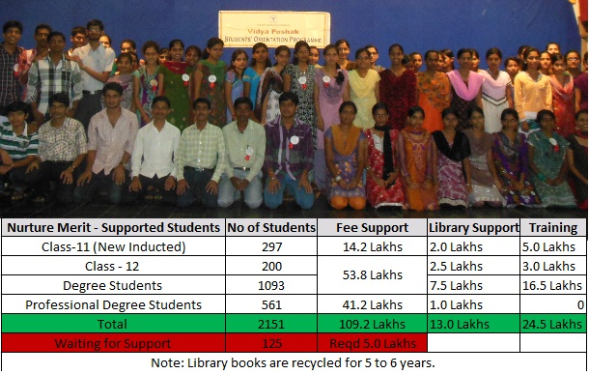
 | 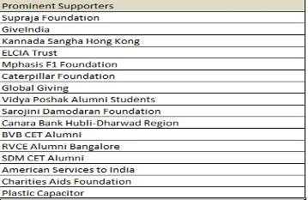  More than 500 Individual donors supported for Vidya Poshak mission during the year 2013.  102 Vidya Poshak Alumni students supported with donations worth 5.02 Lakhs.  We thank 130 Global Giving donors for your support worth $7832. Link: http://www.globalgiving.org/projects/nurturemerit/  Through GiveIndia we have received more than 200 donations during the year 2013. http://www.giveindia.org/m-130-Vidya-Poshak.aspx
  
  Movie Star Puneet talks about VP
  http://www.youtube.com/watch?v=5VcH4jhcsd4
  Camp Video : http://www.youtube.com/watch?v=i6q4FtlQ26k
  Student Video Aishwarya : http://www.youtube.com/watch?v=ZK07cqWJMsQ
  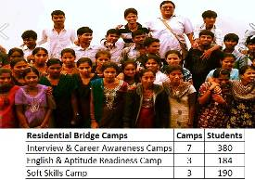
Achievers 2013
  Student Name: Santosh Talvar | 
  VP ID No: BK-533-09-10
  Academic %: 80.97
  Class& Stream: BBA-II
  Secured 1st Rank to his College.
  Student Name: Raju H Haggada | 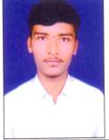
  VP ID No: BJ-343-09-10
  Academic %: 69
  Class& Stream:
  Selected as a Village Accountant by Govt. of Karnataka.
  Student Name: Kamappa B | 
  VP ID No: BJ-270-08-09
  Academic %: 82
  Class& Stream: BA-III
  Selected in Indian Air force.
  Student Name: Kanchana V | 
  VP ID No: BJ-349-09-10
  Academic %: 9.2 CGPA
  Class& Stream: B.E-IV E&C
  Placed in "Toshiba" with the package of 4.0 Lakhs
  Name: Pavitra U Bhat | 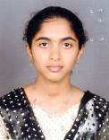
  VP ID No: SM-275-11-12
  Academic %: 97.50
  Class& Stream: PUC II Year
  Passed Common Preparatory Test (An exam of charted accountancy) with the marks of 156 out of 200
  Name: Bailbasappa B | 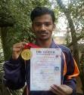
  VP ID No: DW 928-10-11
  Class& Stream: B.A-II
  Scored: 85
  S.K. Arts and Science College, Hubli
  Yoga Championship Got first prize & Bagged Gold medal .
  Name: Chetankumar C S | 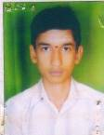
  VP ID No: DVN-045-10-11
  Academic %: 90
  Class& Stream: BE-II (E&C)
  Secured State level 2nd rank in diploma CET-2012-13.
  Name: Sandeep S Hegde | 
  VP ID No: UK-1390-11-12
  Academic %: 94.33
  Class& Stream: PUC II Year, Science
  Secured State level 175th in Medical in Karnataka CET-2012-13.
  Name: Ms. Priya Kabadagi | 
  VP ID No: BM-558-07-08
  Selected for IIT Chennai . She secured 410 All India Rank in JAT (Joint Admission Test) and she joined M.Sc Mathematics.
  Name: Santosh S Bhat | 
  VP ID No: UK-1391-11-12
  Academic %: 94.33
  Cleared Common Preparatory Test (An exam of charted accountancy) with the marks of 141 out of 200
  Name: Bhagyashree R | 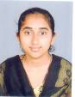
  VP ID No: UK-892-09-10
  Academic %: 88.83
  Class B.Com-III, Commerce
  Passed IPCCE(An exam of charted accountancy) with the marks of 156 out of 200
  Student Name: Ganesh S Bhat | 
  VP ID No: UK-1336-10-11
  Academic %: 95.83
  Class B.Com-II, Commerce
  Passed IPCCE(An exam of charted accountancy) with the marks of 156 out of 200
  Student Name: Amrut Sungar | 
  VP ID No : DW-924-10-11
  Scored: Diploma 89%
  Class& Stream: B.E-II (Civil)
  Bagged 7th Rank in Diploma CET Examination
  Name: Vittal B. Mathare | 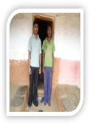
  VP ID No: DW-890-10-11
  Scored : 88%
  Class& Stream: B.Com-II
  IPCC(CA Intermediate Exam) 1 group pass with 213 marks
  Name: Miss.Pooja Joshi | 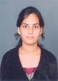
  VP ID No: BM-893-09-10
  Academic %: 91.86 in 4th sem BCA
  first to College (GSS college,Belgaum)in the examination which was held in the month of April -2013.
  Name: Ms.Chaitra N Hegde | 
  VP ID No: UK-1515-12-13
  Academic %: 98.00
  Class: PUC I Year, Science
  Secured 1st rank to her college

