dream seminar / drömseminarium

TABLE OF CONTENTS

PROJECT DESCRIPTION PAGE 2

FINANCIAL SUPPORT & PROJECT PAGE 7
BUDGET

COMPANION STAR ORGANIZATIONAL PAGE 8
BACKGROUND

GENERAL OPERATING BUDGET PAGE 9

TAX DETERMINATION LETTER PAGE 11

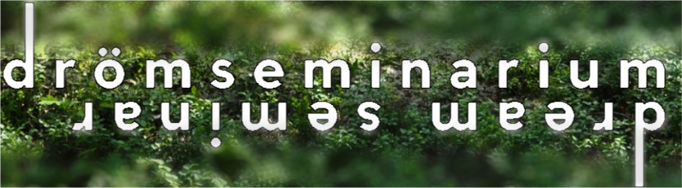

dream seminar / drömseminarium: An Overview of the Project

Fyra miljarder människor på jorden. Och alla sover, alla drömmer.
Four thousand million on earth. They all sleep, they all dream.
-- Tomas Tranströmer,
Drömseminarium

Nordic / American Opera
Nine of Nobel laureate Tomas Tranströmer's poems serve as the foundation of dream seminar / drömseminarium—a devised music theatre piece created by 47 artists from 9 countries through collaboration and improvisation.
The premiere is scheduled at the Gateway Theater, February 2016

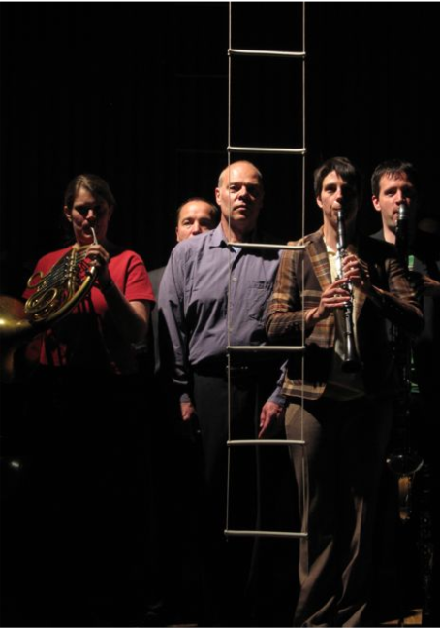
dream seminar / drömseminarium is far more than a musical setting of Tranströmer’s potent texts. It is the result of a cumulative collaboration; an intimate creative process that developed what might have been a singular perspective on the poetry into a multi-cultural, collective response. All of the artists have contributed their own voices in the form of raw creative material that has been composed and musically shaped by composer Ellen Lindquist, with a scenario created by stage director Pat Diamond and soprano Kathleen Flynn. The result is a fluid, non-linear music theatre work in which myriad musical voices mirror the multiple perspectives of the poems.

The piece and the process which created it are an exploration of artists struggling with their own humanity and creative paths. It is a reflection of how we make our way through the forest of life, and how we use our imaginations to shape and alter the landscape surrounding us. In performance, we take the audience with us on that journey.

Audio Clips / Video Clips
Audio clips from dream seminar / drömseminarium are at the following link:
http://www.dreamseminar.org/dreamfly/audio.html

A score is at http://www.dreamseminar.org/dreamfly/scores.html

Corresponding tags in the score for the musical clips:

Flygblad: Flygblad page 8, m. 81-end
Eldklotter: Eldklotter page 11, m. 142-154
Minnena ser mig: Minnena ser mig page 21, 4 sec before reh. P-end
Lamento: Lamento page 5, m. 100-reh. H
Madrigal: Madrigal page 1, 14 seconds before reh. A-reh. D
Längre in, Clip 1: Lamento page 7, 6 seconds before Längre in-reh. F
Längre in, Clip 2: Längre in page 16, just after reh. I-end
Romanska Bågar: Romanska Bågar page 1-end

Four video clips from workshop performances and rehearsals are at the following links:

Flygblad Clip:
https://www.youtube.com/watch?v=mLTHB7CHgMY
Madrigal Clip: http://vimeo.com/user8104370/review/69507062/d052a68740 Lamento/ Lament Clip: http://vimeo.com/user8104370/review/69522035/52b8fbda41 Preludier (II)/ Preludes (II) In Studio Rehearsal: http://www.youtube.com/watch?v=c3DcDDyYuWY

Development History

The world premiere of dream seminar / drömseminarium is planned for February 2016 at the Gateway Theater in Bellport, NY. There have been multiple work-in-progress performances throughout the development of this piece over the, including a concert reading of the full score (August 31 and September 1, 2011 at the Secret Theatre in New York). Six in-depth development workshops, three in Sweden and three in the USA have been held since 2007. All of the workshops culminated in work-in-progress performances; in 3 of these the audience participated in an improvisation that influenced the final piece.

For the complete performance history of dream seminar / drömseminarium, please see the following link: http://www.dreamseminar.org/dreamabout/dreamtime.html

Ensemble
dream seminar / drömseminarium will be premiered by an ensemble of 14 musicians; 12 instrumentalists and 2 vocalists.

Artists Bios here: http://www.dreamseminar.org/dreamcreators/dreamcreators.html

dream seminar / drömseminarium Contributing Artists

Composer: Ellen Lindquist (Norway/USA)
Poet: Tomas Tranströmer (Sweden)
Scenario: Patrick Diamond (USA) & Kathleen Flynn (Canada)
Stage Director: Patrick Diamond (USA), Ted Altschuler (USA)
Stage Manager: Ashley J. Pollard (USA), Marci Skolnick (USA), Katya Kjellbau (USA)
Set Designer: Henny Linn Kjellberg (Sweden)
Music Director: Timothy G. Long (USA), Gregory Oh (Canada)
Lighting Designers: Helena Kuukka (Finland), Torkel Skjærven (Norway)
Movement: Helena Högberg (Sweden), Lotta Gahrton (Sweden), Micke Strid (Sweden), Kate Alton (Canada)
Videographer: S. Katy Tucker (USA), Keja Stenström (Sweden), Brian M. Hedden (USA)
Costume Design: Tove Bergund (Sweden), Camille Assaf (France)
Flute: Malin Trast (Sweden), Erin Lesser (Canada)
Oboe: Laura Karney (USA)
Clarinet: Christa Van Alstine (Canada), Robert Ek (Sweden)
Horn: Nathan Koci (USA), Angela Wilmot (USA)
Trombone: Oscar Utterström (Sweden), Benjamin Lanz (USA)
Viola: Eva Fahlén (Sweden), David Marks (USA)
Violin: Aaron Packard (USA)
Cello: Christian Sahlin (Sweden), Will Martina (Australia), Fanny Bray (France), Ariana Falk (USA)
Bass: Emma Nyberg (Finland), Felix Pastor (Spain)
Harp: Nicolas Tulliez (France)
Piano: Timothy G. Long (USA), Staffan Sandström (Sweden), Laura Barger (USA)
Percussion: Michael McCurdy (USA)
Soprano Vocalist: Kathleen Flynn (Canada), Rebecca Højlund (Denmark)
Bass Vocalist: Michael Douglas Jones (USA)

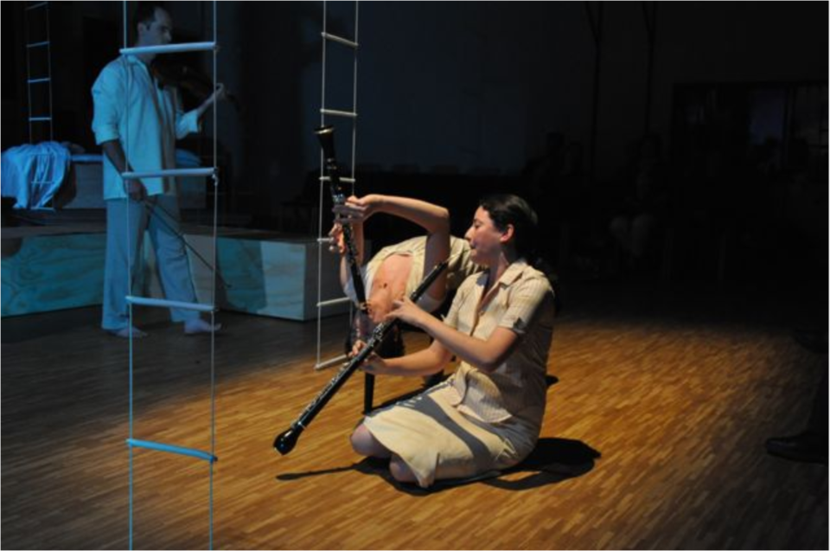

Our Approach and the Results

drömseminarium / dream seminar is created by artists of many disciplines, through an exchange of individual perspectives in a non-hierarchical environment. We came together for a series of development workshops: we began with a small workshop in 2006 with 5 of us, and this work developed into 6 in-depth workshops from 2007-2011. The piece grew out of a series of musical, dramatic and physical improvisations undertaken in these workshops. These improvisations started with Tranströmer’s words and were aided by musical material from the composer. Our non-hierarchical, process-oriented approach amplified his poetry, incorporated the contributions of everyone in the room, and allowed the work to emerge and take shape organically. Tranströmer has referred to this piece as a new translation of his work.
Videotaping and recording our work captured creative moments, which we used to further shape the process. The length of time spent on this project has allowed us to harvest the richest of these moments, and has allowed the ensemble time to digest the process and develop the material we generated together.

As a result of these factors, our piece is structured in a number of unexpected ways. For example:
- the instrumentalists perform and physically interact with each other and the singers onstage, and are vital parts of the narrative. They play, dance/move, speak, and sing.
- The piece is un-conducted. An un-conducted performance shifts the focus away from a central point in front of the stage and onto the interaction between players. It requires a larger commitment to learning the music from each player on the stage.
- Our scenic designer and composer have created special instruments out of porcelain, which are part of the visual life of the piece.

Scenario: Setting, Characters, and Movements

Setting:
dream seminar / drömseminarium traces a day in the life of a writer (Mats) living in Stockholm. He is searching for inspiration through his memory and dreams, and embarks on an involuntary quest. Events are sparked by his environment: the weather, the time of day, a photograph. As time unfolds over the course of an early summer’s day in Mats’ house, we are transported to different seasons, locations and events, and the characters that populate his memories and imagination.

Characters:
Mats (Bass): A middle-aged man living in suburban Stockholm; a writer searching his memory and dreams for inspiration.

Frida (Soprano): Memory. A spirit associated with water that is haunting Mats’ memory; his great, lost soulmate.

Matyas (Violin): Mats’ imagination. An old-fashioned farmer-type, wearing his Sunday best. He is from days gone by. Associates with Tricksters.

Matico (Clarinet/Bass Clarinet): Mats’ desire and need. Dressed in bowler hat and nicely tailored clothing - very modern, very tasteful. Associates with Tricksters.

Mattea (Clarinet): Mats’ intellect – logic and thought. Dressed comfortably in sky blue. Associates with the Guides (Adana and Raphaela).

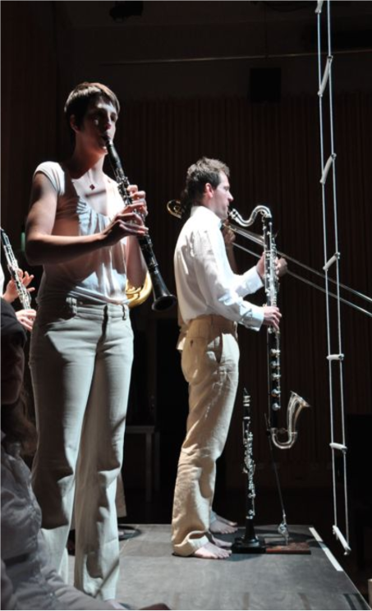
Tricksters, Guides, Watchers & Guardians: from Frida’s world. Each helps and hinders Mats’ in a different way, shaking up the world and memories in which he lives.

Tricksters:
Mab (Flute): the most playful.
Oli (Harp): the farthest-reaching. Storm (Percussion): the brashest, who summons conflict and change.

Guides:
Adana (Piano): of the Earth. A calming spirit who cannot be denied, who gently and consistently moves things forward.
Raphaela (Oboe/English Horn): of the Air. An angel, a nightingale, a healing spirit who lightens the load.

Watchers:
Helio (Horn): the illuminating Sun, lighting up the world, at turns brilliantly and passively.
Badr (Trombone): the obscuring Moon, isolating, slowing, plunging the world into dreams; a lone figure.

Guardians:
The Lovers (Cello & Bass): Mats’ guardians, who sometimes act as barriers.

Movements/Poems:
- Minnena Ser Mig | Memories Look at Me
Mats reluctantly awakens in a dream world populated by his memories, desires, and impulses. He examines them.
- Eldklotter | Fire-Jottings
Sparked by a photo next to Mats' bed, Mats and Frida reconnect and reminisce.
- Lamento | Lament
Mats is inspired to write, but his creativity withers when confronted by more memories.
- Längre in | Further In
Mats straddles two worlds – the outer, “real” world of traffic hustle, and the inner world of the forest and imagination.
- Preludier (II) | Preludes (II)
Although inspired by his dreams, Mats resists facing his true feelings.
- Flygblad | Leaflet
Forced to see himself, Mats rails at the world, life and fate.
- Romanska Bågar | Romanesque Arches
Mats comes to appreciate and embrace his faults.
- Madrigal | Madrigal
Mats begins to see and celebrate the possibilities open to him.
- Näktergalen i Badelunda | The Nightingale in Badelunda
Mats returns to bed and dreams, finding peace.

Financial Support

Development support has totaled $327,000. Contributors include: American Music Center, American-Scandinavian Foundation, American Swedish Institute, Bellport Restaurant, Mary Duke Biddle Foundation, Ernie Canadeo of The EGC Group, Kultur i Länet Uppsala Län, Landstinget Västmanland, Länsstyrelsen Västmanlands Län, Mälardalens högskola, New York State Council on the Arts, Barbro Osher Pro Suecia Foundation, Sparbanksstiftelsen Nya, Stony Brook University Department of Music, Västmanlandsmusiken, Västerås stad, and many generous individuals. A detailed budget and funding plan for the world premiere of dream seminar / drömseminarium February 2016 at the Gateway Theatre, Bellport NY, is as follows:

dream seminar/drömseminarium
Gateway Theatre Premiere 2016
Budget
Travel & Per Diems/Board | $58,800
Artist & Design Fees | $113,000
Lodging & Theater Rental | $112,500
Video, Film & Sound | $20,000
Set & Costumes | $45,800
Transportation | $7,690
Insurance | $2,850
Printing & Administration | $10,420
Marketing | $6,750
Publicity | $5,000
Instrument/Lighting/Equip Rental | $14,850
Technicians | $4,800
Bank Charges/Wires and Transfers | $650
Cargo | $540
Literary Rights/Royalties/Fees | $10,950
Documentation | $2,400
Total | $417,000
Funding Support
Funding Support Committed:
Gateway Theater | $87,500
Online Fundraising | $15,000
Private Donations | $48,000
Funding Support Pending:
New Music USA | $15,000
Knapp Swezey FDN | $25,000
Barbro Osher Pro Suecia FDN | $80,000
Sparkplug FDN | $10,000
Bloomberg Philanthropies | $20,000
Geoffrey Hughes FDN | $15,000
Kalliopeia FDN | $10,000
NEA Challenge America Grant | $10,000
Agler Rice FDN | $3,000
Solow FDN | $5,000
BMI-Rupp FDN | $3,500
Swedish Culture Council | $15,000
Nordic Culture Point | $15,000
Global Giving.org | $17,500
Projected Ticket Sales | $22,500
Total | $417,000

Companion Star Organizational Background

Companion Star was incorporated in NY State in August 2005. We have produced 2 major productions, including the multi-nominated, critically acclaimed Under Milk Wood, an opera. We have produced 25 public concerts of new music in Europe and the USA. Our performance projects typically range 6-8 years from beginning to completion. This length of process is crucial for the research and development of our work.
Federal ID # 56-2535118. United States Internal Revenue Service recognition as a nonprofit tax exempt organization with 501(C) 3 status in August 2007; State of New York Attorney General’s office NY Charities registration # 40-13-60.

Mission

To create, produce and present new music theatre works and opera.

Philosophy and Method

Companion Star creates, produces, and presents new opera and music theatre using a collaborative process. Every facet of a production, from initiation to completion, is shaped by the ideas that arise from the collective work of all members of the collaborative; each project evolves and emerges organically through this process. Our goal is to create pieces of the 21st century which reflect the diversity of our world.

We are particularly interested in the ways material for new work can be developed through improvisation by experienced artists from all kinds of mediums, and we are interested in the ways in which the outstanding moments which come from improvisation can be set in scored music so their magic is not only retained, but developed and enhanced. Those sparks of creativity are our starting points and foundation of our living laboratory for the creative process.

Programming

Moo, Squeal & Scratch: in the garden of shadows (completed 2007)
A performance art piece based on ancient Persian poetry with music by American composers Haleh Abghari and Ben Kreith (scored for narrator, soprano, violin, percussion and bass). This piece explores the popular and classical musical traditions of Europe,
America and the Middle East, combined with the theatrical traditions of story-telling, narration and singing. Premiere at NY Chelsea Art Museum August 2006; performed at the Stone, October 2007.

Under Milk Wood (completed 2014)
A co-production with the Taliesin Arts Centre in Wales and Le Chien qui chante in Montréal of Welsh composer John Metcalf’s seventh opera, Under Milk Wood. Based on the literary classic of the same name by Dylan Thomas this piece features a live radio broadcast setting complete with “foley” artists and recorded sounds. This project toured 4 cities in Wales and played for 7 performances to sell out houses and great critical acclaim. It is the third collaboration of Companion Star’s Founder & Director Michael Douglas Jones, Composer John Metcalf and Stage Director Keith Turnbull. Premiere Wales 2014, NY Premiere in 2017.

Current Projects
dreamseminar / drömseminarium: Nine of 2011 Nobel laureate Tomas Tranströmer's poems serve as the foundation of this piece—a devised music theatre work created by 47 artists from 9 countries through collaboration and improvisation. It is the result of a cumulative collaboration; an intimate creative process that developed what might have been a singular perspective on Tranströmer’s poetry into a multi-cultural, collective response. All of the artists have contributed their voices in the form of raw creative material that has been shaped musically by composer Ellen Lindquist, with a scenario created by stage director Pat Diamond and soprano Kathleen Flynn. The result is a fluid, non-linear music theatre work in which myriad musical voices mirror the multiple perspectives of the poems. The premiere is scheduled at the Gateway Theater, February 2016

Odin: A collaboration with environmental activist/composer/ percussionist Donald Knaack. A cross cultural collaboration comingling spoken word, hip hop and opera; 13 players in a percussion ensemble play instruments constructed entirely from recycled materials. Based on the myth of Odin the God of war and knowledge, we see the devastation of today’s world through the lens of Odin’s struggle for power and control.

The Illumination Initiative: Companion Star operates a performing arts educational program for emerging and professional artists. These workshops introduce our unique collaborative improvisational process, built on the philosophy of our creations for the stage.

Demographics
We operate in local and international communities of diverse ethnicities, incomes, ages and sizes. We’ve performed at the Gateway Theatre, Bellport, NY; the Stone Theatre, Chelsea Art Museum, Tenri Cultural Institute, and National Opera Center, New York, NY; Västerås konserthus, Ängso Castle, and Wiks Castle in Sweden; Taliesin Arts Centre, Aberystwythe Performing Arts Centre, Caernarfon Theatre, and Sherman Theatre, Wales. Discounted tickets are available to all students and seniors within the communities where we perform.

Companion Star Budget
 | 2014 | 2015
 | Expenses  (Actual) | Expenses  (Projected)
Salaries | $0 | $15,000
Office Rent | $9,000 | $9,000
Utilities | $1,319 | $1,319
Office Supplies | $245 | $1,000
Printng | $1,018 | $1,800
Postage | $635 | $1,200
Meals/ Entertainment | $43 | $1,500
Travel | $9 | $500
Programming | $10,472 | $24,000
Fundraising Events | $0 | $6,000
Banking Fees | $144 | $750
Fees/Dues/Subcriptions | $285 | $450
Website | $3,720 | $3,000
Bookkeeping Fees | $296 | $400
Seminars | $300 | $600
TOTAL | $27,486 | $66,519
 | Income  (Actual) | Income  (Projected)
Wales Arts International |  | $5,000
Taliesin Arts Centre | $8,917 | $2,400
Welsh Government |  | $1,650
Individual Donors | $4,000 | $45,000
Mayer, Ross, Hagan | $9,000 | $9,000
Website Master | $3,720 | $3,000
Foundations | $11,383 | $160,000
Revenue | $46 | $800
Interest Income | $19 | $65
TOTAL | $37,085 | $226,915
Companion Star's 2014 IRS 990 will reflect the figures shown above. However, in 2014 we co-produced Under Milk Wood: an opera in Wales. The section below contains our production budget. Companion Star was actively engaged in grant writing, fund raising, budgeting, and managing the project; however, these funds were raised, managed and disbursed in the UK.
Under Milk Wood: an opera | Expenses  (Actual)
Total Vocalists Cost | $120,591
Total Instrumentalists Costs | $71,180
Music Staff | $24,337
Creative/Production Staff | $145,105
Production Expenses | $53,225
Marketing | $33,191
Travel | $12,275
TOTAL | $459,903
 | Income (Actual)
Welsh Assembly Government | $115,060
Arts Council of Wales | $254,461
Foundations | $7,191
Welsh National Opera | $32,704
Vale of Glamorgan | $12,269
Swansea County Government | $16,355
Box Office | $32,704
Program Sales | $1,336
TOTAL | $472,081

Tax Determination Letter

