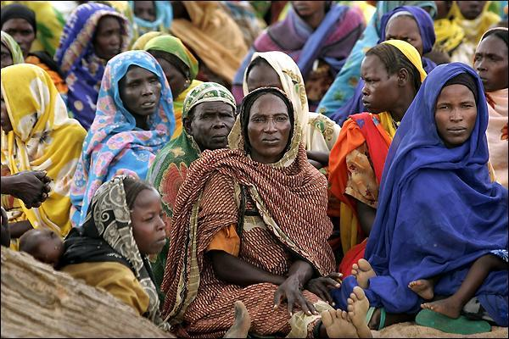 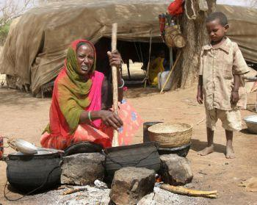

Thank you for supporting our project to provide 7000 Safe Stoves for Darfur Refugee Mothers in Darfur Refugee camp, Touloum in Chad.  You have support Darfur Women Network to secure its partnership with Globalgiving to help the refugee women and girls from Darfur by providing safe stoves to enable them to cook for their families without costs them their lives, poses great health, security, and environmental risks. We believe that without your support we cannot stop the safety risks associated with gathering firewood or provide practical, efficient, and safe stoves in the Touloum Refugee camp.

Feel free to check our Gifts for Good on our partner, Globalgiving’s website to support your project( Safe stoves ): At [www.globalgiving.org](http://www.globalgiving.org), at <http://goto.gg/14531>, at [http://goto.gg/15358](http://email2.globalgiving.org/wf/click?upn=-2FYS0Zo8thSaHj5as6AifwSoPHe2bCoaojQ-2BKcfzZMjSb9DM9-2FY-2FnxCgo11JvxVoZ3Tk18ZpQ66nwHka-2Bp8TbWtCgM13BEJKfY-2FsikX-2BelmEdiozWz4LoFP5EEJMNXUFyI30qZ4chzHTRcJ0mInhl2au9xJbwg3hQKMWu7OwqPVx-2FR9-2F-2F1Tm4P1jJuopWW5i6faz5ua9PrZtLkMYcHe9vUugqDbltOVZJkPKgV4NwlbL8y-2FN6SNdSwDPuq1Bz8cTxceH48MuReVMt0Tn1ovyksg-3D-3D_oyWssuigbAVnvXIXGefB9UoFh6D2E8zK38eT5iKn7CtadxXIbXk3TJ0b3UcuuJdLNG5dHh-2BGsOnkqXS3EyvolY-2FEINSpr9FmpsVkT5jn86wWAEsKHthACkl5NwYt6v-2F21Ee95zYjhVvNMn-2FdduWCzrHhBb29l3kCtIduTU1ot-2BcVhknx4B-2FDZNAjfdnZjW0EI-2FLCFKaLTrWWlUNsWjkkYxsT4jDrHL9MmRN3VPIGxMRW2ZHRxYmwStiGxM30CLz-2B4A3yYo-2FofmRhRTKf6W280w-3D-3D), and on Women Empowerment Project store on Etsy: <https://www.etsy.com/shop/WomenEmpowermentProj?section_id=11987406&ref=shopsection_leftnav_1>

These products will provide you with finely crafted products in tandem with the opportunity support Darfuri women in their struggle to create peace, stability, and a livelihood for their families, provide unique gifts to your loved ones, and provide safe stoves to the refugee women and girls to protect them from rape. The greatest miracle is the bridge created between our customers and our artisans in Darfur.

In 2014, the Darfur Women Network’s(DWN) staff “volunteers” decided to visit Touloum camp to implement our project “7000 Safe Stoves for Darfur Refugee Mothers”. We believe it can happen with your support.

How can you help us to raising $3000 during our three fundraising events below?

You can help by purchase gifts for International Women’s Day on March 8th, 2014

You can donate to our online fundraising from April 1st to April 30th.

You can donate on the Mother’s Day on May 11th, 2014.

You can share our projects with you friends and your contact.

You can host fundraising for Darfur Women Network

You can join our Advisory Board

You can sponsor a family by providing safe stove

On March 7th, the President and CEO of the DWN, Mastora Bakhiet, visiting Fort Wayne due to YWCA Northeast Indiana’s invitation to attend The event that honor women who have been fighting for equality for women and standing in solidarity for equality. She will meet some friends and donors and supporters. Those who are in Fort Wayne and would like to meet her , contact her on 260-602-2607 or email: [darfurwomen@gmail.com](mailto:darfurwomen@gmail.com).

On March 8t, the Strategy and Program Director, Suad Mansour, will be at MT Airy  Art Gallery

Adress/ 11 west MT Airy Ave,Philadelphia, PA, 19119' to celebrate International Women’s Day. Those who are interested in meeting her and learn about our cultural products, our activities, and support us can email her at [suadmansour@aol.com](mailto:suadmansour@aol.com) or call her:215-917-8887.