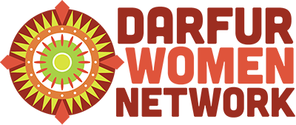

Darfur Women Network Safe Stoves Program

**Introduction**

Darfur is the Western region of Sudan bordering Chad. In 2003, the Sudanese government partnered with Arab militia to launch an ethnic cleansing attack against African civilians in the region. They killed and raped civilians, burned villages and destroyed all the resources of livelihood. The population of Darfur in 2003 was 6 million people. Since the conflict began, 400,000 people have been killed and 2.5 million survived the genocide, but were internally displaced in refugee camps. Refugee camps are located in both Darfur or in Chad. Those who are in Chad are our clients.

Halima is from Um lyoin village. Her husband’s village was destroyed unlike Halima’s village. Fortunately, he survived as one of the few men in the camp. Since her arrival to the camp, Halima and her family depend on United Nations (UN) aid for their food and hygiene materials. However, in 2014, the UN reduced the ratio of distributed food and stop giving away hygiene materials, despite the camp lacking any source of income.

The goal of the project: Is to make and to provide safer stoves for the 6400 mothers in the Touloum Camp. Safe Stoves provide the survivors of Darfur genocide in the refugee camps a source of income, a safer way to provide food for their families, reduce treacherous and lengthy journeys for firewood as well as preserve and restore ecological recovery around the camps.

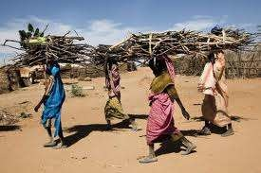

**The objectives of the project are:**

* To reduce the number of trips and distance that women trek to collect firewood from the forest. The forest is an isolated and unsafe place, typically located a day’s journey from the camps. For women and girls, this has been a primary area for brutal attacks including rape and, in some cases, murder.
* Decreasing the serious risks of traditional stoves include smoke inhalation, burns to children and accidental home fires. Open flames encourage respiratory issues and open fire hazards that can quickly ignite a shelter.
* Increase and restore the preservation of the ecological system in and around the camps. Because firewood is required for cooking, the constant collection of resources in addition to desertification, have left the camps bleak and dry. Decreasing the frequency in which firewood is collected and contributing to replanting trees within and around the camp vicinity, helps restore the ecological balance
* Create economic empowerment opportunity for women to earn income for themselves and their families. There is little to no way for women to earn an income which will allow them to purchase food or basic living necessities within the camps. The Safe Stoves Program merges income earning opportunities with filling a vital need that benefits families in the camps.

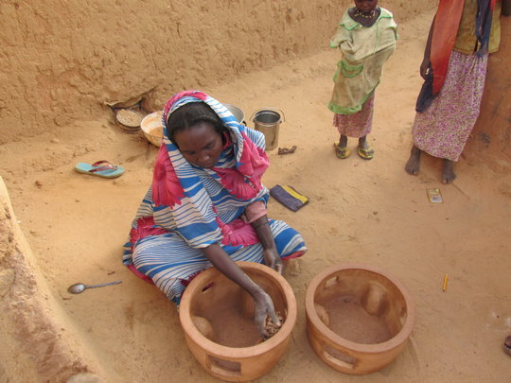

**Problem/Challenge**

7,000 refugee families in Touloum Camp, Chad use traditional wood-burning cooking stoves which can cost lives due to the hazards associated with them. These refugees have no consistent source of income and children suffering malnutrition. Firewood scarcity due to deforestation leaves women and girls vulnerable as they trek long distances into dangerous high conflict territory which put them at risk for rape and violent attacks. In addition to safety issues, smoke inhalation and fire hazards are a constant concern. Also, walking long distance to collect firewood has been burden on the women and weakening their physical ability.

**Solution: Safe stoves are the solution.**

The concept of Safe Stove: The Darfur Women Network was seeking brilliant idea to save Darfur survivors’ lives. DWN Executive Director, staff and beneficiaries participated in the field testing three stoves (traditional, metal, and the clay) to determine the most efficient one. The tests were based on the following factors: energy consumption (firewood), capacity (quantity of food), type of food (traditional meal, Asida), time, density of smoke during cooking process, safety, practicality, and availability.

The field tests proved that adapting a safe fuel-efficient stove reduced the length of time required to collect firewood, the number of trips into the forest (lessening risk of attack), protected refugees from smoke inhalation and open fire threats as well helped preserve and restore the forest from desertification. Because the stoves can be made within the camp from local materials, the stoves are also more cost effective. Our solution thus far has been the formation of production groups in Touloum camp to produce safe stoves. The production groups, made up of 50 women, have created over 800 units to sell them to DWN, which we have distributed to 200 widows and 600 of the poorest families at no cost. The production of the stoves provides women and girls with Economic Empowerment Project as a means of generating income for their families.

Safe stove is the most efficient and could be made locally from local materials. It is practical, culturally acceptable, and it will create economic empowerment opportunity in the camp.

**The Social Impact of the Project**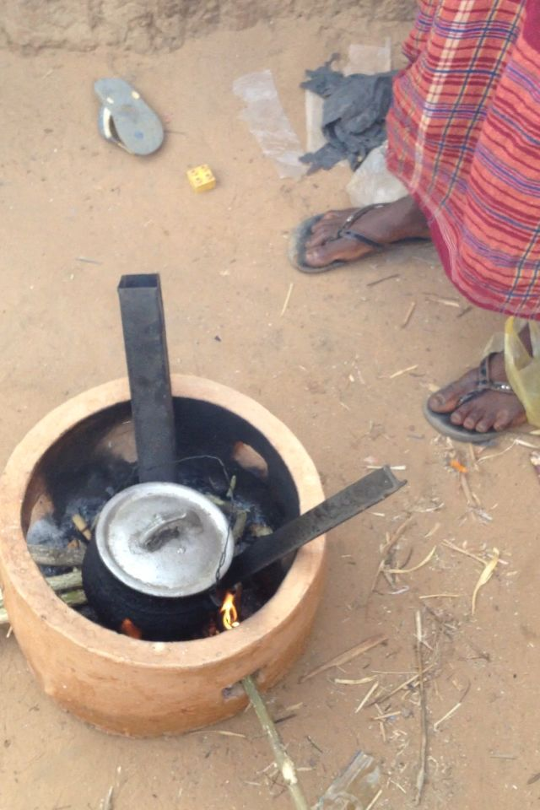

**Long-Term Impact**

The program will provide 7,000 families in Touloum Camp with Safe Stoves and women with safe cooking options, decision-making training, and access to alternative sources of income to improve the wellbeing of their families. After DWN reaches the goal to provide each family in the Touloum Camp with a Safe Stove,   
this program model will be replicated and used in the remaining 11 refugee camps in the region. To date, 800 stoves have been provided to this camp.

This project has empowered women economically, by allowing them to provide care to their family members. This includes building rooms, purchasing new clothes, food and school supplies. The rest of the money was used to transfer their safe stoves and sell them in the nearest cities.

Trips to collect firewood by the 800 beneficiaries has been reduced by 75%. This means that our beneficiaries are collecting firewood once a month from a shorter distance, compared to those on our waiting list at four times a month at much longer distances.

Thus far, we have helped 4000 family members by creating a healthy and safe environment. All of the refugees now know about our safe stoves and the positive impact they have had on the producers, as well as the beneficiaries.

This is the testimony from one of 50 women who produced 800 safe stoves to cover 200 widows and 600 of poorest families in the camp as well as direct impact of 300 family members of their own.

Testimony from one of the production group participants, she said, *“I feel as if I am a new person, I am able to purchase food, clothes, shoes to my kids, and hygiene materials, I added another room for my kids, I have seven of them in very tiny room. I will not worry about rainy season anymore. My family members believe in me and I feel confident and useful. I saved some money; it helps me with transportation to sell safe stoves in Hiriba, which is the nearest city.”*

During an interview with other survivors in the camp, we were told that the perception of the production group by some refugees is somewhat equivalent to that of employees at huge company with high payment and benefits because it the only groups has received income. Our project manager told me that all the campers are aware of the safe stoves and looking forward to receive theirs to reduce their numbers and distance of trips to collect firewood by 75% and to have healthy and safe homes.

**Now we are in need to 6200 safe stoves to cover the entire camp. Your support will help us to continue the Economic Empowerment Project to those who produce safe stoves in the camp to earn money to care for their kids and to transfer themselves from dependency to self-sufficiency.**

**Donation of $10 will safe mother from the firewood collection’s risks. Together we will be able to declare Touloum camp free of traditional stoves.**