Isha Vidhya – Project Brief

Dated: 20th August 2020
Isha Vidhya:

- 10 rural schools (9 in TN in districts of Coimbatore, Erode, Salem, Cuddalore, Villupuram, Tuticorin, Nagercoil, Dharmapuri & Karur, 1 in AP in Chittoor Dt.), creating a bright future for 8,523 children
- About 60% of the students are supported by full tuition scholarships. The rest pay a subsidised fee
- Actively promote education of girl children (50% are girls) by visiting villages & counselling parents of girls to send their children to our schools and by providing proper toilet facilities for girls.
- Transforming parental attitudes to education & increasing educational awareness in rural communities while striving to preserve village identities and culture

Highlights

- Infrastructure by way of clean and spacious classrooms
- Science, maths and computer labs, digital classroom, library, playground and play equipment
- Extensive audio, video and computer material augment English-medium education
- Karadi Path Program for developing English fluency
- Education beyond literacy and rudimentary skills by following a holistic approach
  - Attention to sports, arts & crafts, environmental awareness, health and yoga
- Balanced mid-day meals containing proteins and salt fortified with 7 micro-nutrients
  - For most children, this is the only wholesome meal of the day.
- Most students learn even basic hygiene only in the school
- Student teacher ratio is 20:1, with special care for slow learners
- Total no. of employees – 409 teachers and 241 other non-academic staff.

Coronavirus (Covid-19) situation Ops. Update

- Isha Vidhya has launched a series of home learning programs, to engage students and teachers. The lockdown has blurred the distinction between homework and classwork for the students. We have overcome the hurdle posed by the pandemic by sending lessons via WhatsApp groups. Our teachers prepare short audio/videos and notes and post them on the groups. They also prepare worksheets on the lessons. Students submit the completed assignments in the same groups.

- To help slow learners, who need extra attention to catch up with their classmates, the Academic Team sends worksheets on subjects like Tamil, English and Mathematics.

- For higher classes, Khan Academy videos are also used. Google Hangout classes are conducted from time to time and mock tests too. Children are engaged for about 2 hours in lower classes and for about 2 to 3 hours every day from 9th to 12th.

Unfortunately, only about 50% of our students are able to participate in the digital classes as the rest do not have access to smartphones or internet connectivity.

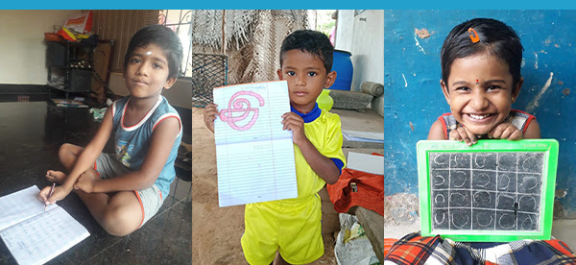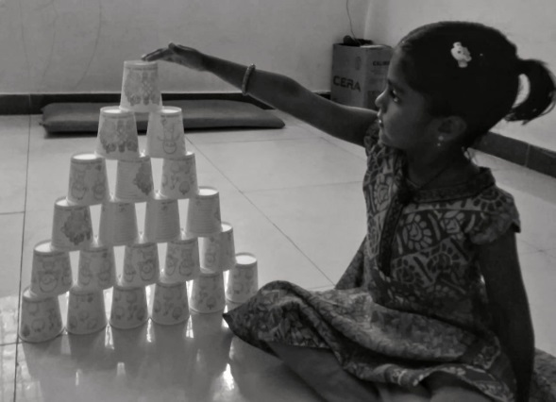

This is the time when the Isha Vidhya school campuses would have overflown with innocence and cuteness as new pupils got enrolled in UKG and LKG. But, now with the new normal in force due to the pandemic, the youngest of our students are studying from home, waiting for their chance to liven up classrooms with their exuberance and energy.

Our academic innovations have helped us press on even during the lockdown. In this period of online classrooms, our teachers have used engaging new teaching techniques to keep our students joyful and abreast with their studies.
2020-21 Budget Details

Category | Amount | Cost/Student
Staff Salary including Staff & labour welfare | 10,49,40,376 | 12313
Students related expenses including for books, notebooks | 1,78,76,401 | 2098
Staff Training & Development including travel & transport | 34,02,431 | 399
School Maintenance Expenses | 77,74,658 | 912
Administrative Expenses | 99,64,194 | 1169
Total (Rs.) | 14,39,58,060 | 16891
Student strength | 8,523
Estimated cost per student | 16,891
Accreditations

Reputed donation platforms Give India, GlobalGiving, CAF (India), United Way of Mumbai, CAF (America), National CSR Hub (Tata Institute of Social Sciences), Guidestar India (Platinum certification).
India Compliances and Approvals

We are a registered Public Charitable Trust with 12A, 80G, FCRA & all statutory approvals.
Internet Presence
Website: https://www.ishaoutreach.org/en/isha-vidhya
Facebook: https://facebook.com/ishavidhya
Twitter: https://twitter.com/ishavidhya
Instagram: https://www.instagram.com/ishavidhya/

