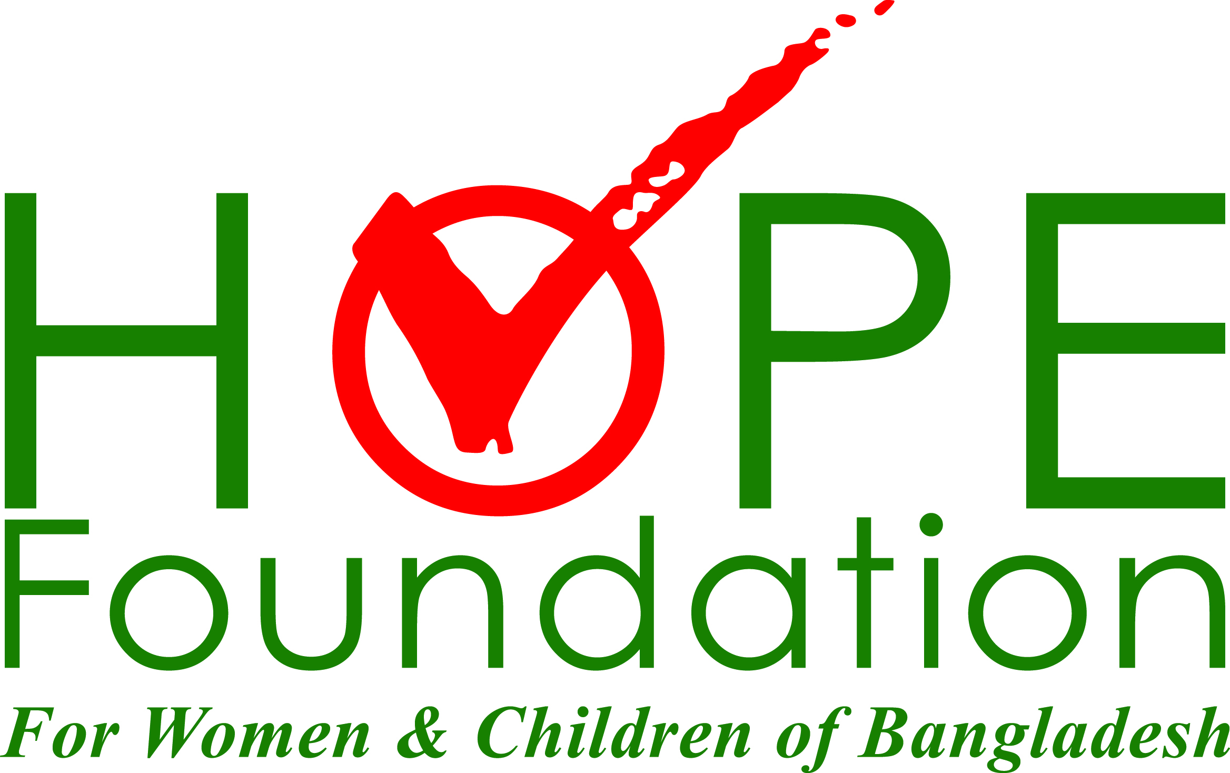
HOPE Foundation Activities
HOPE Foundation for Women and Children of Bangladesh is a US-based non-profit organization providing primary health care in rural areas of Bangladesh, since 1999. The Foundation has a 40 bed ‘HOPE Hospital’in Cox’s Bazar and 8 HOPE Medical Centers (rural clinics) located in different parts of the country.The mission of the Foundation is to provide essential health to disadvantaged people in rural areas of Bangladesh. HOPE Hospital and the rural clinics offer low cost healthcare to the needy people in the community. Free care is provided to patients who are unable to pay and no one is turned away. The Foundation particularly focuses on improving maternal and child health as they are the most vulnerable populations.
Focus of HOPE
- Maternal Healthcare and Research
- Children’s Healthcare and Research
- Healthcare Training and Education
- Burn care
- Obstetric Fistula Surgery and Rehabilitation
- Cleft Lip and Palate Surgery and Rehabilitation
- Trauma Care

Maternal Health:
Hope Foundation for Women and Children of Bangladesh’s work in maternal health is central to our mission. Every hour 3 women in Bangladesh die due to pregnancy or childbirth complications; this is on par with epidemic levels and at Hope we work hard to drive down maternal mortality rates. HOPE provides maternal care in the following areas:
• Emergency Obstetric Care: The majority of women in rural Bangladesh do not have access to health care during delivery. HOPE provides a safe department with trained physicians to perform caesarian sections to both save the lives of mothers and babies when complications arise.
• Natural Delivery: At HOPE’s Hospital, women can go to the hospital to deliver their baby either because they have been identified to have potential complications or because they simply desire to have a secure, smooth delivery. Since HOPE began enacting the World Health Organization’s Safe Motherhood Program, 300 babies were delivered safely in a two year span.
• Family Planning: Providing counseling and education in the field of family planning is crucial to HOPE’s aim of reducing maternal mortality. Through our family planning programs, women are educated as to the importance of being under a physician’s care while pregnant, the essential vitamins and adequate nutrition to maintain while pregnant, the importance of delaying pregnancy as opposed to beginning at an early age which often results in Obstetric Fistula, and so much more.
• Immunization: Hope provides immunizations to women and through the Bangladeshi Government supported immunization program.
• Mothers’ Clubs: To date HOPE has established 30 Mothers’ Clubs where mothers in the same villages congregate to discuss complications, issues, questions and education they have received and encountered. The best way for HOPE to deliver its message to the masses regarding appropriate and available healthcare is through our patients and word-of-mouth to their friends.
• Maternal Health Research Project: A component of our research and training program, HOPE, with its partner Medic Mobile, implemented our project Bangladesh Antenatal Care (BANC). In this project, 500 pregnant women were selected and divided into 2 groups. One group of 250 women visits HOPE’s Hospital for their antenatal check-ups. They also receive SMS or text messages reminding them of their appointments. The other group of women has a community health worker that visits them at their home and conducts their check-ups. HOPE is conducting research into the differences of the care, how receptive the women are to the varied care and what benefits the women most.
Children’s Health:
As the leading healthcare provider in the region of Cox’s Bazar and surrounding rural villages, HOPE’s work in providing services to the needy children is pivotal. “48.6 percent of the country's 20 million children aged 6 months to 5 years are chronically malnourished, a devastating problem caused by food shortages and high prices”-UN World Food Program. In addition to malnutrition, there are 150,000 children born with cleft lip and palate, an estimated 40,000 children with preventable blindness and an estimated 550,000 children possess rickets, the highest prevalence being in Cox’s Bazar. The need for treatment and healthcare services in this area for children is overwhelming and we aim to serve as many children as we can. HOPE provides children’s health care in the following areas:
• Nutrition: 98% of babies that die within their first month of life, are those born in developing countries. HOPE aims to bring down infant and child mortality by providing nutritional counseling to mothers and treating children who are suffering from nutritional deficits.
• In-Patient Care: Children suffering from disease and trauma can be hospitalized and treated at HOPE’s In-Patient Ward for Children.
• Out-Patient Care: Children can seek quick treatment for small ailments as well as nutritional counseling at HOPE’s In-Patient Ward for Children.
• Rickets: With 550,000 children suffering from rickets in Bangladesh, HOPE is working hard to prevent and treat children with rickets. HOPE administers nutritional therapy to prevent and in many cases correct rickets; in severe cases, HOPE refers children to a hospital specializing in rickets operations.
• School Health Program: HOPE implements a School Health Program in which a team from HOPE visits nearby schools and conducts a basic health screening test for students. Those who need advanced treatment are referred to the Hospital.
• Immunization: A vital segment of our child health services is providing immunizations to the needy to not only prevent children from developing diseases initially, but helping to stop the spread of communicable diseases in the schools, communities, villages and region.
General Health Care: The mission of HOPE is to treat the needy people in Bangladesh; while we focus on treating women and children, HOPE does not turn away any individual for any reason. We also provide healthcare in:
• Eye Care: From screening individuals for glasses to correcting cataracts and holding Vitamin A drives for children, HOPE is invested in providing eye care.
• Physical therapy: A partnership formed with Kinesi Theraputes Du Monde (KDM) allows HOPE to benefit from international physical therapists that visit HOPE and provide physical therapy to disabled women and children. HOPE boasts a 10-bed physical therapy unit.
Research and Training:
Equally important to providing healthcare is conducting research into how to optimize health care services, understand the diseases and health challenges the locals face, as well as providing training to local actors in order to create a local team to treat all ailments and develop a sustainable region of healthcare providers. HOPE has the following research and training projects:
• Community based Midwifery Diploma Program (CMDP): A partnership with BRAC and funding from the British Department for International Development (DFID) allowed HOPE to train local women to be midwives through a 5 year program. The girls selected for the program were local girls living close to the hospital or HOPE Medical Centers that will then return to their villages and fulfill the vast need for trained midwives to assist in pregnancy and delivery.
• Capacity Building: HOPE engages in various capacity building programs. HOPE trains community health workers as well as trains a special class of people. The Rohingya, a persecuted minority group from Myanmar who are refugees living in Cox’s Bazar need a lot of services. HOPE believed that in training a group of refugees to act as first responders in the camp, we can help to bring medical care to a special group of vulnerable individuals. If the first responders cannot treat the patient due to skill or complication, the first responders will then bring the patient to HOPE’s hospital for treatment.
• Nutrition Research: To better identify nutritional deficiencies, causes and circumstances in Cox’s Bazar, HOPE is goes out to different communities as well as sees children in the Hospital to evaluate their nutritional status and collect invaluable information so that we may work more diligently to prevent malnutrition.
• Maternal Health Research: A component of our research and training program, HOPE, with its partner Medic Mobile, implemented our project BANC (Acronym). In this project, 500 pregnant women were selected and divided into 2 groups. One group of 250 women visits HOPE’s Hospital for their antenatal visits. They also receive SMS or text messages reminding them of their appointments. The other group of women has a community health worker that visits them at their home and conducts their check-ups. HOPE is conducting research into the differences of the care, how receptive the women are to the varied care and what benefits the women most.

Specialized Care:
Obstetric Fistula:
“Each year between 50,000 to 100,000 women worldwide are affected by obstetric fistula” –World Health Organization.
HOPE Foundation, along with its partner the Fistula Foundation, is working tirelessly to treat obstetric fistula in Cox’s Bazar, Bangladesh. Obstetric fistula is a hole that is formed in the genitalia of women during prolonged birth and where C-sections are not available. This results in the mortality of the child inside the mother, and the mother suffering for the rest of her life from incessant incontinence of urine and or feces. The woman is abandoned by her husband and her community due to the social stigmatization that she is cursed and as well as due to the foul odor.
Obstetric fistula is caused by:
• Lack of maternal health care- Over 90% of women in Cox’s Bazar give birth at home, with untrained, traditional birth attendants. These birth attendants often promote premature bearing down as soon as labor pains begin. This painful labor lasts for days and results in obstetric fistula, and child and maternal mortality.
• Lack of ambulatory and emergency services: During the prolonged and painful labor, there is no ambulatory service or emergency facility to transport these women to a proper health center to conduct a lifesaving C-section.
• Malnutrition- Malnutrition in children leads to stunting of the skeleton, including the pelvis. Smaller pelvises lead to obstructed labor and complicated obstetric fistula.
• Lack of Education- Poor women are largely uneducated as t
• Poverty- Women cannot afford routine doctor’s visits, proper nutritious foods or emergency services if pregnancy complications arise.
• First Pregnancy at a Young Age- The risks for obstetric fistula are much higher in younger women and girls who are not fully developed.

Burn:
“More children in South Asia die from severe burns than from HIV/AIDS, malaria and respiratory disease”-ReSurge International
HOPE Foundation, in coordination with our partner ReSurge International, is providing critical burn treatment. Bangladesh experiences a high volume of burn victims for one main reason: the use of open fire pits to cook, heat and light their homes. The wearing of loose-fitting clothes adds to the danger of this practice, as well as a lack of parental supervision and lack of observance of adequate safety measures. When burn victims do not have access to appropriate treatment, their burns produce scar tissue that often depletes functionality of the burned body area. This perpetuates the cycle of poverty as kids cannot go to school, women cannot care for their families, and so on. “More women worldwide are severely burned each year (4.1 million) than are diagnosed with TB (2.7 million) and HIV (1.3 million) combined”- ReSurge International
Cleft Lip/Palate:
“Each year 5,000 children are born with cleft in Bangladesh”- Smile Train
Cleft Lip/Palate is very prevalent in Bangladesh. Whereas in most countries it is solely a genetic issue, in Bangladesh it is most likely a result of malnutrition of the mother while she is pregnant. When a baby is born with cleft, the mother is blamed as being cursed or of having done something wrong while pregnant to cause her baby’s deformity. Surgery is very expensive; therefore it’s not an option for poor families. Most parents are unaware that the deformity is even treatable. Most of these unfortunate children live their lives in shame - unable to eat properly, talk, go to school and are taunted by many. Many children are abandoned at birth by their parents. A simple surgery can change the life of a child forever. HOPE works with our partner Smile Train to provide cleft surgeries to children in need.
Trauma:
“11,700 people die each year from occupational injuries and several thousands are injured at work”-International Labor Organization
HOPE works with our partner ReSurge International in order to treat the many people in Bangladesh suffering from trauma. Trauma in Bangladesh varies from situation to situation but is very prevalent in poverty-stricken areas where safety conditions are not implemented. Many people in Bangladesh work in sectors which have associated risks, such as the Rickshaw drivers who face traffic accidents every day. HOPE understands how important is it for us to address these incidents in order for the body to heal correctly so that the patient may return to their normal lives without a long lapse of time where they are unable to work. With little access to proper healthcare services or the money to afford them, many Bangladeshis’ trauma injuries go untreated which can later turn into much more serious impediments in the long-term.
Rickets:
“More than half a million children in Bangladesh could be suffering from rickets” –United Nations.
Rickets is a serious problem for children living in Bangladesh, as malnutrition is the leading cause of this condition. The debilitating disease softens children’s bones and causes vast deformities such as pigeon breast, bowlegs and knock knees. The condition also makes these children vulnerable to fractures. With a lack of Vitamin D and Calcium intake in children in this area, it is no surprise that HOPE often comes across patients suffering from the disease. HOPE works in several ways to prevent and treat rickets. HOPE works to educate mothers on the importance of nutrition and ensuring children are taking those vitamins that are crucial to proper development. HOPE also recently conducted a research study in which we administered Vitamin D and Calcium tablets to children suffering from Rickets whom were under the age of 8. We evaluated their progress and in many cases were able to cure them of Rickets. In complicated cases where the children’s diseases are not improving, HOPE refers these children to a nearby hospital. HOPE is currently working to build a surgery center for rickets in the near future.

