Report No 3 Secondary Agricultural School:
About the living conditions of the students
Girls’ foyer:
In March 2013 we have opened the girls’ foyer. This unable the girls to have a better and safer environment.
A lot of the students come from villages far from the school. The parents have to find tutors in the nearby villages. This is not easy and often the conditions in which the students leaves are very poor: problem for the food, too much promiscuity.
The girls foyers has already given some results: better hygiene for the girls (we have to stop them taking showers), better academicals results.

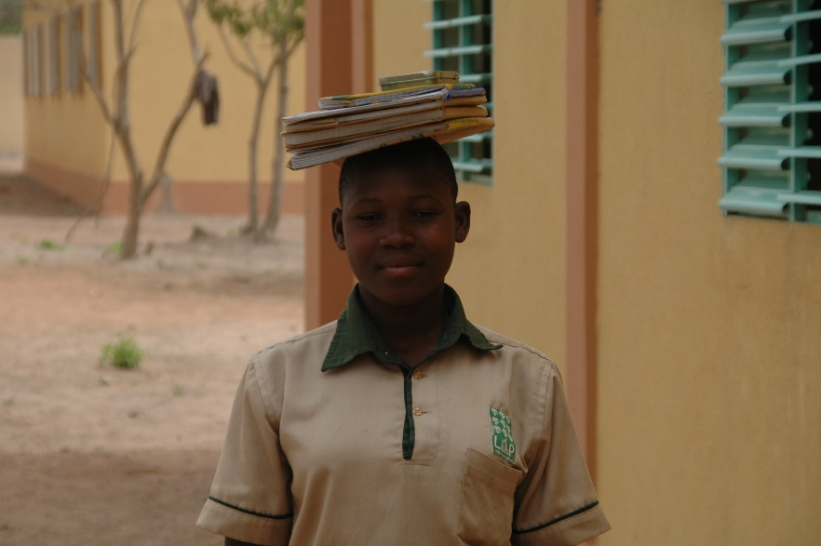
Solange (nurse in charge of the girls foyer) A girls going to class from the foyer
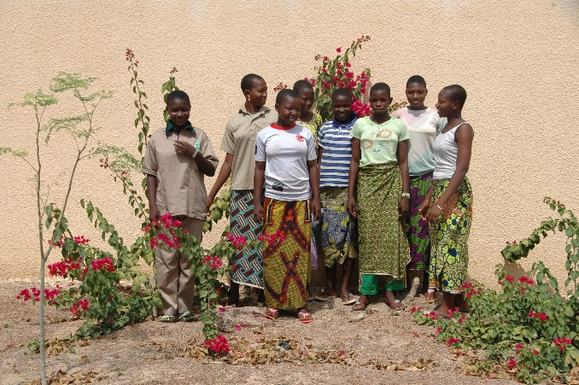
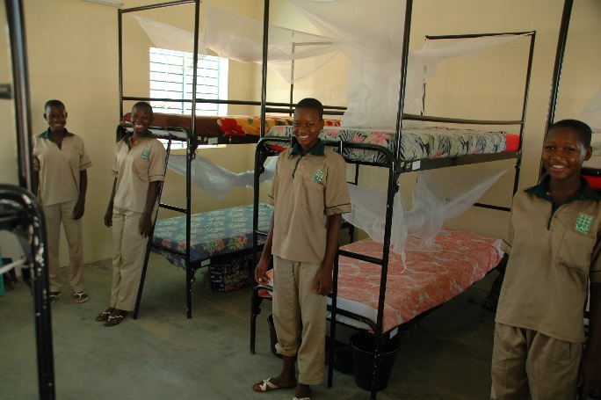
Girls in their dormitory (16 per room) and out

Boys’ foyer:
Thanks to generous donors we have been able to start the construction of the foyer for the boys. We are far from completion and all donations for this are welcome. 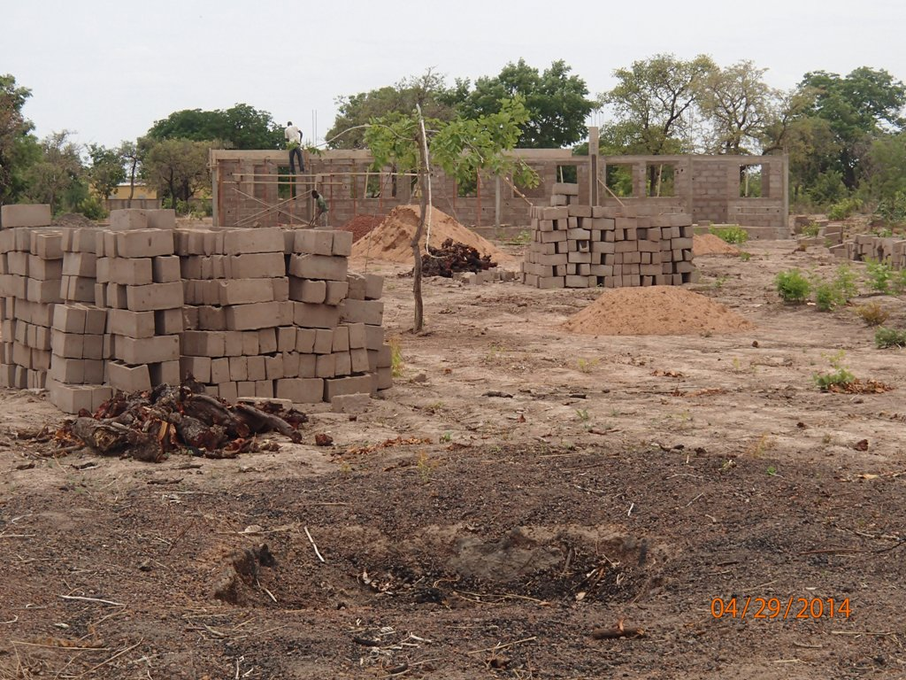
First dormitory buying built for the boys

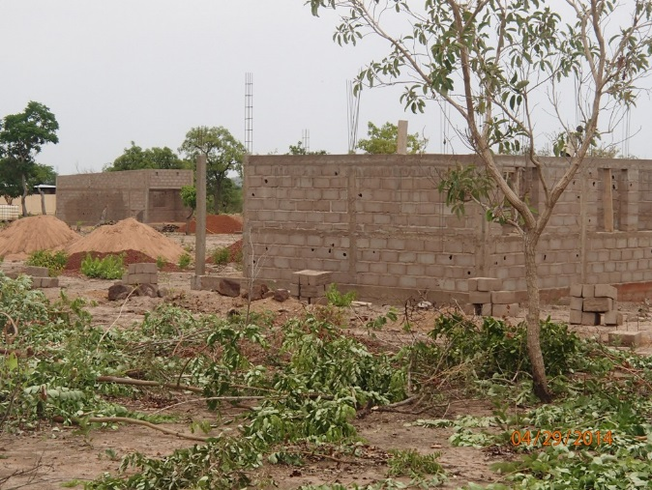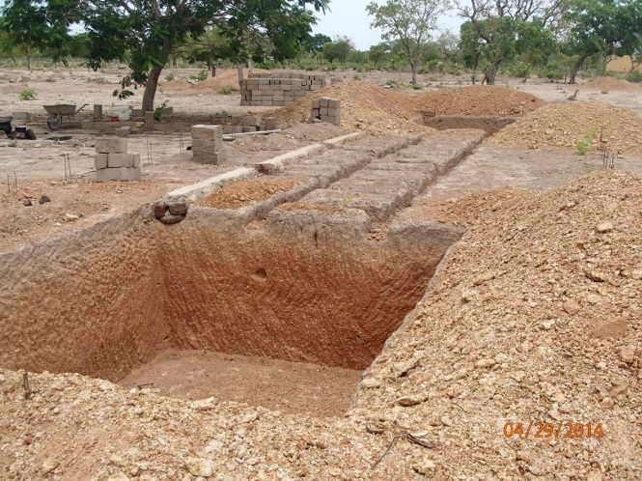
Back of the dormitory and house of the supervisor Hole for the latrines

We should be able to take around 25 boys in the foyer for the school year 2014-2015.

