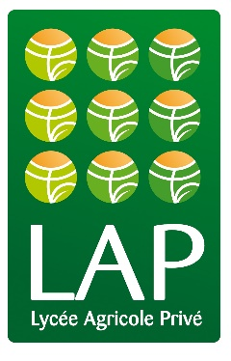

LAP report March 13th 2016,

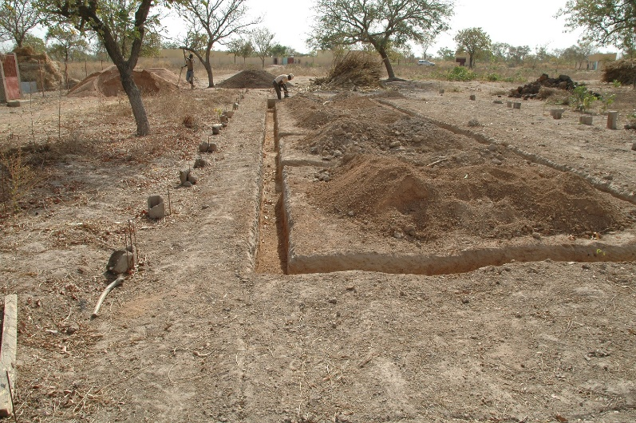
New infrastructure:
We have been able to find funds for the construction of a stable. It will be ready at the end of May. We are planning to have 1 bull, 3 cows, 2 oxen, one ram and 10 sheep. This will complement the already existing piggery for the husbandry studies of the students.

Foundation of the stable

Second cycle secondary studies at the LAP:
4th year Students who will be successful with their state exam (BEPC) will be able to keep studying at the LAP. This second cycle is for also for 4 years. The final goal is to get the baccalaureate in agriculture. There is an intermediary step after 2 years when students pass another exam called the BEP (brevet d’études professionnelle agricole). We expect to have between 40 and 50 students starting this new program in September 2016.
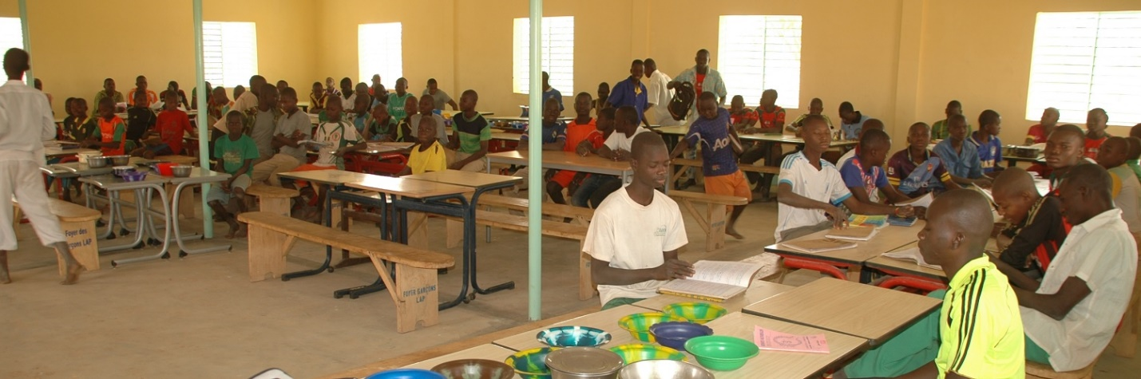
Boys students in their refectory

New liquid organic fertilizer:
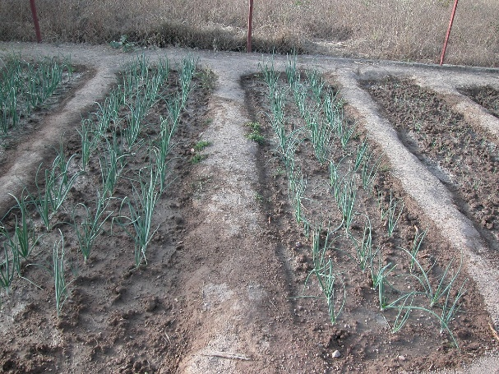
The agronomy teacher has trained the students to produce a liquid fertilizer using earth, grass and manure. It is being tested on the growing of vegetable and it is very promising.
Onions left of the picture have received liquid fertilizer, right onions did not.

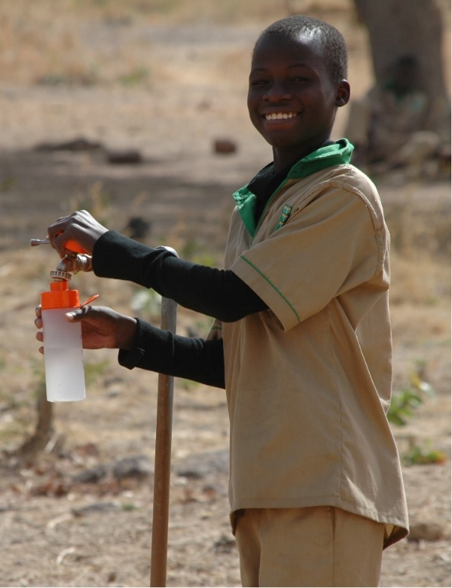
Distribution of water bottles:
Each of the student has received a water bottle which we got from the association “Jointhepipe”. Students will not drink from their hands and we expect that there will be less spillage of water.

Boys filing his water bottle.

Thank you for your donations.

