98 Patients in all! And Eight Patients in March and April, 2018 !
Seven anxious patients and their families waited in the hall of the Charity Department in Central Vietnam and one little patient waited in the pediatric unit. All were anxious to learn if their child or young adult would be chosen and sponsored for life saving heart surgery! All were chosen and sponsored. Here are three of their stories: One little infant was only 23 days old, his mother shocked by grief was now so relieved when she heard that MEDRIX would sponsor her precious little one for surgery! She was still concerned, but also so relieved to know that surgery was an option, and that he was fully sponsored.
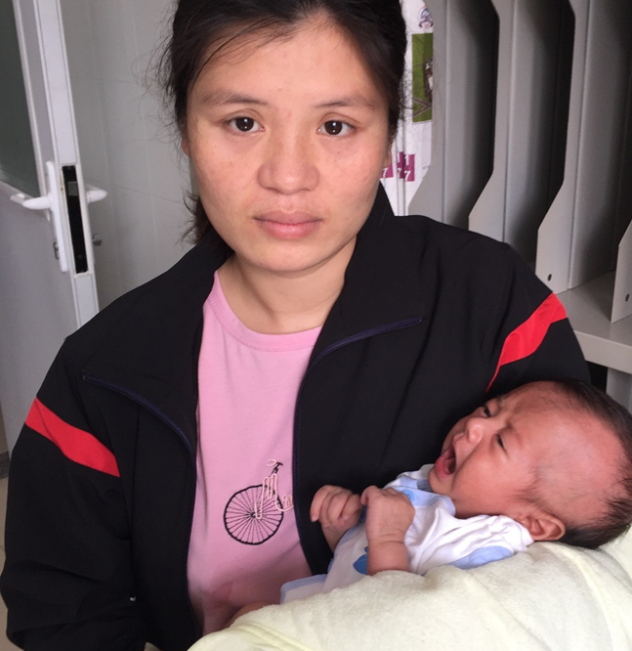
Mai was 21 years old when he learned that he must have heart surgery. Wow, what a surprise to him. It now explained some of the difficulties of his life. He works when he can, but he has not been able to find labor jobs due to his shortness-of-breath. People thought he was ‘wimpy’, but now he knows why he could not work hard like other young men – his heart and lungs just could not keep up with the needs of his body! Perhaps this is why he had a hard time keeping up in school too. Now he’ll have a new lease on life and after recovery he’ll regain the health he never had. Without help from donors like you, we may not have been able to assist this young man! Mai is grateful and so are we!
Mai is hopeful after having surgery!
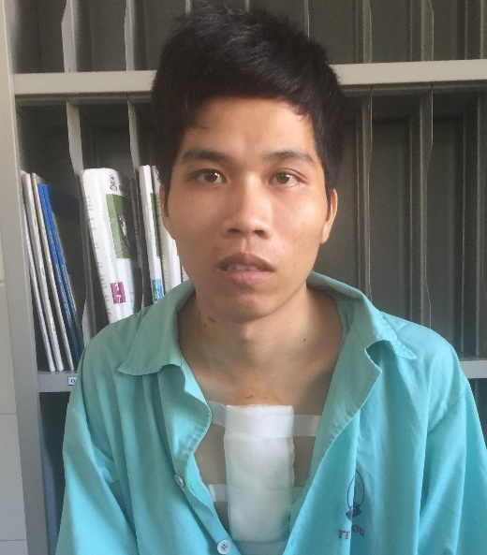
Two year old Chi listens to her own heart 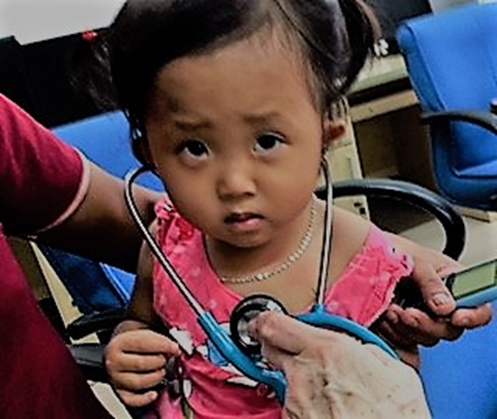
MEDRIX could not sponsor kids like Chi or life-saving heart surgery without your donation and support. Thanks to your help, we've been able to sponsor 9 more children in 2018 and hopefully that number will be even greater by the conclusion of this year! Not only are these precious children and amazing young adult regaining their health, but they now have the opportunities in life they never would have had without the benefits of heart surgery! Sincerely, “thank you” for helping MEDRIX to change lives every day in Vietnam.
All eight patients have now had their surgeries and returned home to their families with healthy hearts and a new lease on life!

