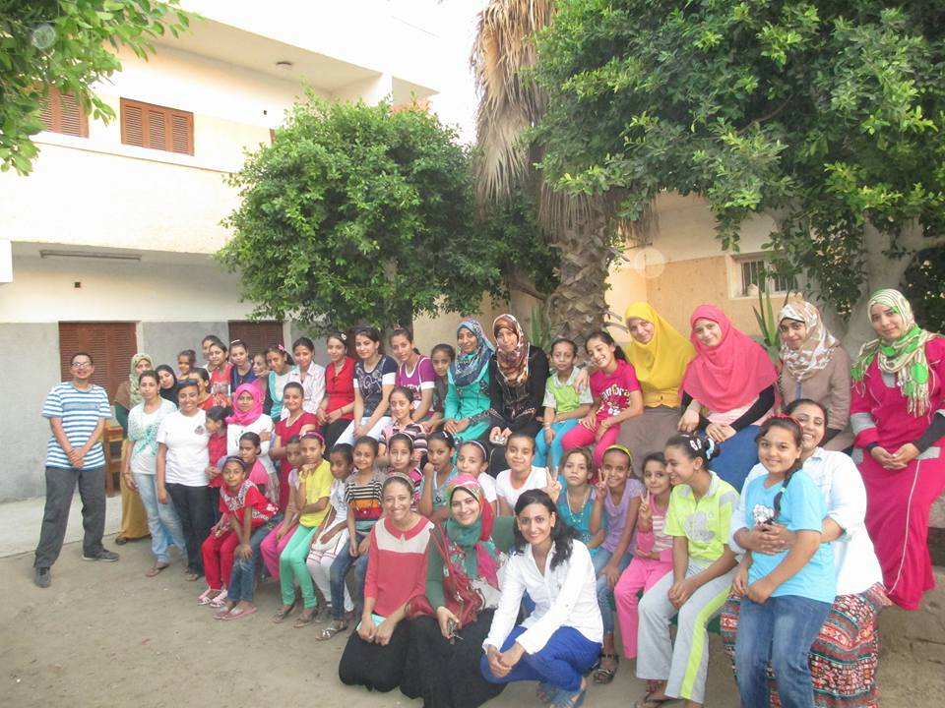
The girls and young women of the Valuable Girl Project site in [Matay, Minya] meet volunteers
with Coptic Orphans' Serve to Learn program.
Education, Education, Education — That's the Key
It's a muggy day in [Matay], but no one hesitates to hug and crowd together for a photo. Here in [Middle] Egypt, girls and young women are used to the heat. It's just another challenge for these participants in the Valuable Girl Project, like coping with run-down schools, making ends meet in a tough economy, and making their voices heard in a male-run society.
Only a few of these challenges are familiar to today's visitors to this Valuable Girl site — they're volunteers from abroad, here in Egypt to take part in Coptic Orphans' Serve to Learn program. They're spending three weeks teaching English to kids in [place], and they may have gotten used to sweltering heat. But because they're from places where the schools are more functional, the economy more developed, and patriarchy less pronounced, it's harder to familiarize them with what it's like to be a girl in Egypt.
Nevertheless, the [2] project coordinators, [Sawsan] and [Doaa], do their best. There are smiles on both sides as their description unfolds of the Valuable Girl Project. In Port Said, Matay, Armant, Sohag and Luxor, the volunteers learn, [137] Little Sisters and [137] Big Sisters meet twice a week. The older sister mentors the younger one in schoolwork and life skills; the coordinators teach them the value of teamwork, creativity, planning, and accepting others. Many times, the Big-Little Sister relationships are Christian-Muslim, offering an important bridge between people whose paths might not otherwise cross.
The Valuable Girl Project participants, in turn, find out what brings this gaggle of foreigners to Egypt. They hear how the volunteers are lured from around the world by the chance to see the real Egypt, form close relationships with Egyptian children, and be transformed by their love. They learn how the volunteers are inspired by the kids, even as they teach a love of learning with fun educational activities.
The most interesting thing about today's encounter is how it reflects the fruition of three projects. The Serve to Learn volunteers have also been meeting the mothers of the fatherless children served by Coptic Orphans. It's precisely because of those mothers that the Valuable Girl Project exists.
The story is this: The more Coptic Orphans staff got engaged with the orphans' families, the more they began to see a really striking trend. Mothers were dying — denying themselves medical care — because they felt valueless and were using what little money they had to meet their children's needs. But of course, a healthy child requires a healthy mother. Stopping this destructive cycle seemed desperately important, so a decade ago the Valuable Girl Project was founded.
Since that time, the Valuable Girl Project has been working with girls to ensure they stay in school, believe in themselves, and become healthy mothers.
So now the Serve to Learn volunteers have the full story: from the fatherless children they've met, to their mothers, to the young women that the Valuable Girl Project aspires to put on a different path. It's a path that's heavy on studying, and soon the girls head back inside to continue learning together. Meanwhile, the volunteers are back on the road to [place] to teach their kids. Education, education, education — that's the key.

