Progress Report on

“Help Cambodia's Children Escape Poverty and Abuse”

of the Cambodian Children’s House of Peace

March – May 2015

Khmer Traditional New Year
The Khmer New Year is one of the most important holidays in Cambodia. To celebrate the New Year the Cambodian Children's House of Peace – CCHP sent all the children to their home villages for their school holidays for two weeks so that they could spend time with their families and relatives. We usually celebrate the New Year by arranging some recreational activities for the children to enable them to have fun with one another before they leave for their home villages. The activities included small party at the Children’s Home and visited local attractions. The children had a great time with one another.
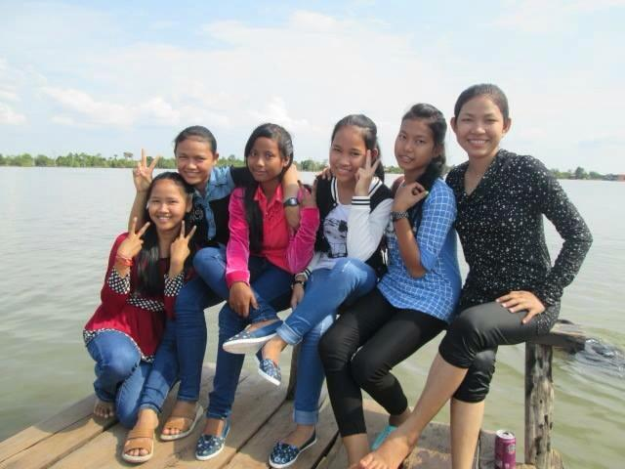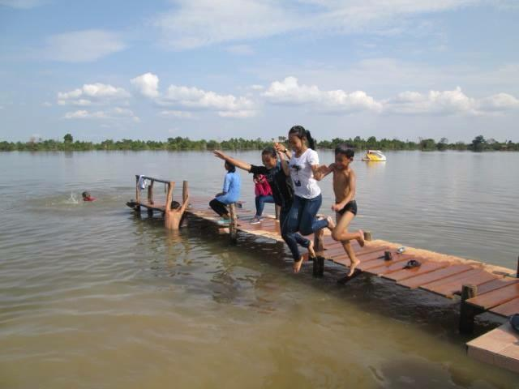

Volunteering at CCHP
Volunteers are an important and vital resource for CCHP. They bring talent, teaching skills, English language, agricultural and environmental education, IT, sports, art, and lots of fun. We welcome all kinds of volunteers around the world so that our children will have opportunities to learn different cultures, share information and exchange ideas – besides, they have made their contributions and donations to our project. They have brought lots of supplies and materials that the children need for their daily lives. Thanks to the volunteers, they have made our Children’s Home possible.
