Progress Report on

“Help our Disadvantaged Youths Project”

of the Cambodian Children’s House of Peace

March – May 2015

Peace Walk for Peace World in Cambodia
The youths of the Cambodian Children's House of Peace – CCHP attended “The Peace Walk for World Peace” at the Royal Garden in Siem Reap, Cambodia on 24th May, 2015. The event was co-hosted by the International Peace Youth Group (IPYG) in South Korea and the International Peace Organization in Cambodia. The goal of the Peace Walk is to commemorate the Declaration of World Peace. This is the first time for our youths to participate in this event in Siem Reap, Cambodia. Our youths delivered the peace message so that everyone who belongs to the family of humanity must now become a messenger of peace.
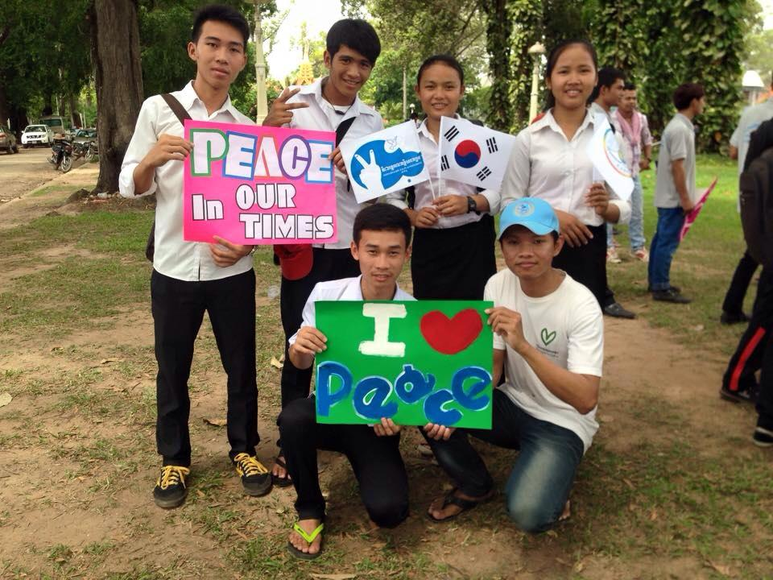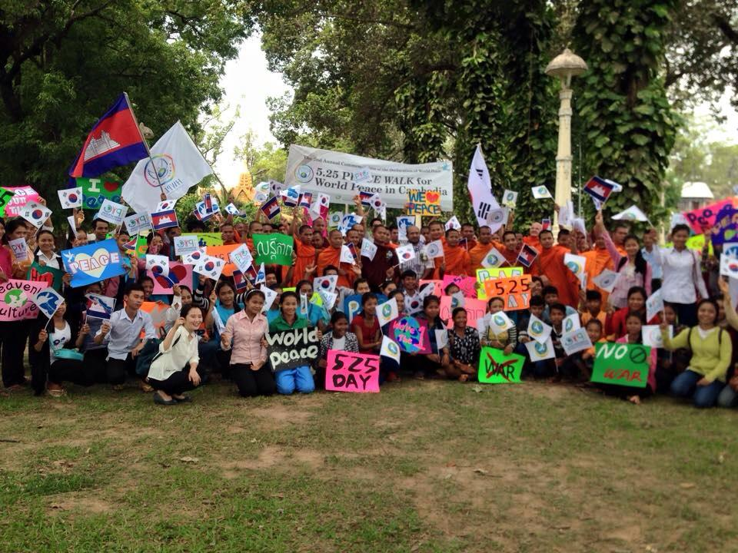

Youth Vocational Training
Skills development plays an important role in the economic and social prosperity of individuals, employers, communities and nations as a whole. CCHP is trying to motivate its children who turned 18 to pursue their education either through an educational system with the ministry of education or the TVET (Technical & Vocational Education and Training) system through the ministry of labour and vocational training. During the reporting period CCHP supported a youth to have access to vocational training so that he can be fully qualified for employment and at the same time, accommodate the needs of the labour market. Once he completed the training within one year he will be immediately placed in employment within the line of industry or enterprise that is the focus of the TEVET.
