**MAY NITU SOUL REST IN PEACE**

We are tearful by the death of Nitu, one of our ex-pupils from Bhagawatpur panchayat. Exactly a year ago, Nitu was forced to leave school for marriage by her parents. We did everything we could to stop the marriage, but they didn’t listen to us. Even Nitu didn’t want to get married, but sadly she didn’t have a choice. Nitu was only fifteen, and she had only a year left in finishing school.

After three months of her marriage, she became pregnant and, a week ago she died in hospital during the delivery. We all are shocked by her death. Despite the laws, the tradition of teenage marriage is still common in the community. Nitu is no longer with us, but the message that teenage marriage is a death trap has to be spread widely. The mistake has been made. Now, we take it as a learning and will try to persuade parents in the community even harder to stop the teenage marriage.

Currently, its summer school holiday in Nepal for one and half months. Sunita and Shankar, the project assistants, are organising quiz contest with the girls in various groups. Through the contest, they educate the girls about our work, the rules and regulations, their parent's role in it and theirs own. They also make sure that the girls study in the home regularly to avoid losing interest in schooling. The girls do get treated with chocolate in the quiz contest.

The financial year of our partner organisation ends in July and, it is also the month to bring new girls in the scheme. There are eleven girls who are in most need of our support in the panchayats. Without our support, the girls cannot continue their schooling and if they don’t then it means they will end up marrying someone soon. The cost to keep a girl in secondary schooling for a year is £60 or $85 or 7,800 rupees and in primary schooling £50 or $70.

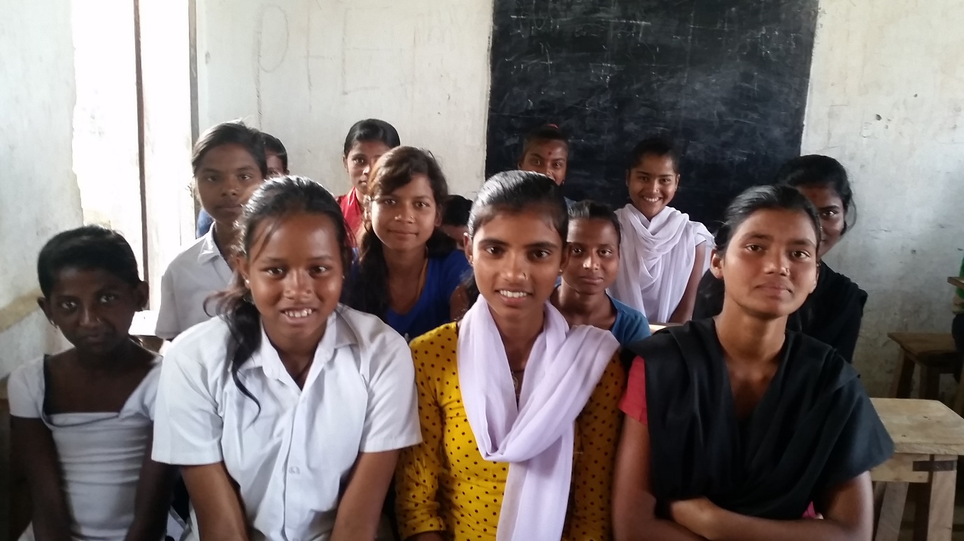

If you can afford then, please sponsor a girl today. It doesn’t just enable them to retrieve a formal education; it also changes their life to good forever. Once Nelson Mandela said ‘’an education is the most powerful weapon to fight poverty and inequalities.’’ On addition to that, we strongly believe ‘’educate a girl today, and we never have to educate their children again.’’