Report Back from Darfur

As told by Fatima Ahmed, MADRE’s partner in Sudan
In July 2005, MADRE donated an emergency humanitarian aid shipment worth $500,000 to Darfur, Sudan. The shipment included urgently needed clothing and bedding for women and families whose villages have been destroyed by militias in ongoing violence in Darfur. It was distributed by MADRE's partner in Sudan, Fatima Ahmed. Below, she reports on her experience. For more information visit www.MADRE.org

MADRE's donation was the biggest shipment of non-food items that government officials and other international agencies had seen arriving in Darfur. To make sure the aid reached those most in need, we concentrated on distributing it in smaller refugee camps, including Asref, which is about 15 minutes east of the big city in Darfur. Hardly any other NGOs were working in Asref.
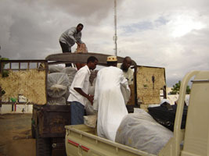
© Zenab
In all, it took five months to get the shipment distributed. First, we had to get it released from customs, which was a tremendous challenge because of the terrible bureaucracy and complicated government procedures. Then we had to bring the shipment from Sudan's only port, which is in the east of the country, all the way to Darfur, which is in the West. It was too dangerous for me to travel with the shipment overland, so I had to fly to Darfur. Volunteers from our organization met me at the airport in Darfur and we began the big job of delivering the aid to families in the camps. We went from the airport to the warehouse where the shipment was being stored. We rented a truck, and over the next nearly two weeks, we distributed the shipment, little by little, to displaced families in the camps.
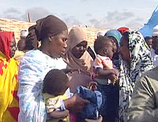
© Zenab
We were very careful when distributing the aid that it get to those most in need. We relied on volunteers from local organizations, mostly women's organizations, to keep things running smoothly and to prevent conflict between people waiting to receive the aid. We made packages for families--each one containing clothing for children and women, and sheets and blankets which are very needed now. It is the rainy season and people need dry clothes, not just to stay comfortable, but for health reasons. Soon it will be winter in Darfur. It will be very cold and the blankets that we distributed will be a huge help to people in the camps.
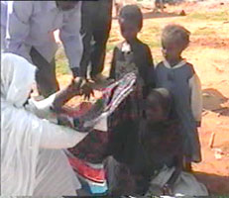
© Zenab
It was a great experience to be able to share this emergency relief with women and children and elderly people and do something to make them happy.

