Report of post-disaster reconstruction
Shanghai United Foundation (SUF) is working for post-disaster reconstruction following the magnitude 7.0 earthquake which struck Ya'an prefecture in Sichuan, on April 20th. The powerful quake caused extensive damage to homes, buildings, roads, communities, water systems and culture in the three counties of Lushan, Tianquan and Baoxing. As you known, community reconstruction not only needs a long time, also needs a lot of money with the help of the whole society.
An advised found named reconstruction advised found was set up for helping people affected by disasters by SUF in April 2013. From 30 September 2013, post-disaster reconstruction found received a total income of 989,000 RMB donated by people from enterprise and public all over the world. At the same time ,there are fifteen proposals which come from NGOs working for rebuilding Ya’an prefecture have been submitted to SUF for applying for froject funding. Follwing the general provisions of SUF, who can get a grant is decided by public evaluation meeting.
Post-disaster reconstruction programs are selected from public evaluation meeting by SUF on 11 October 2013. The judges include donor representatives and charity advisor, but donors have a final decision. There are four programs won the funding, and total expense was 610,000 RMB, the rest about 300,000 RMB will be spent on the selected project follow-up support. The detail is as follows.

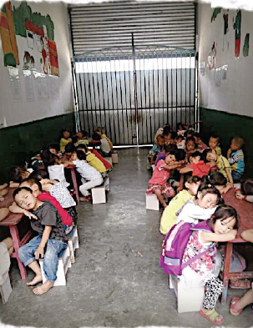
Program one:
Tables, chairs and moisture-proof pads for Lushan county’s kindergarten
The grant was awarded to buy 146 tables, 902 chairs 1066 small beds and moisture-proof pads for Lushan county’s kindergarten.
Program two:
Youth ability construction and community development of Lianglu Town
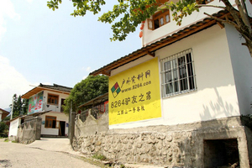
The grant was awarded to add an innovative program to the promoting of the development of local tourism as another way of motivating youth to realize their full potential and connect in positive ways to their community.

Program three:
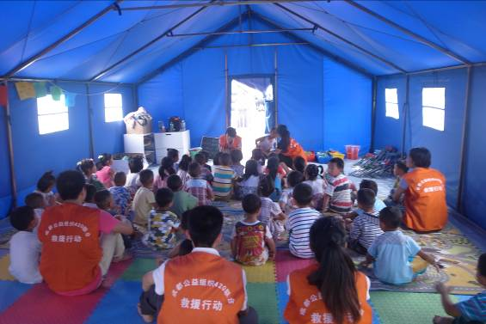
Preschool children’s community service support
The grant was awarded to add an program to improving the quality of preschool education of the Ya’an’s children.

Program four:
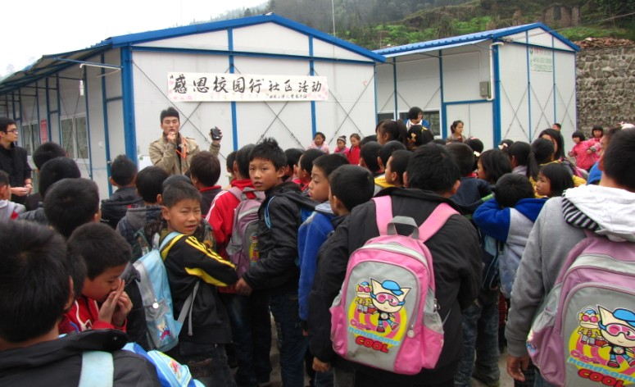
Social work station of Ya’an Shuangshi primary school
The grant was awarded to help establish a new station to provide psychological aid for more than 600 students affected by the earthquake and help children and other earthquake victims recover from the disaster.

