Preschool of Future for rural poor kids in China
First report

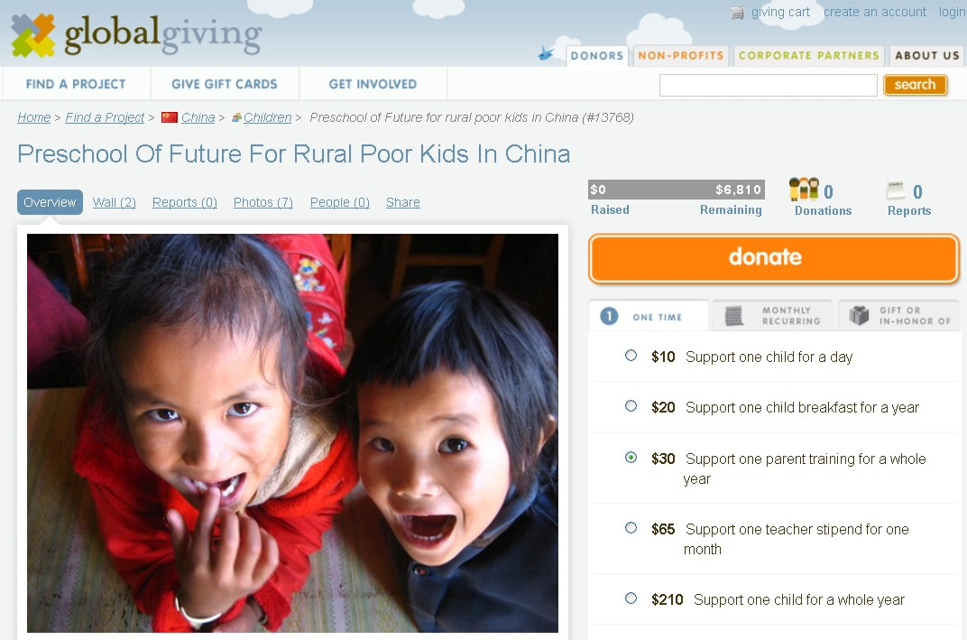

Since April to July 2013, Shanghai United Foundation and Humana People to People together have strived to promote this globalgiving online donation “Preschool of Future for rural poor kids in China” project in different channels – organization website, QQ, Facebook, Emails and information spread among friends.

The significant results:
- Now we already have three donations total amounting 135 USD.
- Thanks for the Globalgiving platform, a Canadian school got to know this project and contacted HPP for donations in forms of Chinese- Canadian student connection. It is still under discussion.

Thanks very much for the support of all of our donors!

These days, we visited some natural villages like Shuabuchang Village in Nansan Township, parents would love to have a preschool in the village! We can see the needs of the local community for building up a new preschool.
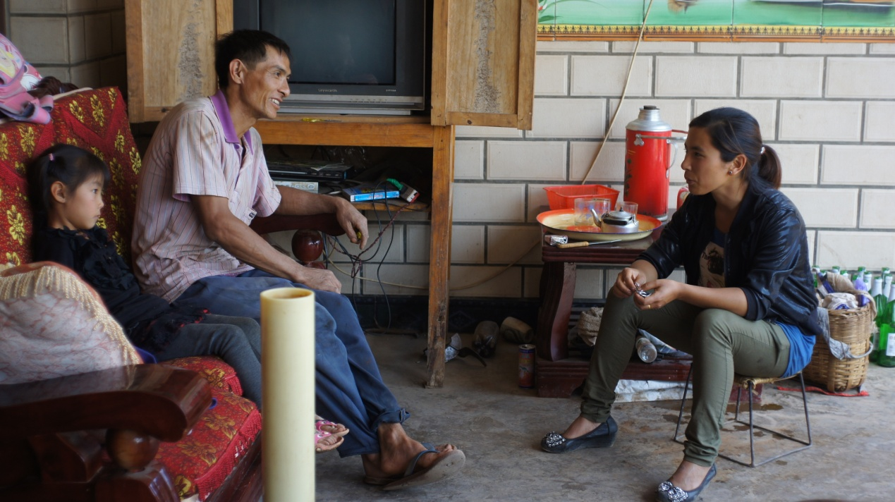

During this summer vocation, we would love to collect 6810 USD on Globalgiving to support 25 rural children into preschool. How do you love this project and do you have any suggestion? We would love to hear from you!

- HPP website promotion
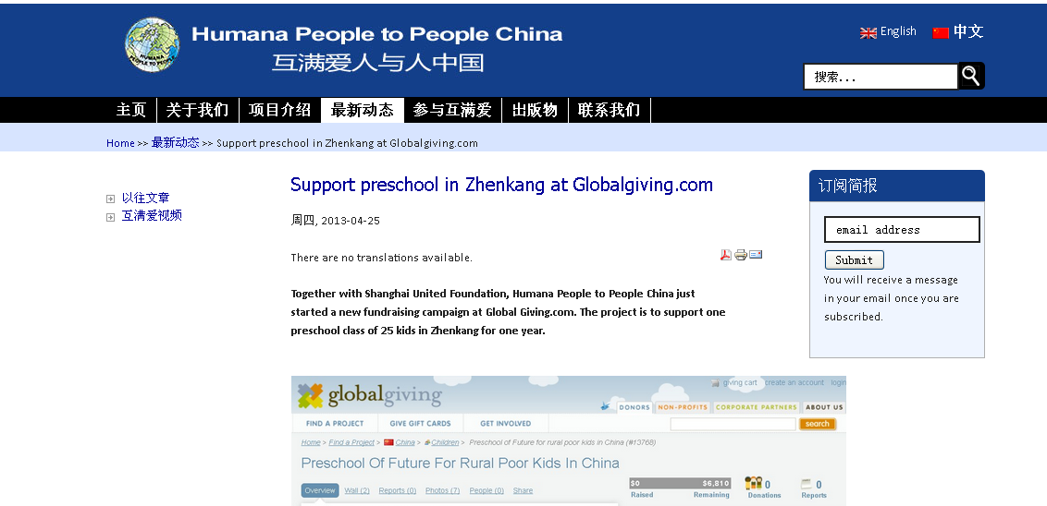

- Donation link in email signature
