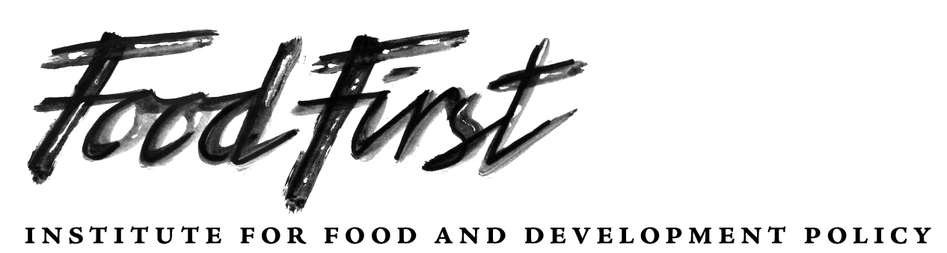

398 -60TH STREET, OAKLAND, CA 94618 USA * PHONE: 510-654-4400, FAX: 510-654-4551, www.foodfirst.org
Ending Injustices That Cause Hunger and Environmental Destruction
Background from a URIN News report, January 23, 2013
Difficult situation in Gao
Disruption to the Mopti-Douentza-Gao corridor has also led to severely diminished cereal supplies in Gao markets, says Action Against Hunger (ACF) - Spain’s head in the capital, Bamako, Franck Vannetelle. Gao residents are relying on cereal imports from Niger. “If the border with Niger closes then they will be completely cut off… It would be a disaster,” Vannetelle warned.
Most herders have fled into the bush with their animals, leaving very little meat available in the market, he said. And banks have shut down and most private money-lenders have stopped their activities, leading to a severe cash liquidity crisis in Gao, he said. Bombs destroyed a fuel depot in Gao town; residents fear fuel will soon run out, leaving them in darkness.
The International Committee of the Red Cross (ICRC) will try to continue to supply fuel for water pumps across northern Mali’s main towns, as it has done for many months now.
These factors, plus the cutting of all phone lines over a week ago, have left residents feeling vulnerable.
“For one week now, the phone network has been cut so no one can speak - we’re cut off from the rest of the world, which frightens me,” said Jafar Haïdara, a member of the regional youth council in Gao, through a satellite phone.
“Gao is like a no-man’s land,” he said. “Everyone is on edge. We have no idea what will happen tomorrow.”
Following the 2011 drought and 2012 Islamist occupation, northern Malians were “already very vulnerable”, said Vannetelle. The level of global acute malnutrition in Kidal Region was 13.5 percent as of October 2012, according to Doctors of the World (MDM) - double the rate in 2011.
If food dwindles further in Gao, residents are likely to head to Kidal in search of more, which means stocks could dwindle very quickly, said WFP. Kidal traders are also predicted to head to the rice-producing Timbuktu region to procure local rice, says WFP.

Continue to page 2 for the Food First/Institute for Food and Development Policy plan with the Mali NGO, BERADA to supply seeds and pumps to farmers in the Gao area.

-2-
The Institute for Food and Development Policy’s Plan with the NGO, BERADA to provide seeds and pumps to allow Gao area farmers to feed themselves and their families
Gao had a population of more than 65,000 before the war. CICR reports that only 40% of the people stayed, most of them farmers who did not leave.
The Institute is conducting this campaign to raise funds for seeds and pumps so that farmers who are tied to their land and have not fled can begin to grow their own rice and vegetables rather than become dependent on international aid. They know how to feed themselves. They just need our help to purchase seeds and pumps for rice and vegetable planting this summer.
About BERADA

At BERADA we recognize that people learn best by doing and then reflecting on what happened. We also believe that education is not only for building the capacity of individuals, groups, civic associations and institutions, but education should also be for empowerment and transformation. For this to happen, we understand that effective leadership and equitable participation of the local citizenry in sustainable development depends upon respecting, valuing and utilizing the cultural knowledge, resources and know-how of indigenous people. This approach to social and economic development utilizes both empirical analysis and also necessarily involves the equitable participation of people across various sectors of the society in developing self-sustainable and culturally sensitive solutions to their own problems.

Equitable and interdependent sustainable development activities must involve women's effective participation as well, in order to increase the value of education and training for other women and girls in the region. The intervention strategies BERADA proposes are based on sound principles and experience in integrated science and literacy education and sustainable economic and social development. In recognizing the close, interdependent relation between problems such as poverty, illiteracy, ignorance and joblessness, we take a holistic, systemic approach in solution development. BERADA's previous experience with funded projects will support the successful implementation of the proposed project. The organization has successfully completed an applied research and development project funded by the African Development Foundation (1988-1991) as well as other sponsored projects. The founding president, Dr. Hassimi O. Maiga, was also instrumental in building the school and maternity facilities in Thirissoro Village and many other schools in the Region of Gao.

BERADA’s work involves close collaboration with local governmental and non-governmental and international agencies to develop and implement solar energy and education projects. Such collaboration is required by formal agreement between BERADA, as a non-governmental organization, and the government of Mali. For example, the Gao Women's Association will play a key role in the implementation of activities that support women's economic and social empowerment. In addition, BERADA has already demonstrated successful collaborations at the international level.

ALHOUSSEINI ISSA MAIGA is a Mechanical and Solar Energy Engineer in Bamako, Mali (MS). He is a native of Gao and he continues to be active in his home region, as Vice-President of BERADA (Le Bureau d’Etudes et de Recherche Appliquée pour le Développement en Afrique- Institute of Applied Research for Development in Africa). This NGO was founded in Gao in 1988.

Alhousseini Issa Maiga was born in the Village of Thirissoro, Gao, Mali. He holds a Silver Medal of Mali Independence for his scientific work. After completing his elementary education in Gao, he earned a scientific diploma at Sankoré High School in Bamako and his undergraduate degree in Applied Engineering Science at the National School of Engineering (ENI) in 1980. He holds the Master of Science Diploma in Engineering from Oldenburg University in the Federal Republic of Germany (1989).

As Vice President, Maiga contributes in the following ways to the work of the organization:
- Organize agro-silvo-pastoral education and health care education activities to increase and improve agropastoral and fish production, alleviate poverty, increase literacy and improve the wellbeing of the population;
- Help the people use their local languages, appropriate green technologies and integrated science teaching as a methodology;
- Facilitate the planning and development of self-reliant and environmentally sustainable projects; and
- Strengthen indigenous leadership development, participatory (action) planning, research and evaluation.
More about this project to provide seeds and pumps
There are 26 villages that are part of the Gao Commune which is the capital city of this region of Mali in West Africa. Additionally there are four headquarters (Gouroum, Djiddara, Bagoundie I and Bagoundie II) located on the extreme outskirts at some distance from the center of the town of Gao.
This Institute for Food and Development project will supply seeds and pumps to the Gounzoureye Rural Commune including 13 villages (Koima, Thirissoro, Sadoukoyra, Lobou, Sidibey, Kossaye, Gorom-Gorom, Kadji, Wabaria, Arhabou, Bagoundie I Bagoundie II, and Tacharan). An additional 13 villages in Sonni Ali Ber Rural Commune of Gao (Zindiga, Berrah, Seyna, Batale, Magnadawey, Forgo-Arma, Forgo-Songhoy, Hamakouladji, Kocha-Karrey, M’Balde, Karey-Bandia, Kokorom, Bangnadji) will receive seeds and pumps if sufficient funds can be raised through a series of Global Giving project campaigns. The two villages of Magnadawey and Thirissoro have been designated to receive two water pumps each because of their size and history of successful community gardening.
On the ground implementation will be carried out by BERADA, a Gao-based NGO. They project that, should funds be raised for the full project with projected overall cost of $45,000 for seeds and pumps, 3,000 people will be able to feed themselves. The cost to allow these farmers to feed themselves and their families for a year is just $15 per person.
Growing their own food is far more effective and cost efficient than importing rice and other dried commodities. Recently insurgents raided such a food storage facility in Gao, which means that food that was imported to feed malnourished women and children did not reach them.
Working with the NGO, BERADA, we, at the Institute for Food and Development Policy, are confident that we can help these stranded farmers feed themselves and their families.
###

