GLOBAL GIVING REPORT 2015
- Progress and success of the project.
- LDPA also mobilizes disabled members to implement the project together and practice wheelchair basketball 3 times per week. Members spend 2 hours each time,
- , we plan to promote this activity to our members, continue regular practices, and have from 5pm to 7pm, at practice. Also, many more women with disabilities and new players become interested to participate in the activities.

- Beneficiaries
- Practicing wheelchair basketball directly benefits the players through physical activity, as well as socially. It gives the community a sense of unity and builds the confidence of individual players. It also shows others the potential of people with disabilities, specifically in sports.

- The impact of the project.
The members have come together to create a basketball team – some of them develop leadership skills and learn to play as a team, which they can use in friendly competition. Besides regular training, it also creates awareness about disability and the abilities people have in playing sports together. Many people in the community also take interest in this sport because it is very It is also a good family event. Members often bring their children to watch them practice.

Future plans
To encourage participation in sports and community activities like this tournaments twice a year.

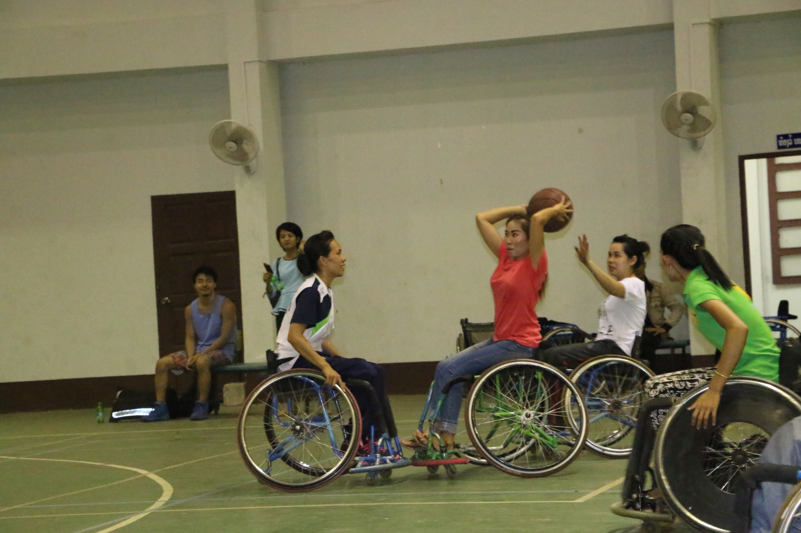
- Participants’ story.

“My name is Phatsala and I am 30 year old. I am happy about participating in the wheelchair basketball practices. I never heard of people with disabilities playing basketball. Whenever I come to play, it's always very fun and good exercise, we have good teamwork, I get to meet new friends, and I have even had the opportunity to go to a tournament in Oudomxay. I really enjoy it.”

Appreciation for our Donors
We would like to show our sincere appreciation to all the donors for giving us the opportunity to practice wheelchair basketball and supporting people with disabilities in this kind of social activity. We hope that all those who have provided support feel proud.

