GLOBAL GIVING FUND
WHEELCHAIR BASKETBALL ACTIVITIES REPORT
“8th ASEAN PARA GAME IN SINGAPORE 2015”
  - December 2015

8th ASEAN Para Games

As a befitting finale of a major year for Singapore sports, December 2015.Singapore hosting the 8th ASEAN Para Games. It is history in the making as it will be the first time Singapore hosts the ASEAN Para Games and a multi-sports event for the persons with disabilities of this scale.
ASEAN PARA GAME is a sport for the disabled peoples in the region, especially in the 10 ASEAN countries after SEA GAME must be held this sport more specific for person with disability. For this event Lao P.D.R. to send athletes to the disabled join 4 Sport such as: Goal Ball, Swimming, power lifting and Athletes.

Lao Disabled People’s Association (LDPA) also support wheelchair basketball to attend the game in Singapore by fundraising from the local companies, organizations and NGOs as well as with some support from Global Giving fund, we have support 14 athletes to attend the game in Singapore.

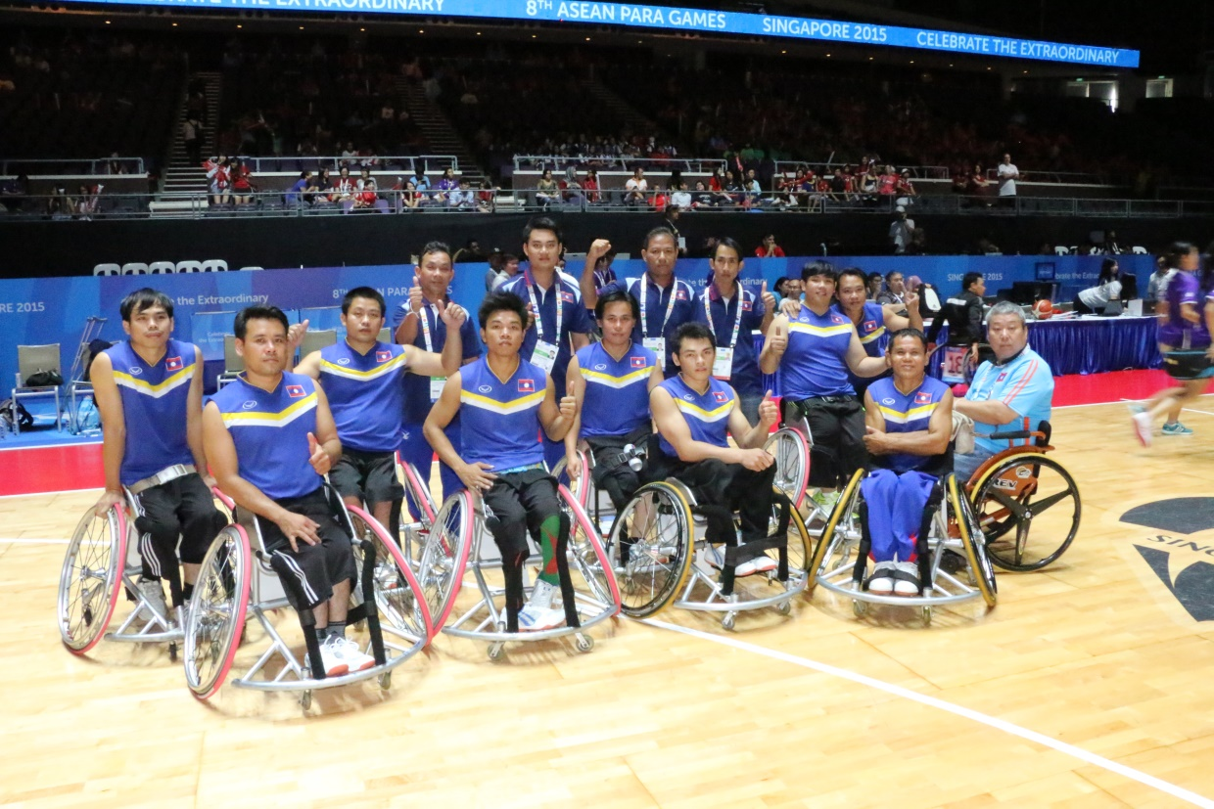

- Main Sponsors
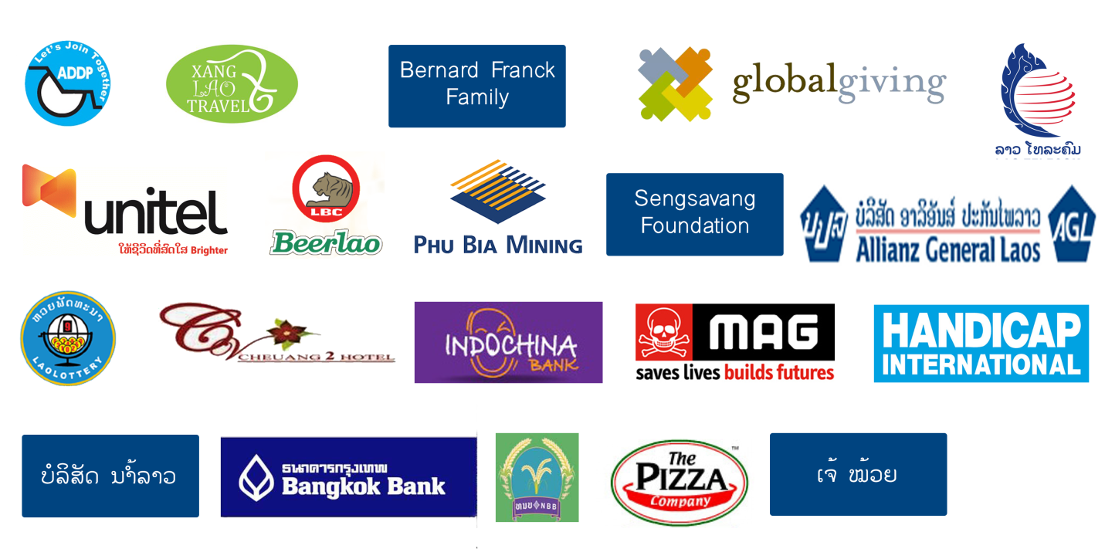

- Team and competition
Team
1 | Thailand
2 | Malaysia
3 | Philippine
4 | Laos
5 | Myanmar
6 | Singapore

Competition:
06-Dec-2015, 18:00’ (Click here to watch video)

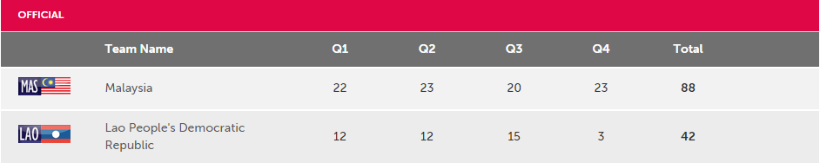

07-Dec-2015, 16:00’ (Click here to watch Video)
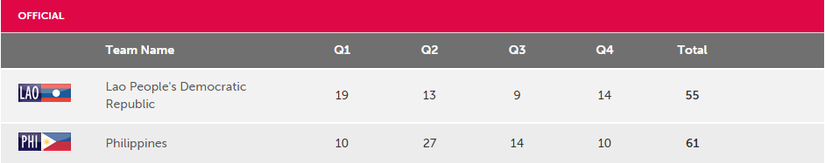

09-Dec-2016,08:30’
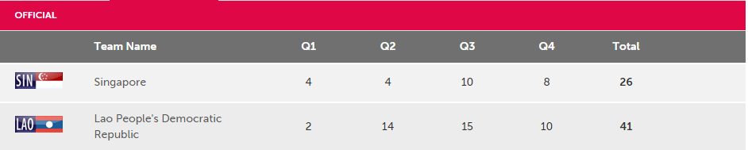
Competition result
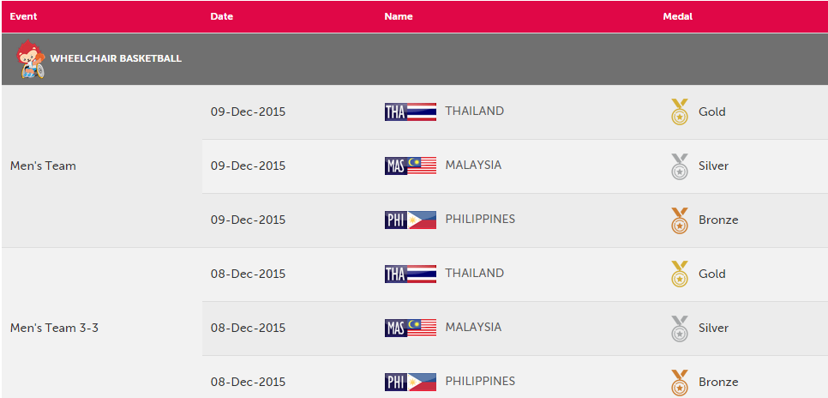

- Competition ranking
- Thailand
- Malaysia
- Philippine
- Myanmar
- Laos
- Singapore

- Developing plan for wheelchair basketball
This is our first international competition game that we have attend, it is a very good lesson learn for us to develop our team to grant the high standard practicing and to be able get the good record among the ASEAN countries in the next ASEAN PARA Game in 2017 in Malaysia by follow activities.
- Continues practice
- Do fundraising
- Set up mini tournament in country
- Attend national game in 2017

