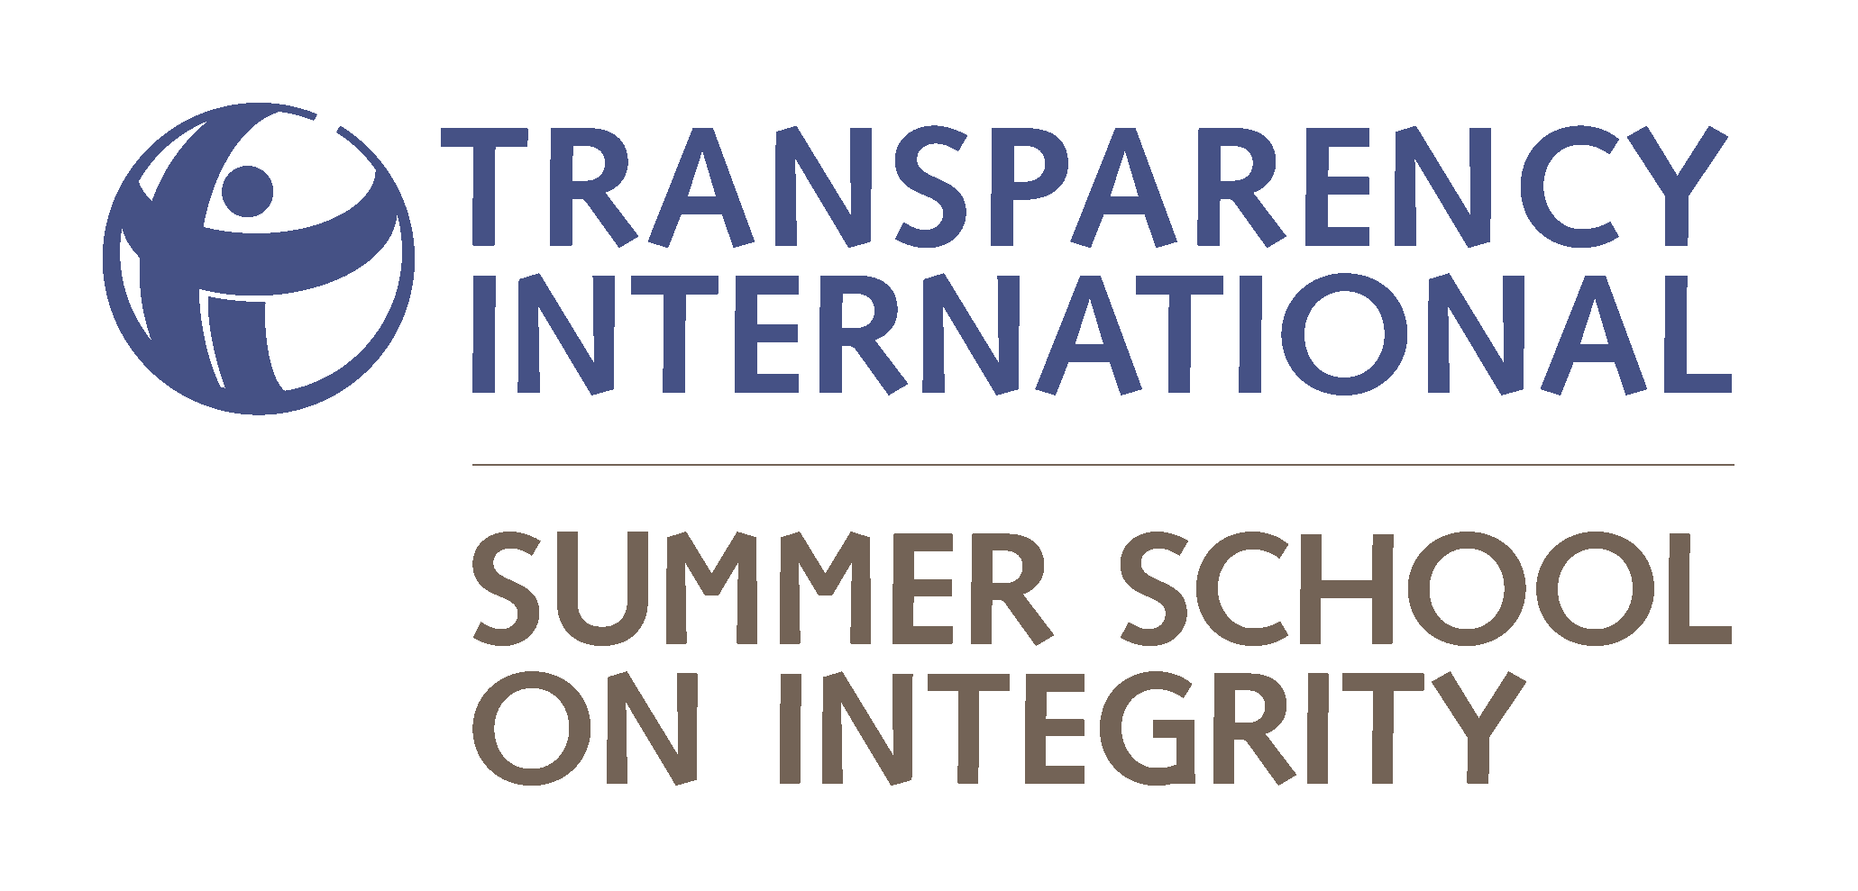

www.transparencyschool.org

Summary
In July 2013, more than 100 young people from over 40 countries will come together for Transparency International‘s fourth Summer School on Integrity. The students will learn from leading anti-corruption experts, take part in field visits, workshops and social activities and leave the School inspired and confident to fight corruption in their countries. With your help we plan to offer scholarships to talented students who would like to participate, but who otherwise would not be able to do so. Together we can help more young people attend the course and invest in those who hold our future in their hands.

What is the issue, problem, or challenge?
Young people have the potential to drive real change as today’s citizens and tomorrow’s leaders. Many young people are passionate about creating a better society in their countries and are highly motivated to attend the 2013 Summer School on Integrity, but need financial assistance to do so. We need your support to help these people realise their ambition to come to the School, contribute to its diverse learning environment and, most importantly, pick up the anti-corruption skills and knowledge they need for in their own countries.

How will this project solve this problem?
Taking place in Lithuania, the School brings together the leading anti-corruption professionals and young enthusiasts who work together on compelling real-life corruption cases, participate in lively discussions, develop their own ideas and have an opportunity to implement them with the help of the School competitive action grants. With your help we seek to make it possible for more youth leaders to participate in the School by providing competitive scholarships to those who otherwise would not be able to attend.

Potential Long Term Impact
The Summer School on Integrity sets out to inspire future leaders and invest in those who will be making public decisions in the near future. The School addresses the concepts of civic empowerment, e-democracy, public transparency and accountability. Members of the School’s alumni network do not only talk about change, they implement it. The network is composed of more than 200 youth leaders who joined our community and help take the fight against corruption to another level. Check out the pictures to see what our alumni are up to nowadays!

Project Message
Young people can be the catalyst for a brighter corruption-free future – they shouldn’t resign themselves to the status quo.

Project Quotes

‘You learn a lot, and you have fun. I have met people who care passionately about corruption, and I’ve learned hugely from them.’
- Nikola Ljubicic, student in the 2011 Summer School

‘It would be a mistake to think that only the participants get something out of this. It’s also those people invited to speak.
- Remigijus Šimašius, former Minister for Justice, Lithuania

'It is a fantastic innovation.'
- Daniel Kaufmann, Head of the Revenue Watch Institute, ex-Head of the World Bank Institute

