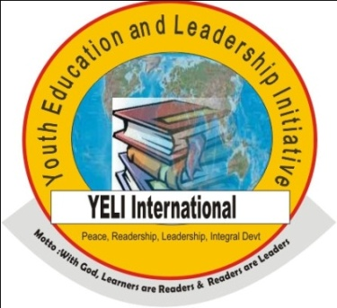

YELI Change Ambassadors Writing and Reading Competition Report

– in Partnership with (1) Nigerian Ministry of Education, (2) Dr. Parasaran Rangarajan’s Family in India, (3) The Taylor Paige Foundation USA and (4) International Peace Committee for Law, Justice and Human Rights, Romania.
Report by Mohammed Nurudeen and Amedu Monday Amedu – 23rd April, 2015
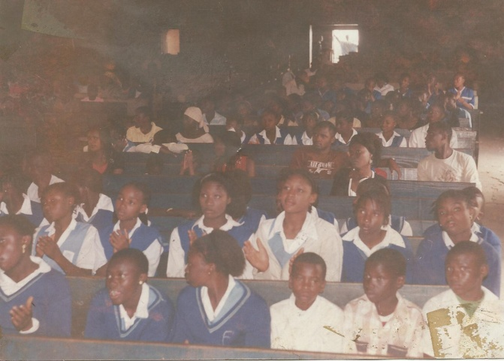
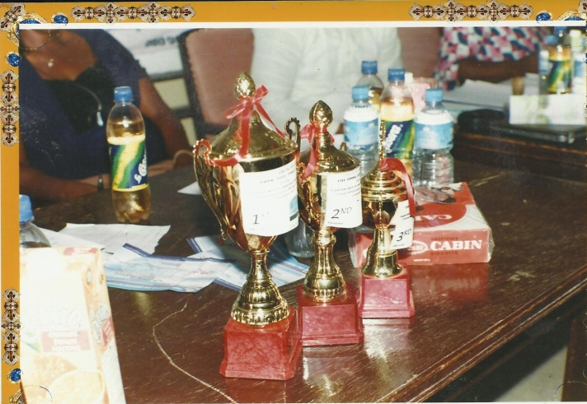

YELI Change Ambassadors Writing and Reading Competition successfully took place in Jos, the capital city of Plateau state, Nigeria. A few things you may want to read about Jos city. We had 13 contestants from Rochas Foundation College, 12 from Federal Government College, 13 from Airforce military school, 15 from St Paul's Academy, 11 from Airforce Girls Comprehensive School, 10 teachers from the 5 schools and many more non-student participants and stakeholders at the event.
Our members of the incorruptible panel of judges were made up of people of high profile in educational activities and very reputable calibers of individuals in youth social development.
Members of the panel of judges are as follows:
- Mr. Nsikan Udo, program officer, Bring Back the Book (BBB) Initiative
- Mrs. Josephine Gyang, education activist and teacher, Government Secondary School
- Dr Emmanuel Ande Ivorgba, CEO and founder, New Era Educational and Charitable Support Foundation
- Mrs. Beaty Lewis, Writer, motivational speaker and co-owner, Lubes Nigeria Limited
- Amb. Danjuma Ojei, project coordinator and founder, ICON Afrique Advancement Network
Reports in Detailed:
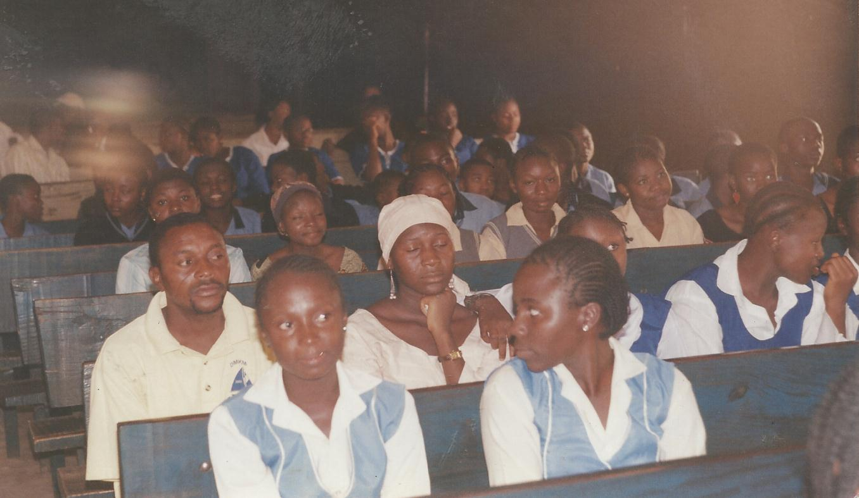
In an opening remark during the event, the president of YELI, Amedu Monday Amedu stated that the contest is meant to expand learning capacity of young people in primary and secondary schools, including other non-student youth so they are able to build good reading culture and establish confidence in essay writing, self expression, effective communication of written words and finding accurate ways to access the ability to form words creatively, as well as acquire leadership skills with which to be able to do better in all spheres of life. According to him, the entire program is entitled “Building Young people’s capacity through intensive reading and research, how possible, and what challenges?”
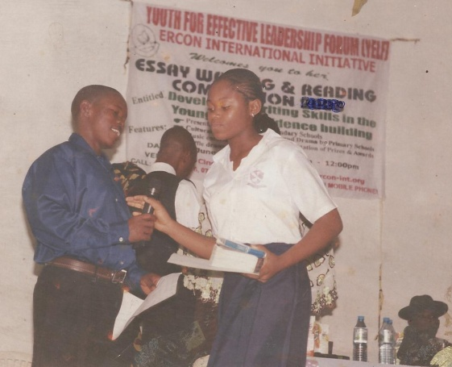
Amedu further re-iterated that every student/person that applied for this event is automatically qualified to be a Change Ambassador with Youth Education and Leadership Initiative (YELI), which means that the project will continue to work with and support these youth even when they have passed out from their various schools. “And while they are still in schools, their change ambassadors’ ID card gives them free access to reading and writing materials, including professional coaching on reading and writing skills training and effective leadership skills development opportunities as well as right to access and use a lot of educational DVDs and books from our office collection/library”, he concluded.
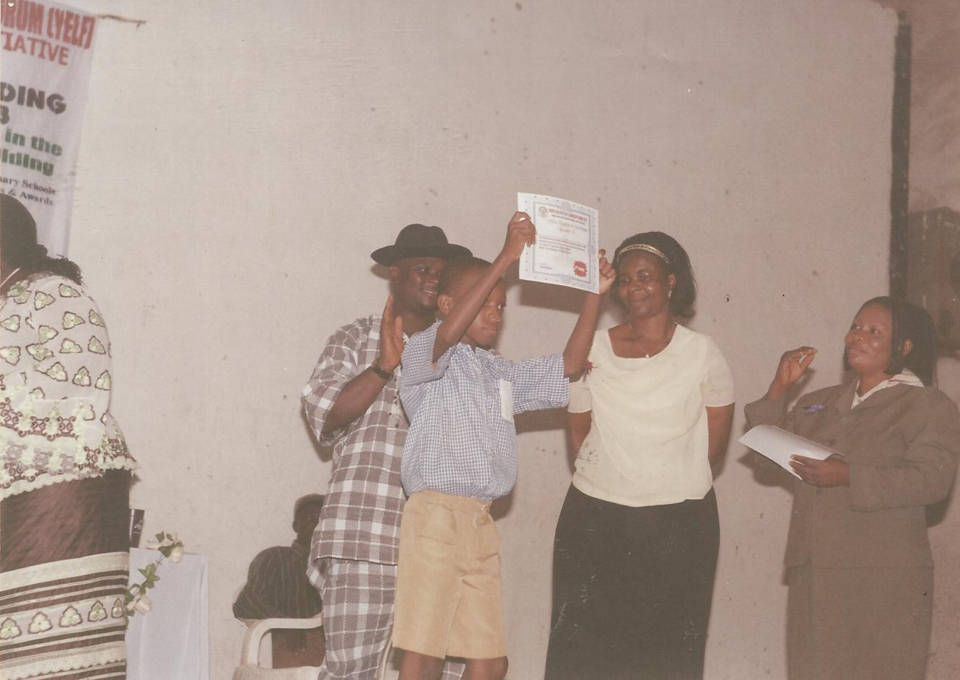
Another speaker at the event and also a member of the panel of judges, Mr Nsikan Udo who came from Bring Back the Book (BBB) project, one of the major partners to YELI’s change ambassadors program made short presentation on the theme “Reading and Research, the Basis for Literacy Promotion and Poverty Reduction in Nigeria”. During his presentation, Nsikan who was awarded a certificate of impact for excellence in leadership at the event disclosed that reading of books and intensive research task could help develop young people’s critical thinking ability, which will then easily enable them organize their intentions on papers in a manner that would be clearly understood by the reader, those who listen to the reader, interpret and commit these intentions to work for the purpose of solving illiteracy, ignorance and intellectual poverty challenges.
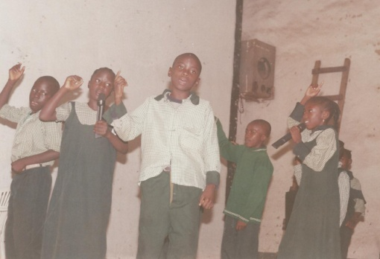
Commenting on the entire program, Nsikan also posed that YELI change ambassadors reading and writing event is not just a tool for promoting Universal Basic Education projects in schools, where ignorance, illiteracy and people’s intellectual quagmires are reduced to the barest minimal level, but that it would contribute immensely to a sustainable process of building effective leadership spirit in the youth and institution of intensive books reading culture in the entire Nigerian communities.
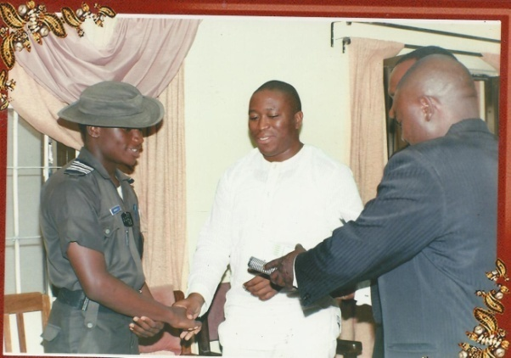
The founder and the Executive Director of New Era Educational and Charitable Support Foundation, Dr Emmanuel Ande Ivorgba, who is also the founder of the Int’l Center for African Philosophy and Metaphysics accepted the fact that YELI event was really worthwhile, and called on well-meaning individuals and organization home and abroad to partner so as to support and create sustainability of such laudable initiative. Ande also said that young school goers need to be given this kind of opportunities to build their confidence in presentations through often public communications, of the composed readable symbols as they grow into effective future leaders of Nigeria.
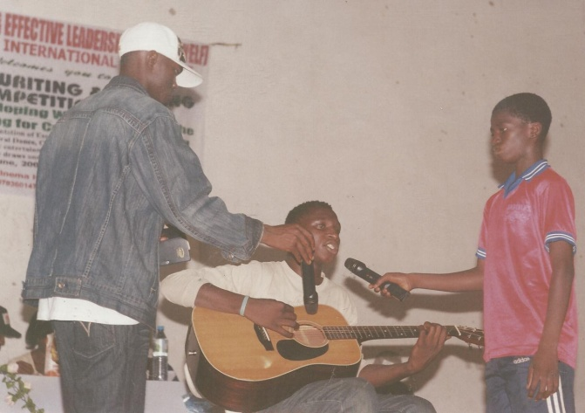
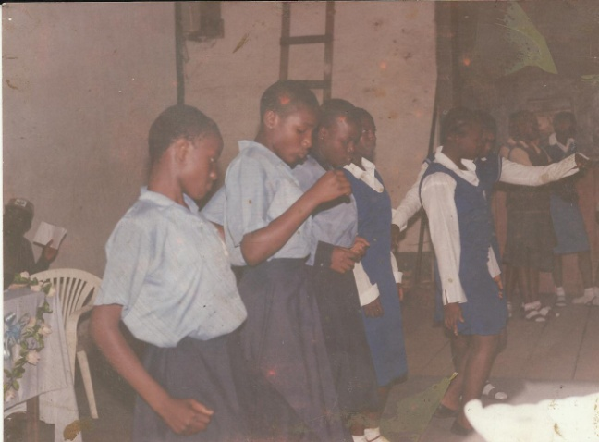
High points of the occasion were essay presentation from the various schools, musical show by Destiny boys, Comedy, questions and answers and award of prizes which came in both cash and kind. 1st prize of #150,000 ($1,250), a certificate, a bigger size trophy and a set of books went to Airforce Girl’s Comprehensive School; 2nd prize of #130,000 ($1,150), a medium size trophy, and other packages went to Federal Government College and St Paul’s Academy won the 3rd of prize of #120,000 ($1,000), a smaller size trophy etc. other schools also got certificates and set of books for their schools.
The event came to a successful end with a vote of thanks from YELI’s project officer, Mr. Mohammed N. Afolabi, who thanked all the participating schools for their support of the contest and encouraged them to keep promoting the vision of YELI as change ambassadors. Afolabi also extended the NGO’s appreciation to Bring Back the Book project for donating the trophies and commended New Era Educational and Charitable Support Foundation and other partnering organizations for their supports. He concluded by also thanking the MD of Hamaz Communications and Esbad Nigeria Limited for their various support.
CONTACT US TODAY FOR SPONSORSHIP OF NEXT MONTH’S EVENTS:
Office address: No 22B, Tudun Wada Ring Road, Jos Plateau, Nigeria.
Phone No: 08098147740, 08037451705 and 08097573335
Emails: writeyeli@gmail.com Website: www.yeliprojects.org

