Design Proposal for Siyaphambili Orphan Village Soup Kitchen Project on Global Giving 3/2013

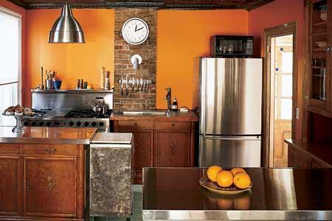

This document shows one idea of how the kitchen at Siyaphambili Orphan Village could be renovated 100% to make it a fully functioning large scale cooking and storage space as is so badly needed for that area in Langa Township – a real soup kitchen. The design photo [above] of the proposed kitchen for this Project kitchen would require only minimal carpentry as it would fit into the footprint of the current kitchen/dining area of Siyaphambili. We would plan to use locally available, lightly stained, pinewood simple-style cabinets only along the sink wall, and the sole built-in appliances are the dishwasher and a grill. The commercial grade refrigerator and 6 burner range with hood, placed against the opposite wall stand independently, as does the 30-by-72 stainless-steel table/work surface that centers the room. There is a small second sink to provide water for drinking, hand washing and to handle the extra pots and pans when the meal is serving a larger crowd. We particularly like a freezer-on-the-bottom refrigerator like the one shown, because while it is only 24 inches deep, it is 48 inches wide, and holds three times what the current refrigerator does without taking up the whole kitchen. A second, badly needed stand alone freezer would be placed in the garage.
The lighting fixture provides task lighting for food preparation as well as overall illumination. To store the cookware, moveable wire shelving on wheels adds flexibility to the space. For the countertops, a stone-like porcelain tile is cost-efficient, is durable and easy to clean. The backsplash could be tumbled marble in a similar hue, or plain porcelain tiles.

A more institutional type soup kitchen is also being considered and priced out and would look something like this:
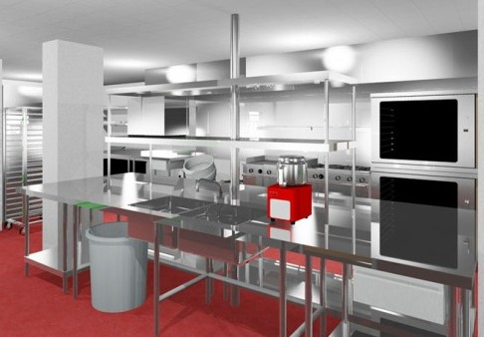
This would be sized to fit the space available and modified to make it as safe and efficient as possible.
Right now only a dream, but with the completion of the fundraising for this project – a reality and a huge immediate impact on the situation at Siyaphambili today and for the future for Langa.

