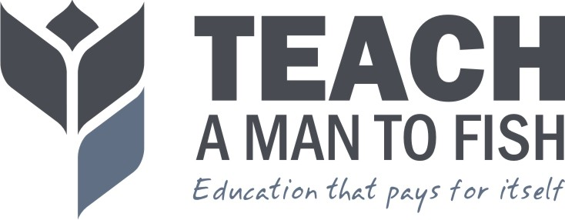

Technical Assistance Proposal: Embrace It Africa

Brief:

Embrace It Africa is a small community based organisation working in the village of Bethlehem, close to Kyotera Town in Rakai District, Southern Uganda. Embrace It Africa have approached Teach A Man To Fish to provide training on business planning to those giving and receiving micro-finance loans as part of the Embrace It Africa Micro Finance programme.

What Teach A Man To Fish can offer: Teach A Man To Fish have 7 years experience training teachers and students in school business planning and development. Our experience training a wide range of age and abilities on the basics of business planning and budgeting for profitable businesses makes Teach A Man To Fish ideally suited to training in a micro-finance context as well.

We propose one of the following options for support:

Option 1: Two Day Workshop

Option 2: 2 x Two Day Workshop

Both Option 1 and Option 2 include a resource pack that supports the content covered in the workshop.

Objective: To hold a business planning workshop for up to 30 community members, either receiving or managing micro-finance loans.

Output: Up to 30 community members (including Micro-loan managers) will be trained in basic business plan research and writing. The community members will be clear on how to replicate the process and training, using the resources they will be given by Teach A Man To Fish. The output of the training will include an easy to use resource back to be used by community trainers to train the recipients of micro-loans.

Outcome: Micro-loan receivers will have an increased ability to research and write an effective business plan. Micro-loan managers will be able to replicate the training given by Teach A Man To Fish to future groups of borrowers. This makes the training inherently sustainable, since the loan managers are able to replicate the training to further beneficiaries without further assistance from Teach A Man To Fish.

Impact: The businesses being supported by the micro loan foundation will be better researched and planned, leading to a higher success rate of business implementation.

Proposed Programme

Option 1: Two Day Workshop

The aim of the 2 day workshop would be to train loan receivers and loan managers on a simple business planning methodology that can be easily replicated by the local community. The workshop will be accompanied by a resource pack that loan managers can use to train further groups, and that loan receivers can use to plan their business.

Day 1

Morning Session – Introduction to Business Planning Part 1
- Resource Assessment
- SWOT Analysis

During this session the participants will be introduced to the Business Plan Template that they will be completing. They will also take part in a Resource Assessment activity which will highlight the importance of using exiting resources. By looking at the Strengths, Weaknesses, Opportunities and Threats (SWOT) for their existing or new businesses, the participants will be able to identify ways they can improve their chance of business success.

Afternoon Session – Introduction to Business Planning Part 2
- Market Research
- Competitor Analysis
- Marketing and Sales Plan

During this session the participants will devise their own Market Research Survey which will enable them to identify their target market and analyse their needs. Participants will also analyse their competitors and create strategies to beat the competition .These skills are essential in order to perform effective business research which leads to a higher chance of business success Information from the Market Research Survey and Competitor Analysis will be used to form a Marketing and Sales Plan.

Day 2

Morning Session – Introduction to Financial Planning
- Completing a simple Financial Plan

During this session the participants will be introduced to Financial Planning and the Financial Plan Template they will be completing. The participants will then take part in a group Financial Planning Activity which will prepare them for completing their own Financial Plans. A lack of financial planning and management is the most common cause of business failure. Learning to plan for income and expenditure on an annual basis can greatly improve the chance of business success.

Afternoon Session – Record Keeping and Financial Management

During the final session the participants will learn and discuss the importance of Record Keeping and Financial Management. They will then devise their own Record Keeping and Financial Management strategies, which are essential for maintaining control over business profitability.

Option 2: 2 x Two Day Workshop

The first Two Day Workshop will be the same workshop as described above, with the same objective.

During the second Two Day Workshop the community trainers will deliver the workshop to a different group of participants using the resource pack. The Teach A Man To Fish Field Officer will support and guide the community trainers through the workshop, ensuring they are delivering the material effectively. The aim of the second workshop will be to consolidate the training skills of the Community trainer, to ensure the training can be replicated accurately with future groups of micro-loan borrowers.

Finances

Option 1: Two Day Workshop

Field Officer Day Rate: 200,000 UGX

5 x Field Officer Day Rate = 1,000,000 UGX
- 2 Day preparation of workshop
- 2 Day delivering workshop
- 1 Day preparation of resource pack

Resource Pack: 15,000 UGX per participant

This does not include transport, food and accommodation. This should be covered by Embrace It [estimated cost of 150,000 UGX]

Option 2: Three Day Workshop

Field Officer Day Rate: 200,000 UGX

Three Day Workshop

7 x Field Officer Day Rate = 1,400,000 UGX
- 2 Day preparation of workshop
- 2 Day delivering workshop
- 2 Day supporting community trainers deliver workshop
- 1 Day preparation of resource pack

Resource Pack: 15,000 UGX per participant

This does not include transport, food and accommodation. This should be covered by Embrace It [estimated cost of 300,000 UGX]

We are welcome to discuss a combination of the two options, or any suggestions you have.

We look forward to working with you soon!

