Enviro Options (Pty) Ltd

A Strategy for International Growth

October 2005

I Background

II Export Constraints

III Business Model

IV Existing International Licence/Marketing Agreements

V Target Countries & Customers

VI Why invest in the Enviroloo?

VII Contacting Enviro Options (Pty) Ltd

Appendices

Investing in a Mexican Manufacturing and Marketing Licence

Investing in an Enviroloo Public Toilet Franchise in [El Salvador]

List of Awards and Institutional Recognition for the Enviroloo toilet

I Background

Enviro Options (Pty) Ltd (“EO”) was founded by Brian, Gavin and Mark La Trobe in 1993 based on the research and development work of Brian. The company was first registered in 1995.

Since 1995 some 24,000 units of enviroloo toilets have been installed across 10 countries in Africa, Australia, Europe, (Greece), South, Central America, the Middle East, Asia and the USA. The Intellectual Property of the technology has been patented in some 64 countries.

The company’s first exports from South Africa were made in 1997 on the sale of toilets to Botswana and Ghana, and such external sales now represent an important part of EO’s business.

II Export Constraints

The nature of the enviroloo, and the target market for the product, impose a number of limitations on export sales from South Africa, namely:

- Transport costs are a material factor;
- Distribution direct to the public via retail outlets is not (at this stage) a viable option;
- The application of the enviroloo is frequently within public projects where there is an emphasis on local production and job creation.

For the above reasons and other strategic considerations, EO believes that international growth will ultimately be driven by local manufacturing and marketing licence agreements.

III Business Model

EO defines itself primarily as a technology development company. Outside of South Africa, EO does not seek to play an active part in the manufacture and marketing of the product. This is the role intended for local licence holders. A standard licence agreement for the right to manufacture and market the product within a country includes an upfront fee to cover the costs of the necessary moulds, tools for production and training, with royalty payments on sales revenue. EO’s motivation is to select and then support appropriate licence holders in key global markets. The upfront fee generates some return on EO’s considerable capital investment in the enviroloo, and ensures a minimum level of service attention from EO. However, the alignment of interest between EO and the licence holder (via the royalty payments as a % of sales) goes beyond contractual service arrangements, in that both parties are motivated to work together to maximize enviroloo sales.

IV Existing International Licence/Marketing Agreements

EO has agreements in place on the production and marketing of the enviroloo toilet in the following countries:

- Australia
- Botswana
- Ghana
- Nigeria
- USA
- Sales to other countries are exported from South Africa to distributors who have been trained to install and maintain the units

The existing licence holders do not demonstrate a single profile, but EO typically looks for a licence holder with the following attributes: manufacturing experience, construction industry and/or Government contacts, and a reputable market profile.

V Target Countries & Customers

EO is open to any new licence opportunities, but is particularly motivated at this stage to establish a manufacturing and marketing licence within Latin America and Asia. These two markets represent very substantial growth opportunities for EO, and a high profile success in a country within each region would be a valuable boost for the company. Moreover, a manufacturing base in a country such as Mexico could then serve surrounding countries far more cost effectively than exporting the product from South Africa to El Salvador for example. EO’s initial research highlights the following countries as priority markets for development:

- Mexico
- Brazil
- Philippines
- Thailand
- Indonesia
- USA
- Saudi Arabia/UAE

It is estimated that some 3 billion people in the world have inadequate access to effective sanitation. This is a very large potential market for the enviroloo, and there will be much variety of need and want from the product within such a substantial proportion of the world’s population, but in a superficial sense there are two broad customer profiles for users of the enviroloo.

Firstly, impoverished groups of people with very limited resources of their own, and realistically therefore not potential buyers of an enviroloo for their exclusive use, and secondly individuals/corporations willing/able to purchase an enviroloo for exclusive use. In the first instance, the enviroloo needs to be applied in a collective social setting, in the latter case the enviroloo represents an aspirational consumer product.

EO’s existing global sales are spread across a variety of sector buyers covering both of the above user categories: Municipal/Government for public housing and social infrastructure projects, Multilateral Aid Agencies and NGOs for emergency relief and development projects, Private Housing Developers, Nature Reserves/Beaches & Public Parks and Private Home owners. Each of these sectors will remain target markets for the enviroloo, but lower-middle income residential housing projects in the above countries are considered particularly important. The projected growth in urban development here will place great burdens on existing water and sanitation resources, and the enviroloo offers developers an alternative route to expensive waste water treatment plants.

VI Why invest in the Enviroloo?

The stakeholders in EO are extremely proud of what has been achieved in the first ten years of the company’s history:

- The technology behind the enviroloo toilet has been widely recognised and rewarded;
- 24,000 units have been installed in ten countries;
- A number of major institutions have backed the product through the purchase of enviroloo toilets for a variety of installations, e.g. World Bank, Impala Platinum Mines, Northern Province of South Africa. Dept of Education, the Municipality of Middelburg, the Municipality of Cape Town for high profile public toilets on the scenic drive of Chapman’s Peak and Signal Hill near Table Mountain, public toilets for the city of Accra Ghana and for the University Uganda in Kampala.
- Patent protection for the product is in place in some 64 countries;
- EO has developed strategies for delivering the enviroloo product to some of the world’s most economically impoverished communities.

But, the scale of the challenge and opportunity for the product dwarfs such past achievements. The enviroloo represents a cost effective and hygienic form of sanitation in a world where some 3 billion people are living without such services. This is a very significant investment opportunity, both financially and in terms of its “greening” environmental impact.

VII Contacting Enviro Options (Pty) Ltd

Individuals or corporations interested in working with EO can make contact as follows:

Mark La Trobe MD Enviro Options (Pty) Ltd. P.O. Box 13 Kya Sands. Johannesburg South Africa 2163.
Tel : +27.11.708.2245. Fax : +27.11.7082180. Mobile : +27.11.82.567.8654.
E Mail : {mark@eloo.co.za } Web-site. www.eloo.co.za.

The company is open to a variety of investment proposals. Two potential strategies for investing in the enviroloo are attached for consideration.

Appendix 1 - Investing in a Mexican Manufacturing and Marketing Licence

The opportunity – to acquire the rights to manufacture and market the enviroloo within Mexico.

Market potential – Mexico with a population of 106 million people, and an economy continually expanding within NAFTA, has in the past decade seen a transformation in its public finances. The country is in a period of aggressive renewal of its physical and social infrastructure, including low-income housing.

Likely investor profile – individual(s) or corporation with good understanding and contact base in the country, and an existing business focus overlapping with the enviroloo product.

Upfront costs in establishing manufacturing facility – It is presumed that the actual manufacturing would be subcontracted out to a roto moulding company.

Cost of a double set of moulds and other required production equipment.

Model 2010 (8 to 10 users per day) residential. $100,000.00. US
Model. 2040 (20 users per day) schools & public toilets $ 110,000.00.US.
Model DC (10 users per day) Residential $ 120,000.00.US.

Key terms of Licence Agreement with EO – See attached agreement.

Service commitment from EO – See attached agreement.

Basic Manufacturing & Assembly process for the enviroloo –

The enviro Loo is manufactured in polyethylene in a roto moulding process. To increase the rate of production the moulds are made as double units. The cycle time is around 45 minutes. When the items are released from the mould they are devided, trimmed and stacked. In the case of large projects the breakdown (CKD) parts are delivered to site where the unit is assembled. This saves on the cost of transport. The larger sections of the unit can be nested to save space on the vehicle. In the case of Model DC most of the parts are induction moulded.

Details of Enviro Loo product models and their current US$ retail prices:-

Model 2010 $ 3,100.00.
Model 2040 $ 3,550.00.
Model DC $ 2,500.00

Appendix 2 - Investing in an Enviroloo Public Toilet Franchise in [El Salvador]

The opportunity – providing a pay-per-user public toilet facility using the enviroloo within urban areas of [El Salvador].

Conceptual layout
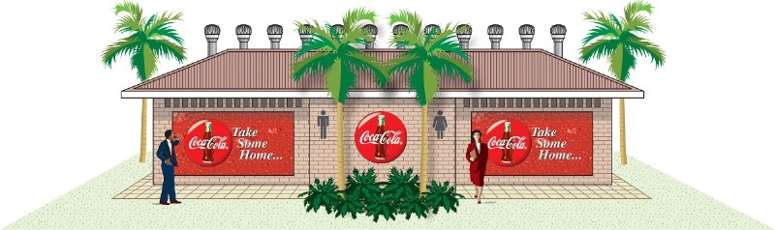

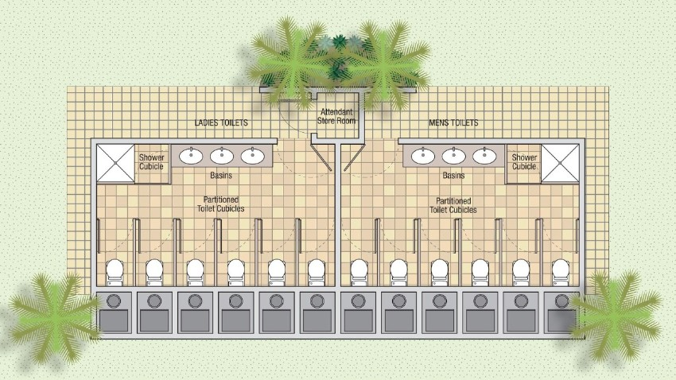

Market potential – the company’s experience within Africa indicates that urban dwellers without adequate sanitation, even those living in relatively impoverished conditions, are willing to pay a small fee for the use of a hygienic toilet facility.

Likely investor profile – individual(s), corporations, Multi-laterals, NGOs wishing to promote ecologically friendly small business development within economically impoverished communities.

Business model – the investor/sponsor funds the erection of a public toilet facility, and then selects a suitable candidate to manage the facility on a franchise basis, i.e. a proportion of revenue is returned to the investor, the balance remains with the franchise holder to service the toilets and generate a livelihood (successful franchise holders ideally encouraged to open additional franchise toilet facilities).

Upfront costs – a typical public toilet facility using Enviro Loo toilets would require the following funding (in US$):

- 10 Enviro Loo toilets
(Inc Shipping from South Africa; excluding duties - US$ 30,000.00
- External toilet structure estimate– US$ 50,000.00
- Secure perimeter estimate for the public toilet facility – US$ 15,000.00

The prices listed above are estimates only. It is recommended that the construction prices be qualified at the intended location, to ensure accuracy.

Ongoing costs – maintenance of the facility will be minimal, but some training and co-ordination of the franchise holders will be required.

EO would normally expect the licensee or franchisee to visit South Africa for training at our head Office and factory. As the organization grows, this might not be practical, Expert EO staff will then have to travel to the country in question to provide the training.
In any event would not be at a significant cost.

Appendix 3 – List of Awards and Institutional Recognition for the Enviroloo toilet
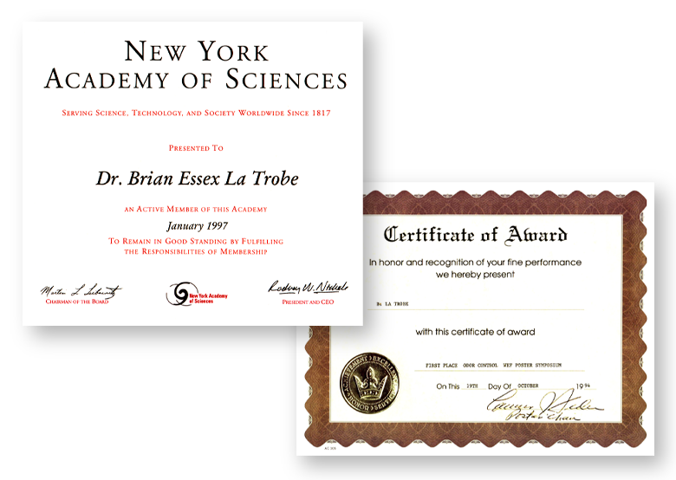

AUDI TERRA NOVA AWARD
UTILZATION OF LANDFILL
GAS AS A RENEWABLE ENERGY SOURCE
DATE: 1992
NEW YORK ACADEMY OF SCIENCES
RECOGNITION OF CONTRIBUTION TO SOCIETY (1997)
WORLD ENVIRONMENTAL FEDERATION
BIOLOGICAL MALODOROUS
FILTRATION SYSTEM
1995
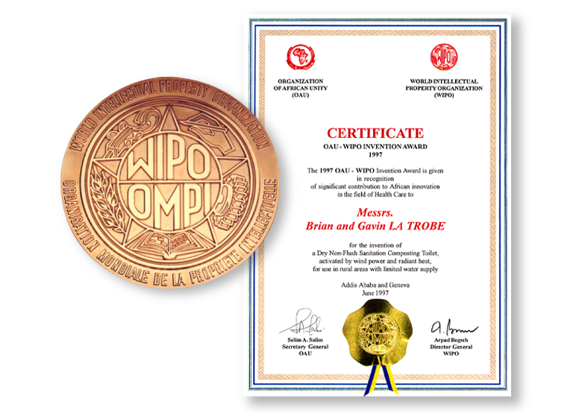

THE OAU – WIPO INVENTION AWARD (1997)
IN RECOGNITION OF CONTRIBUTION TO AFRICAN INNOVATION IN THE FIELD OF HEALTH CARE

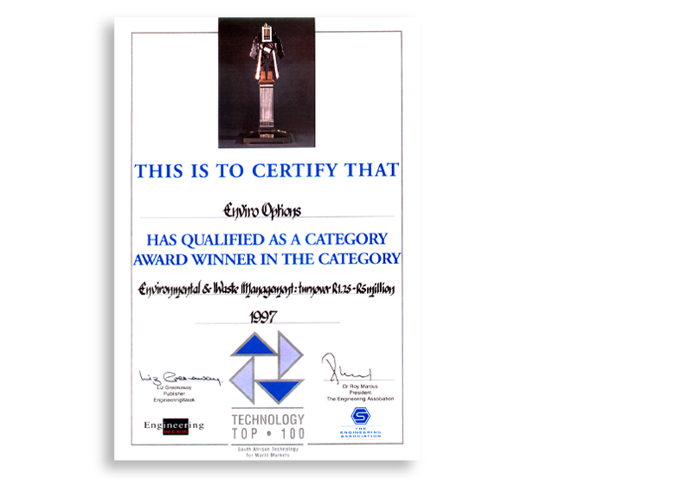

TOP TECHNOLOGY 100 AWARD
1997.

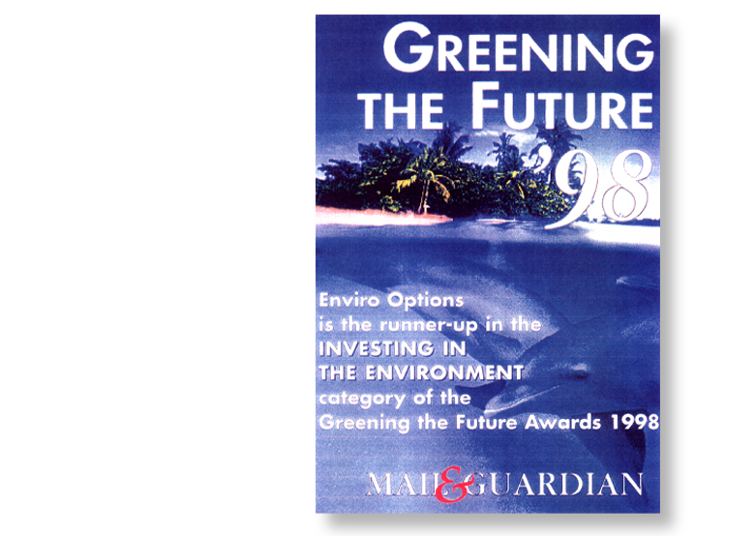
THE ENVIRO LOO

