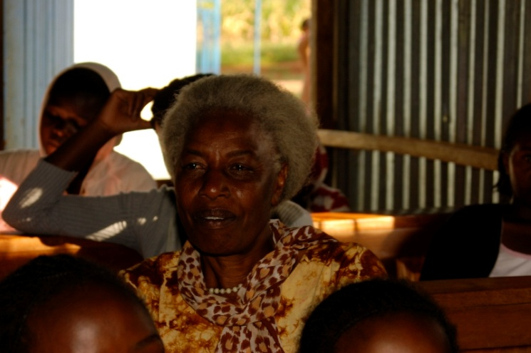
Grace, our team member and treasurer to the board, she spoke to girls who opened up to her their problems that led us realize our failures.

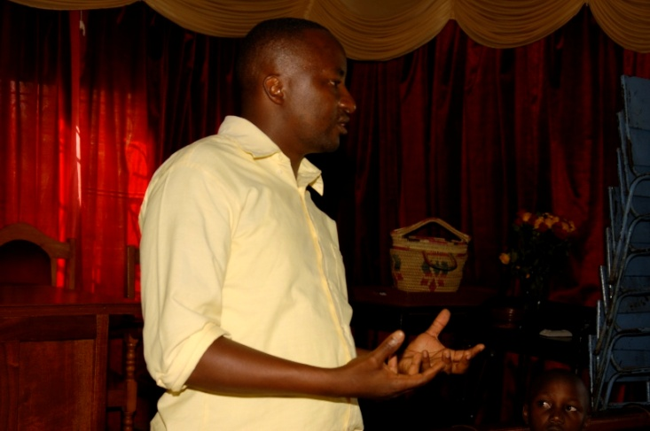
James, our project manager admitting to failures and apologizing to the beneficiaries for not being keen to listen to their issues.
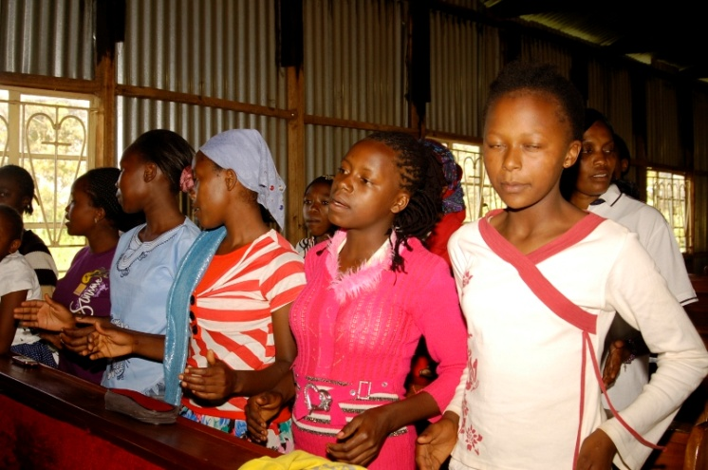
Some beneficiaries in a training session. Here we have encouraged them to speak out without fearing prejudice from the project workers.
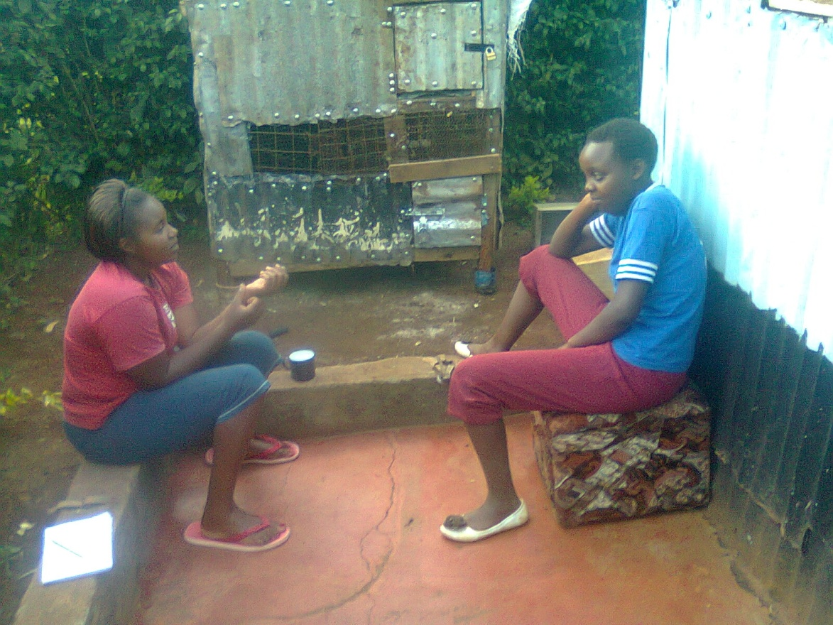
Soni on the left our team member talking to a beneficiary, this was the first girl who spoke negatively on reusable sanitary kits but we quickly dismissed her, today we take the guilt and is actually our hero for it is through her we have learnt though our failures.

