AMAI– Mozambican Association for the Support of Older People

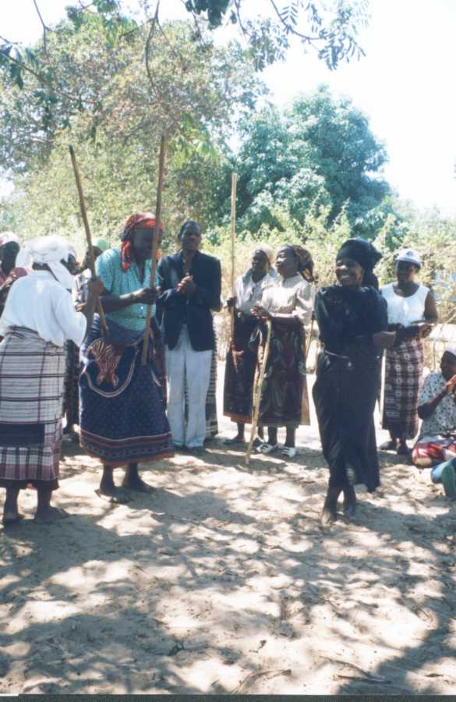

“Working towards
Social
Justice
and
Sustainability”

Origins:

AMAI was formed by a group of 25 founding members, intervening in several program areas responding to the changing needs of older people. AMAI emerged in 1996 and was officially recognized by the government in 1998. From the beginning of its activities, AMAI has provided social assistance to older people, through construction of houses and distribution of clothing, food items and seeds and tools for agricultural activities, covering over 300 older people.

In 2002 AMAI re-focused the organization to be more development orientated implementing programs in, agriculture, water supply and the environment. AMAI is currently working in the Province of Maputo outside of the urban area.

Mission:

AMAI is a Mozambican NGO, working for social justice, and cultural survival through practical interventions that motivate positive changes in older people’s lives. AMAI achieves its goals by sharing human and material resources and information. AMAI aims to assist older people to improve their quality of life and well being through a combination of programs in: Agriculture, The Environment, Income Generation, Gender, Health (HIV/AIDS), Civic Education including Lobbying and Advocacy, and Intergenerational Linkages in the Community and through Institutions.

Vision:

Continuously contributing to the development processes in Mozambique by proposing creative policy approaches to alleviate poverty and socio-economic exclusion and make a difference in the lives of older people.

Objectives:

- Ensure broad participatory approaches are engaged within the community while promoting Rural Development, Health and Income Generation activities to raise the quality of life for older people.
- Encourage socio-economic development strategies, promoting the incorporation of older people’s concerns into the policies, strategies, and decision-making bodies of all levels of Government through advocacy and the facilitation of studies and research.
- Promote measures, which will contribute to the change of socio-cultural behavior and the reinforcement of traditional cultural structures.

Strategic areas:

- Sustainable livelihoods: Contribute to the provision of economic alternatives for older people and their communities by facilitating access to credit schemes and Income generation activities.

- Health: Assist community health efforts, to become more efficient in providing health education to communities and to prevent the spread of HIV/AIDS.

- Rights: Strengthen the capacity of communities, particularly older women, to be more effective in gaining access to land and to increase the capacity and skills of agriculture production for their survival.

- Action on Ageing Campaigns: Participating in the National and International Commemorative dates such as International day of Older People -1st October, HIV/AIDS Day 1st December, International Workers Day -1st May, Mozambican Women’s Day – 7th April.

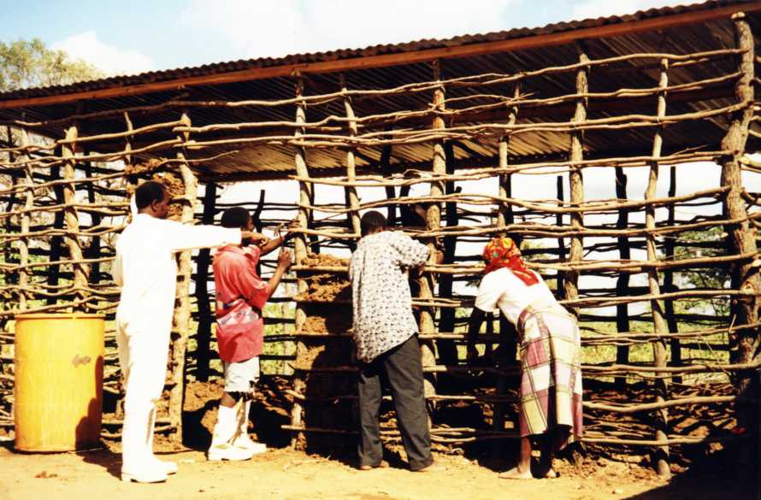

Program activities

- Emergency and floods assistance:

  - Constructed 60 houses in partnership with older people and their families.
  - Distributed seeds and tools to promote market and gardening activity, and the re-establishment of the food security in the area.
  - Lobbying and advocacy through linking local governments and older people and to promote their requirements and needs.

- Home visitations:

- Identification of the major problems affecting older people, and establishing links with Departments of Social Action and Health for possible solutions.
- Identify possible coping strategies for older people and to fundraise for their needs to improve their well being.

c) Exchange visits

- AMAI has participated in reciprocal exchange visits among its partners.

d) Who are our Partners?

- AMAI has been linked with the 'Third Age Forum' (FTI) in Mozambique for or the last 7 years. The organization currently has 10 national affiliated members.

e) Lobbies and Advocacy

- Trained older people in gender and legal issues to claim and better understand their rights.
- Involvement of older people in discussions on the National Policy on Ageing, recently approved by the Mozambican Government.
- Older people participating in radio and TV discussions on various issues affecting them.

Involvement of older people

- The members of the Organization are actively involved in all activities. Older people participate as volunteers, and are involved in sports and cultural activities, home visits, and counseling.

Organizational Structure:

The Management and Supervisory Boards are comprised of three members each and are elected through a General Assembly. There are three project staff, Senior Citizens Council and 15 activists. AMAI currently has 35 affiliated members.

Strengths: Strong links with the beneficiaries and community based Organizations, including local leaders and local government structures.
Highly community orientated in rural based activities.

Weaknesses: Lack of enough financial resources and adequate skills for the on-going demand of the projects.

For more information, please contact:

José Pedro Momade,
PO. Box 4112,
Rua Valentin Siti n. 410,
Maputo, Mozambique

Tel: 082 32 58 73

Water, Tools and Seeds for Communities in Mozambique

Mozambican Association for Helping Older People
(Associacao Moçambicana de Apoio ao Idoso- AMAI)

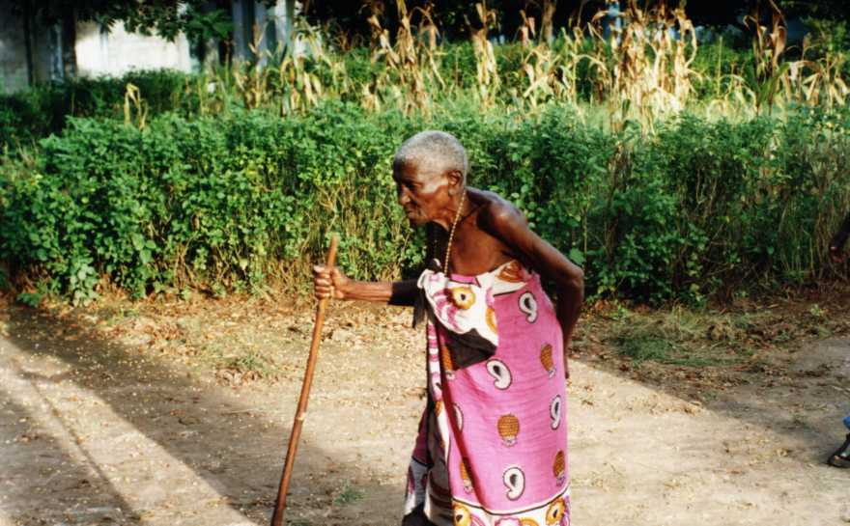 | Older women are travelling 6 miles to fetch water. Older People need easier access to drinking water reducing their burden of caring for orphans and reducing the risk of diseases. Older Women in particular are not given the legal rights to their land. We are working to change this.
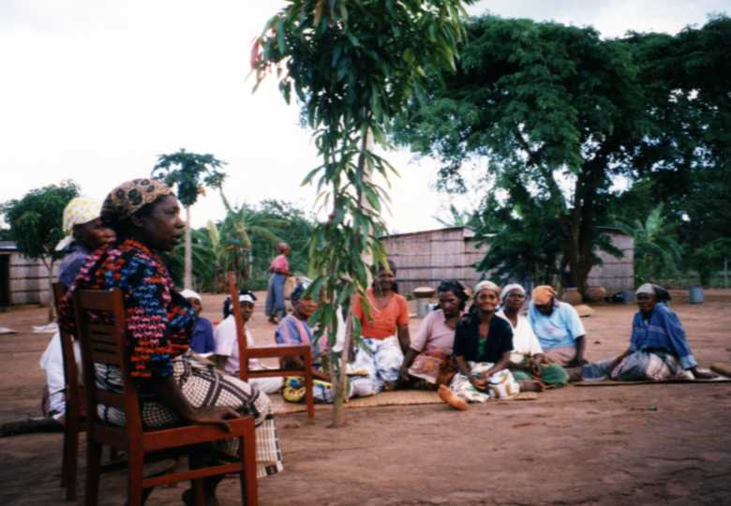 | We participate within the communities helping to find the resources to solve their problems. Women are travelling 6 miles to fetch water. We want to build wells, and provide water filters so as to reduce diseases. We help them produce their own food through distributing seeds and tools.
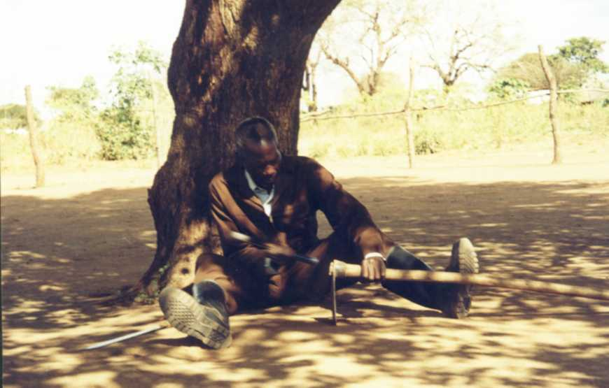 | We help them produce their own food through distributing seeds and tools. Older people feel that they contribute to their families when we help in this way. They have orphans to look after, there is no time for resting.
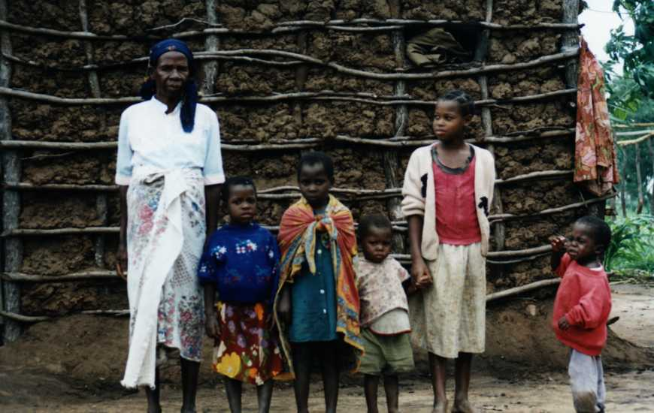 | Older women are travelling 6 miles to fetch water. Older People need easier access to clean drinking water reducing the risk of diseases and their burden of caring for orphans. We are opening doors to better health by building wells and providing water filters.
 | Opening doors to clean water, and food security through building wells, providing water filters and distributing agricultural seeds and tools. Older people are left out of most projects. They have the main burden of caring for orphans. It is through older people that we help the whole community.
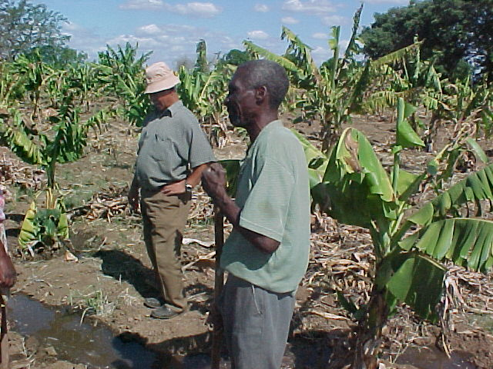 | Through our Agriculture projects we help make the land productive. Through access to water, provision of seeds and tools the community works together to alleviate absolute poverty.

