PROPOSED INTERVENTIONS FOR GOVT. GIRLS SENIOR SECONDARY SCHOOL, AZGHESAN NAGAR, CHENGALPET, CHENNAI, INDIA: 2013 -14
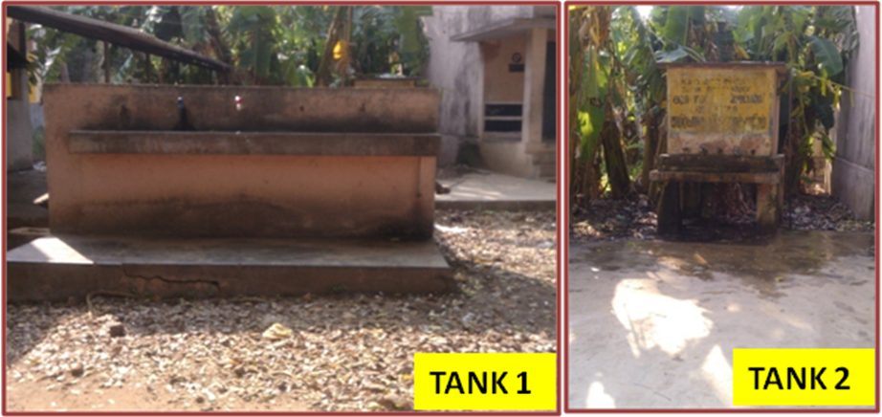
THE PRESENT DRINKING WATER FACILITIES IN THE SCHOOL
I. PROPOSED ACTION:
- CONSTRUCTION OF A NEW 10,000 LITRES STORAGE TANK WITH TAPS FITTED AROUND IT
- PROVISION OF WATER PURIFICATION SYSTEM
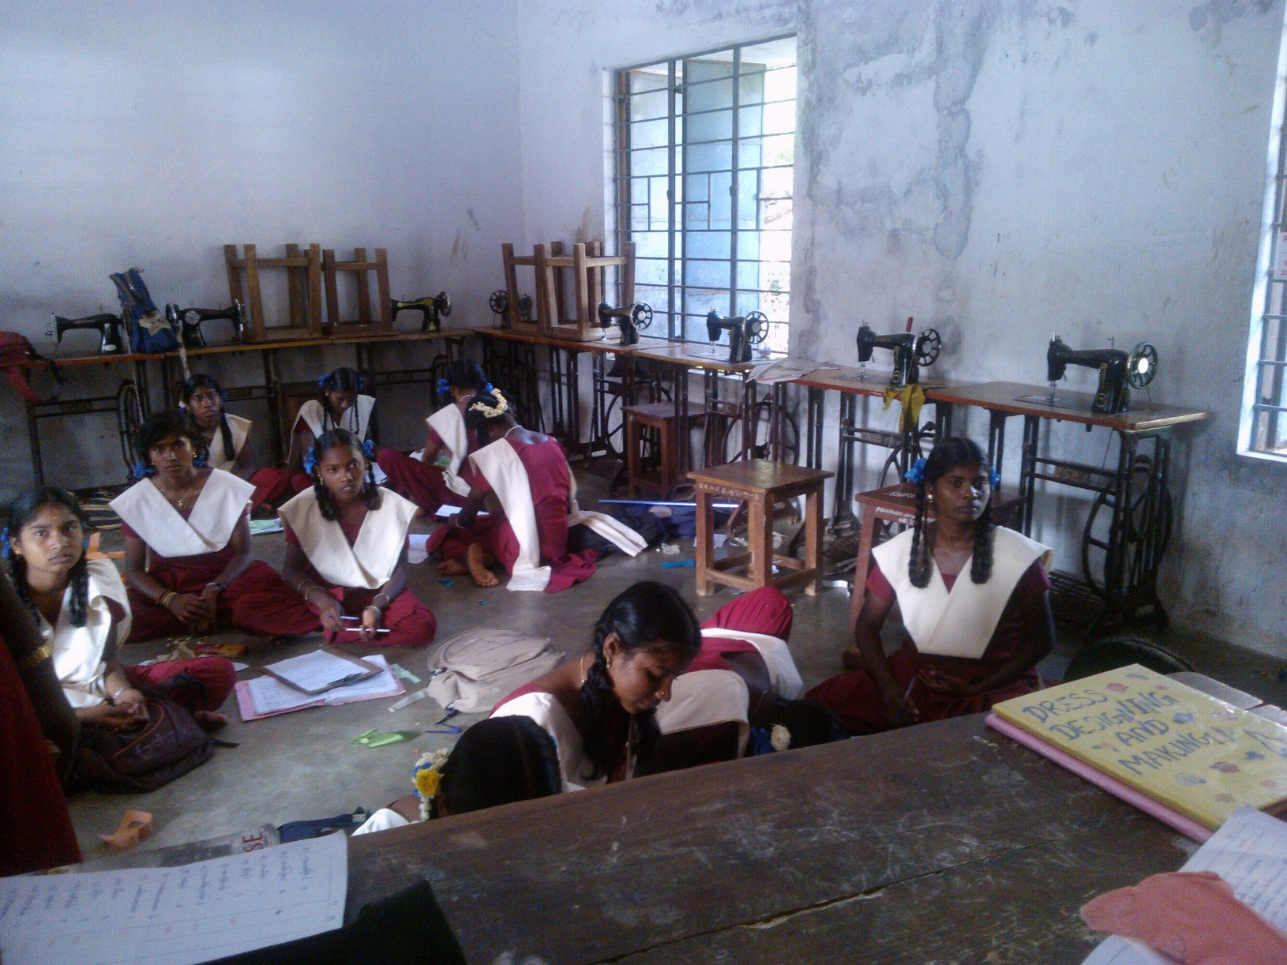
PRESENT CUTTING & TAILORING BATCH OF 30 STUDENTS

II. PROPOSED ACTIONS w.r.t DRESS MAKING VOCATION: ADDITION OF
- CREATIVE DESIGNING/ EMBROIDERY MACHINE , JUKI MACHINE
- IRONING BOARD AND IRON
- INTRODUCE WORKPLACE VISITS
- CUTTING TABLE (S)
- DUMMIES TO HELP UNDERSTAND BODY MEASUREMENTS & PROPER FITTING OF GARMENTS STITCHED
- DISPLAY BOARDS, STORAGE UNITS, IMPROVE SECURITY SYSTEMS OF THE ROOM
- TEACHING LEARNING MATERIALS: BETTER EQUIPMENTS, CHARTS, LIBRARY etc.

III. PROPOSED ACTIONS w.r.t. NURSING TRAINING: ADDITION OF
- RE-INTRODUCE VISITS TO NEARBY HOSPITAL FOR PRACTICAL LEARNING
- DUMMY & TEACHING LEARNING MATERIALS FOR BETTER LEARNING OF BODY ANATOMY, etc
- IMPROVED HOUSEKEEPING STANDARDS, NEW FLOORING
- LEARNING HOW TO USE MODERN DEVICES LIKE GLUCOMETER, B.P. APPRATUS etc
- DISPLAY BOARDS, STORAGE UNITS, IMPROVE SECURITY SYSTEMS OF THE ROOM
- 2 –SETS OF UNIFORM, LIBRARY FACILITY
- MEDICAL EQUIPMENTS

IV. CONSOLIDATED LIST OF PROPOSED INTERVENTIONS TO IMPROVE THE QUALITY OF EDUCATION
- Developing purified drinking water facilities
- Water connection to the toilet blocks (presently toilets have no water facility)
- Strengthening practical opportunities of learning dress making in the school beyond sewing machines nothing exists as of now
- Strengthen quality of nursing training offered in school - learning is limited with no tie-up with any hospital, no teaching aids, etc
- Introduce personality grooming complete with soft skills, spoken English, financial literacy as a new course in the new academic session, which could well see them manning counters at retail outlets
- Support girls for preparation of entrance exams to technical polytechnics (FUTURE Operating Engineers)

