What does metamorphosis mean?
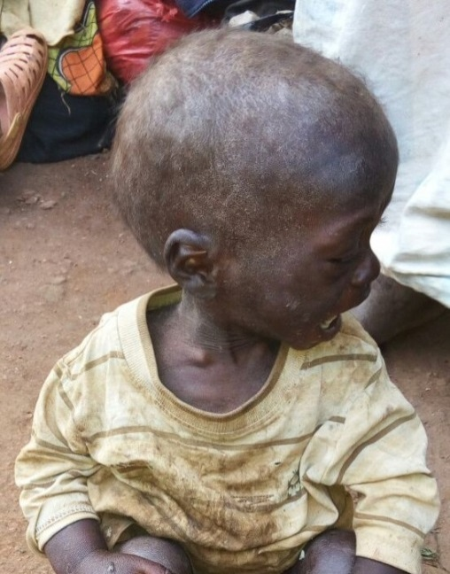
Metamorphosis is what happens to a little boy after a concerned neighbor becomes aware that a demented ninety year old grandmother daily leaves her orphaned two year old grandson alone.
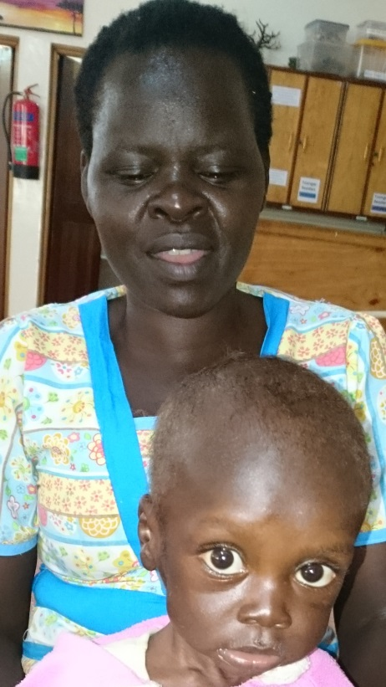
The neighbor brought Sheldon to Moi Teaching and Referral Hospital’s new Shoe4Africa Children’s Hospital last week, malnourished - weighing less than ten pounds - and developmentally delayed – unable to walk or talk.
After only a week of enriched food, lots of love, and attention, this sweet little boy’s eyes communicate his curiosity about this new world as he scoots around on our playroom floor, basks in the sunlight, cuddles up when the temperature drops and the rains fall, and watches his new “siblings” at play.
Best of all Sheldon’s broad smiles communicate the HOPE he finds among his new Sally Test family. This wee little one immediately won our hearts.
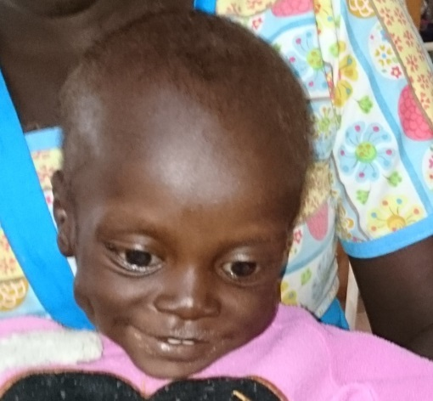
We anticipate Sheldon will be walking and talking as his world opens up with new found freedom.
How grateful we are for your generous support as you share in the journey toward metamorphosis with many children who are a part of the Sally Test Pædiatric Centre.
From everyone at the Sally Test Pædiatric Centre,
ASANTE SANA

