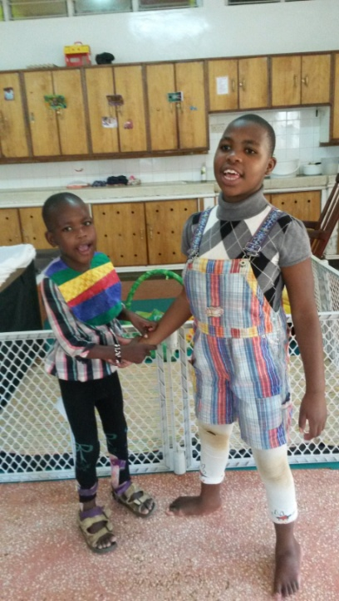Sally Test Pædiatric Centre continues to provide loving care to abandoned children brought to Moi Teaching and Referral Hospital in Eldoret Kenya.

The completion of the new Shoe4Africa (S4A) Children’s Hospital at Moi Teaching and Referral is requiring creative solutions as we care for abandoned children. Without adjacent play area for these young ones, an ambulance brings the kids from the pediatric hospital to our wonderful Sally Test Centre. They are returned each evening to sleep.

Currently we have four children cared at the STPC; two long term children, Serah and Lydia, have begun their fifth year with us. Lydia, who is mute, uses her donated iPad and is able to understand most applications. She also has mastered many daily living skills. Serah is very social and her vocabulary is slowly growing as she beats rhythms on any potential drum.

From left: Lydia and Serah

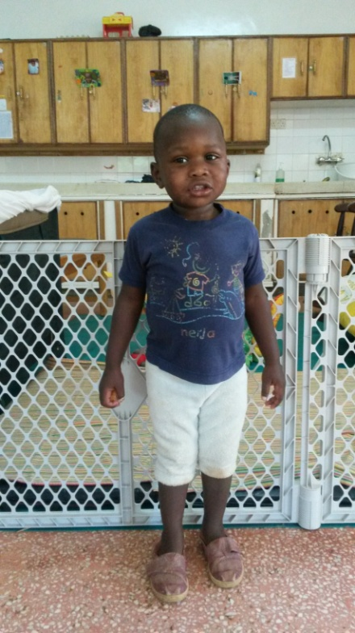

Dennis is a loving, energetic and joyful young man who was rescued from an abusive family. For the past four months, Dennis has brought smiles and hugs to the STPC family and all its visitors.

Dennis

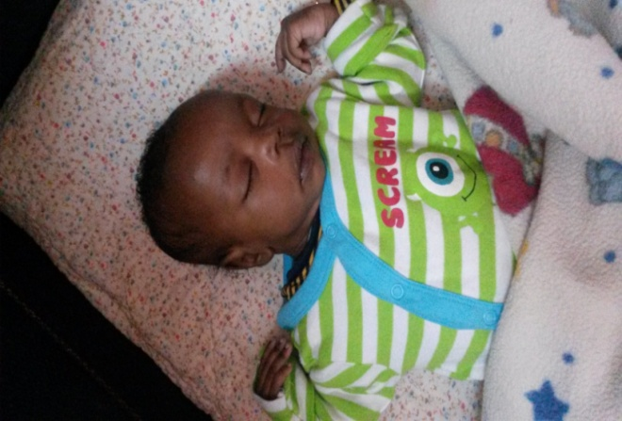

Justus

This year we did not have long rains that have swollen our number to 15-17 abandoned children in the recent past when it seems to “rain babies.”

Justus is our newest addition. He was rescued from a pit latrine by Good Samaritan and is growing rapidly in our care as he learns to know how to trust his strange new world.

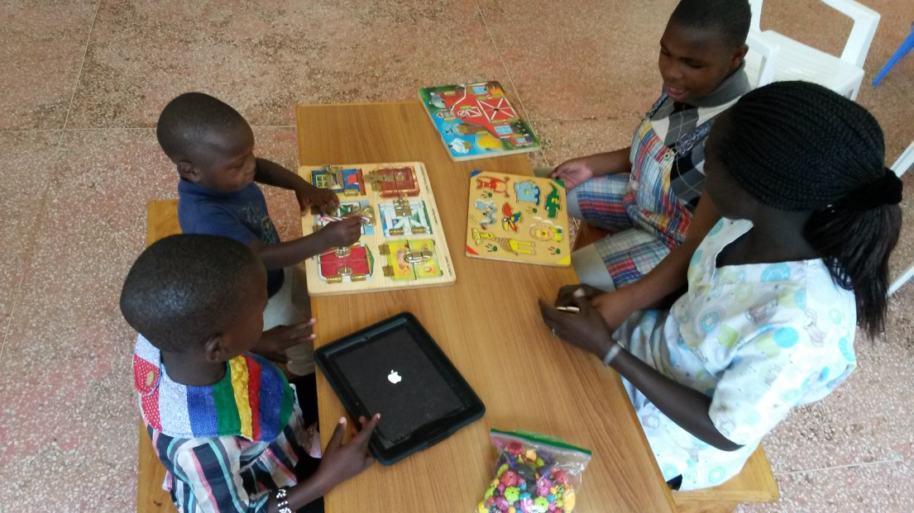.

Anita engaging our children in daily activities