Thank you for your continued support since our project started receiving funds through Globalgiving. As the new year begins, we appreciate the continued support you will give our project till it attains its goal!
We are happy to announce two of our children getting new homes away from the hospital. One of them went to a nice orphanage while another was put into a hospice home to allow strict adherence of ARVs she was started on. We also have a new beneficiary of our program! This is a two year old malnourished oncology child that was abandoned in the hospital by the mother. With no one else to look after him, we decided to take him into our care. During the day, this child is taken to our centre for stimulating activities and therapy.
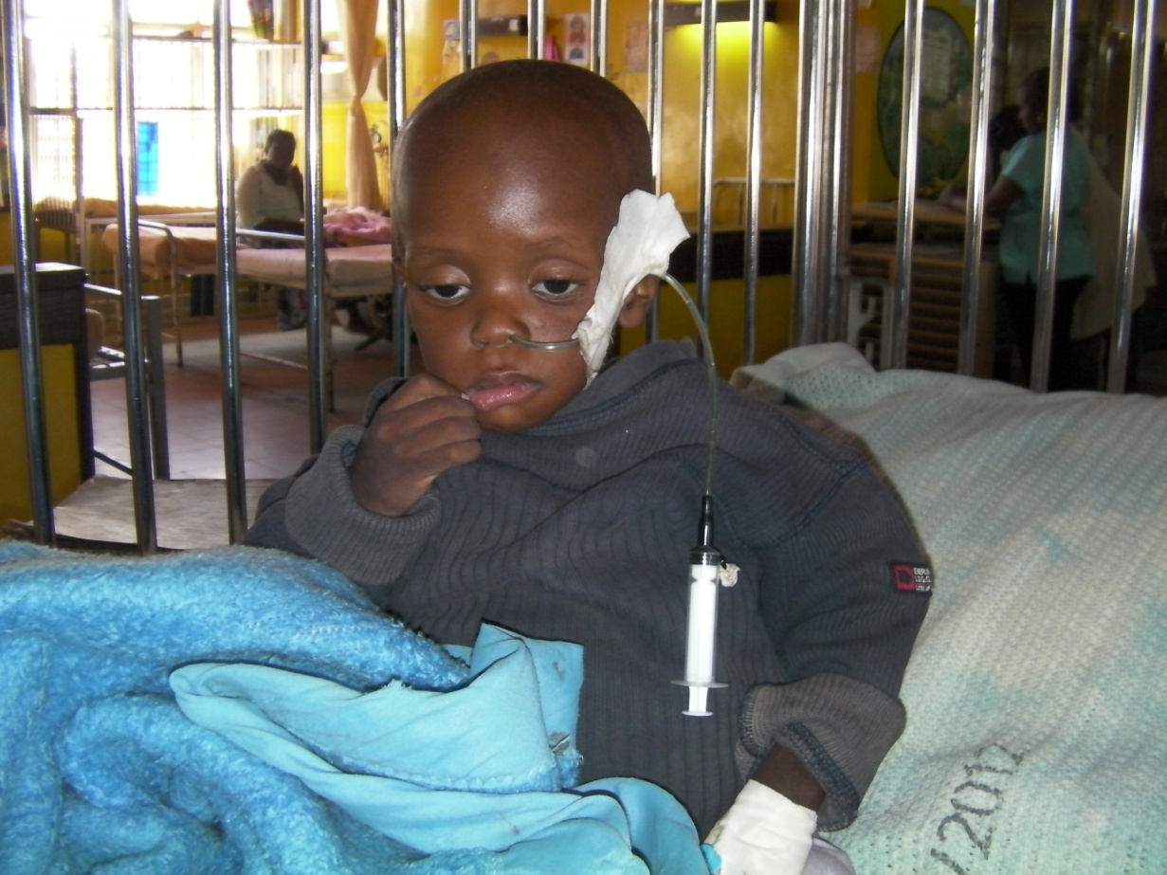
Other than abandoned children, we organized a Christmas party for children admitted in the wards of Moi Teaching and Referral Hospital. Children and their caretakers were served cookies and drinks. Santa distributed a small gift basket which had inside a beanie baby, petroleum jelly, crackers, candy and a small toy car.
We closed our doors for Christmas break on 19th Dec, 2013 and we reopen on 6th Jan, 2014. During this time, children are in the care of nurses in the wards. They stay in their caged beds around the clock. During a brief visit, photos of some were taken:
