A WEALTH of Precious “S-es”

Lydia and Sarah, the children whom social workers at Moi Teaching and Referral Hospital (MTRH) have not been able to place are still with us, growing and thriving. Teenage Sarah happily babbles as she arrives in the playroom each morning, while Lydia grows taller and continues to show signs that learning to read is not far away in spite of her inability to articulate the words she forms.
New children also come while others leave us after being placed with families or in children’s homes.
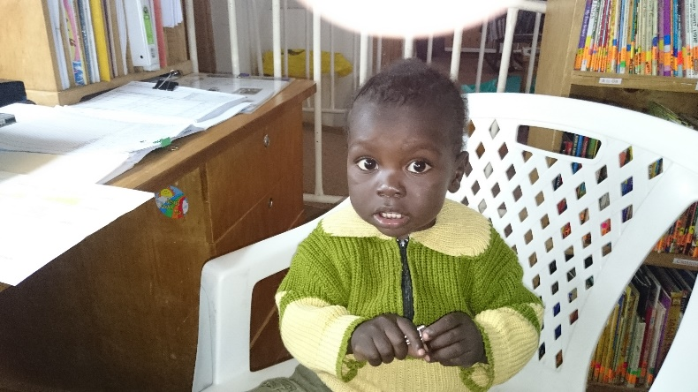
Lately it seems as if the names given to many children on their arrival at the hospital begin with the letter “S.” Our last report told you of a two year old who came into the hospital malnourished, neglected, unable to crawl, and with significant delays. Today this little “S” shows few signs of delay or malnourishment. This little “S” is full of curiosity and mischief as he begins to communicate and explore all over the Sally Test Pædiatric Centre (STPC) walking and climbing. One of his favorite areas is the STPC Office and its computer. Any wire or flash disk sticking out of the CPU is just his height and must be pulled out! “S” also loves to “borrow” any book at eye level.
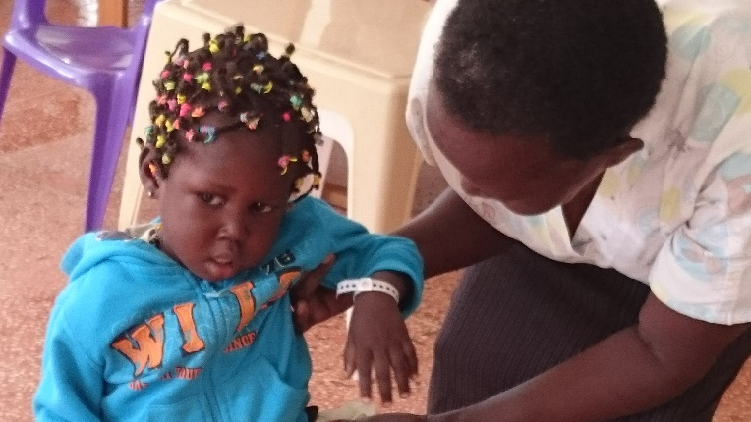
The latest child to join us in our original playroom is another “S.” She was undernourished but also abused. Slowly this young “S” is learning to trust and make friends, but it will take her time. Her smiles are few and far between, but they increase daily as she plays with other children and gets used to friendly faces.
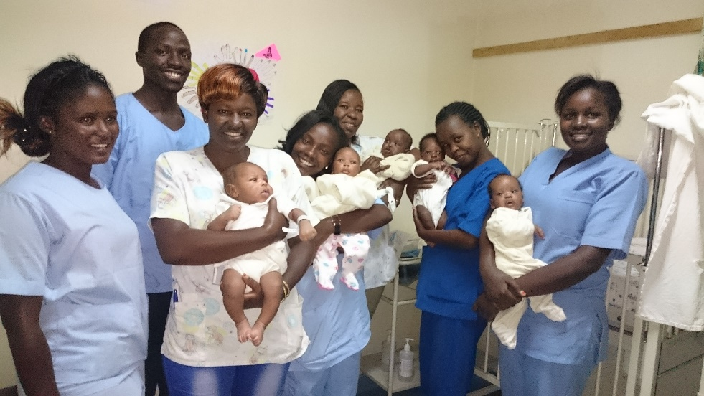
Our Child Life Specialists have begun a new adventure to ensure newborns abandoned at birth do not lack for attention and stimulation. They regularly go to the Riley Mother Baby Hospital at Moi Teaching and Referral to use STIM cards to help young minds begin to focus along with feeding and caring for infants left or brought to the hospital at birth. They provide classes for new mothers to help them understand ways to help their children grow into healthy, vigorous, bright adults.
A few of these newborns’ names begin with “S” because if the child was delivered in the hospital, the infant is known by the name its mother gave before delivery.
Helping these beautiful young children learn to trust and feel the security of love are goals as we nurture these little ones. Thank you for sharing in that effort.

